Instruction for notifying changes to information in compulsory social security insurances on the M-3 form via the SPOT portal

Document history

Version | Amendment | Author | Description of amendments
1.0 | 30. 08. 2021 | ZZZS | Document preparation
1.1 | 23. 09. 2021 | MJU | Editing of document
1.2 | 26. 11. 2021 | MJU and ZZZS | Updating

Contents
1. Form for changing information in compulsory social security insurances and SPOT 5
2. Instructions for notifying changes to information in compulsory social security insurances via SPOT website 7
2.1 Selection of the business, procedure and insured person 8
2.1.1 Selection of the business entity that is liable for registration 8
2.1.2 Selection of the ‘Application to change information in compulsory social security insurances (M-3)’ procedure 9
2.1.3 Selection of insurance 10
2.2 Completion of application 10
2.2.1 Details of liable person and insured person 10
2.2.2 Information on change to insurance 10
2.2.3 Information on insurance that is not being changed 11
2.2.4 Information on insurance that is being changed 12
2.2.5 Notes 16
2.2.6 Date 17
2.2.7 Contact details of user 17
2.3 Selection of attachments 17
2.4 Preview of information 18
2.5 Attachment of documents 18
2.6 Signing 23
2.7 Status of the application 23
2.7.1 Application returned for additional information 25
2.8 Option to search completed applications 28

List of figures

Figure 1: Login to SPOT portal 8
Figure 2: Selection of business entity 9
Figure 3: Selection of the “Application to change information in compulsory social security insurances (M-3)” procedure 9
Figure 4: Selection of insurance 10
Figure 5: User’s contact details 17
Figure 6:Start attaching documents in the CEH 18
Figure 7: Attaching mandatory documents for the selected procedure 19
Figure 8: Attaching individual document 19
Figure 9: Electronic signing of the attached document 19
Figure 10: Warning window stating that the application has not yet been sent to the relevant authority 20
Figure 11:More details of attached document 20
Figure 12: Selection of other documents relating to the procedure you are conducting 21
Figure 13: Attachment of other documents relating to the procedure you are conducting 21
Figure 14: Details of application 22
Figure 15:Partial list of submitted applications 23
Figure 16: Submitted documents of the selected procedure in the CEH 23
Figure 17: Search for application by SPOT number 24
Figure 18: Details of an application to be amended or corrected 24
Figure 19: List of applications in procedures 25
Figure 20: Details of application 25
Figure 21: You can find an eplanation of a deficient application in the CEH by clicking on the ‘Podrobneje’ button 26
Figure 22: Display of the error list 26
Figure 23: Search for a business entity’s closed applications 27
Figure 24: Search for closed company applications by date or EMŠO number 28

Form for changing information in compulsory social security insurances and SPOT

The form for notifying changes to information in compulsory social security insurance “obrazec M-3 – sprememba podatkov o pokojninskem in invalidskem ter zdravstvenem zavarovanju, zavarovanju za starševsko varstvo in zavarovanju za primer brezposelnosti” (M-3 form – changing information in pension and disability insurance, health insurance, parental care insurance and unemployment insurance) is prescribed by the Rules on registration forms for pension and disability insurance, health insurance, parental care insurance and unemployment insurance – Pravilnik o obrazcih prijav podatkov o pokojninskem in invalidskem ter zdravstvenem zavarovanju, zavarovanju za starševsko varstvo in zavarovanju za primer brezposelnosti.

Via the SPOT website, businesses entities registered in the Slovenian Business Register (PRS) arrange compulsory social security insurances for the following insurance basis codes:

Code | Description | Legal basis
001 | persons who are employed in Slovenia at an undertaking, institution, other organisation, or employer, or at branches of foreign businesses, or who are elected or appointed holders of public office | - pension and disability insurance – paragraphs one and two of Article 14 of the Pension and Disability Insurance Act  - health insurance – point 1 of paragraph one of Article 15 of the Healthcare and Health Insurance Act  - parental care insurance – point 1 of Article 8 of the Parental Protection and Family Benefits Act  - unemployment insurance – indent one and three of paragraph one of Article 54 of the Labour Market Regulation Act
002 | persons who are employed by an employer established in Slovenia and who are posted abroad for work or workplace training, unless they have compulsory health insurance in the country to which they have been sent | - pension and disability insurance – paragraph three of the Article 14 of the Pension and Disability Insurance Act  - health insurance – point 2 of paragraph one of Article 15 of the Healthcare and Health Insurance Act  - parental care insurance – point 2 of Article 8 of the Parental Protection and Family Benefits Act  - unemployment insurance – indent one of paragraph one of Article 54 of the Labour Market Regulation Act
005 | sole traders who independently pursue a gainful or economic activity in Slovenia | - pension and disability insurance – Article 15 of the Pension and Disability Insurance Act  - health insurance – point 5 of paragraph one of Article 15 of the Healthcare and Health Insurance Act  - parental care insurance – point 4 of Article 8 of the Parental Protection and Family Benefits Act  - unemployment insurance – indent five of paragraph one of Article 54 of the Labour Market Regulation Act
013 | persons employed in Slovenia by persons who independently pursue a gainful or economic activity | - pension and disability insurance – paragraph one and two of the Article 14 of the Pension and Disability Insurance Act  - health insurance – point 1 of paragraph one of Article 15 of the Healthcare and Health Insurance Act  - parental care insurance – point 1 of Article 8 of the Parental Protection and Family Benefits Act  - unemployment insurance – indent one and three of paragraph one of Article 54 of the Labour Market Regulation Act
019 | persons who independently pursue a professional activity in Slovenia | - pension and disability insurance – Article 15 of the Pension and Disability Insurance Act  - health insurance – point 5 of paragraph one of Article 15 of the Healthcare and Health Insurance Act  - parental care insurance – point 4 of Article 8 of the Parental Protection and Family Benefits Act  - unemployment insurance – indent five of paragraph one of Article 54 of the Labour Market Regulation Act
029 | persons employed in Slovenia by persons who independently pursue a professional activity | - pension and disability insurance – paragraph one and two of the Article 14 of the Pension and Disability Insurance Act  - health insurance – point 1 of paragraph one of Article 15 of the Healthcare and Health Insurance Act  - parental care insurance – point 1 of Article 8 of the Parental Protection and Family Benefits Act  - unemployment insurance – indent one and three of paragraph one of Article 54 of the Labour Market Regulation Act
034 | persons taking part in public works schemes | - pension and disability insurance – paragraph one and two of the Article 14 of the Pension and Disability Insurance Act  - health insurance – point 1 of paragraph one of Article 15 of the Healthcare and Health Insurance Act  - parental care insurance – point 1 of Article 8 of the Parental Protection and Family Benefits Act  - unemployment insurance – indent one and three of paragraph one of Article 54 of the Labour Market Regulation Act
036 | persons who perform supplementary work in accordance with Article 147 of the Employment Relationships Act | - pension and disability insurance – paragraph one and two of the Article 14 of the Pension and Disability Insurance Act  - health insurance – point 1 of paragraph one of Article 15 of the Healthcare and Health Insurance Act  - parental care insurance – point 1 of Article 8 of the Parental Protection and Family Benefits Act  - unemployment insurance – indent one and three of paragraph one of Article 54 of the Labour Market Regulation Act
084 | persons undergoing vocational rehabilitation during employment | - pension and disability insurance – paragraph three of the Article 14 of the Pension and Disability Insurance Act  - health insurance – point 13 of Article 9 of the Rules on compulsory health insurance  - parental care insurance – point 2 of Article 8 of the Parental Protection and Family Benefits Act  - unemployment insurance – indent one of paragraph one of Article 54 of the Labour Market Regulation Act
085 | mothers with children who work part-time under special regulations | - pension and disability insurance – Article 14 of the Pension and Disability Insurance Act  - health insurance – point 1 of paragraph one of Article 15 of the Healthcare and Health Insurance Act  - parental care insurance – point 1 of Article 8 of the Parental Protection and Family Benefits Act  - unemployment insurance – indent one and three of paragraph one of Article 54 of the Labour Market Regulation Act
101 | persons who pursue a gainful or professional activity in Slovenia, after the onset of a Category I disability | - pension and disability insurance – Article 15 of the Pension and Disability Insurance Act

For all the above-mentioned insurance basis codes, it is also possible to carry out the process of registering for compulsory social security insurance using the personnel (staff) interface (eHRS).

Instructions for notifying changes to information in compulsory social security insurances via SPOT website

An M-3 form via the SPOT website is used to change or correct information submitted on the M-1 form in or M-3 for uncompleted (open) insurance in the following sections:
  - Block 19 – Registration number of business unit;
  - Block 21 – Single permit number;
  - Block 22 – Expiry of insurance conditions;
  - Block 23 – Type of education (KLASIUS-SRV);
  - Block 24 – Field of education (KLASIUS‑P‑16);
  - Block 25 – Occupation (SKP‑08);
  - Block 26 – Employment;
  - Block 27 – Shift work;
  - Block 29 – Type of disability.

With regard to closed (completed) insurance, liable persons may only report the annulment (cancellation) of fully completed insurance using the M‑3 form.

Completed insurance is annulled in the following cases:
- if incorrect information was provided in the M‑1 form in:
  - Block 2 – Registration number;
  - Block 4 – Liable person’s personal identification number (EMŠO);
  - Block 6 – Insured person’s personal identification number (EMŠO);
  - Block 15 – Date of start of insurance;
  - Block 16 – Insurance basis;
  - Block 17 – Insured person’s working/insurance hours;
  - Block 18 – Liable person’s full-time working/insurance hours;
  - Block 28 – Posted abroad.
- if the incorrect information was provided in the M‑2 form in:
  - Block 31 – Reason for termination of insurance;
  - Block 32 – Date of termination of insurance.

The annulment (cancellation) of completed insurance is reported by entering Code 16 (Cancellation of completed insurance) in Block 13 of the M‑3 form (Reason for change to insurance). A new application to register (M‑1 form) and application to deregister (M‑2 form), containing the correct information, shall be submitted at the same time as the application to change information (M‑3 form).

If submitted applications contain incorrect information or if the required supporting documents have not been enclosed with an application, the ZZZS will returns the application to the person liable for the registration for the application to be supplemented.

If the prescribed conditions for insurance are not met, the ZZZS rejects the application.

You must log on to the system in order to carry out electronic procedures via the SPOT website.
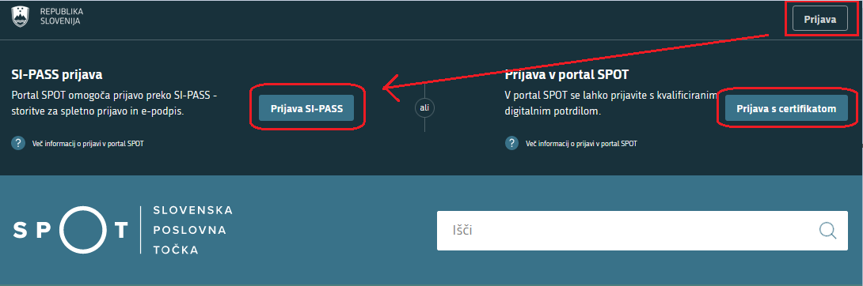

Figure 1: Login to SPOT portal

Selection of the business, procedure and insured person

The following must be selected before a start is made on completing the application:
- the business entity that is liable for registration;
- the ‘Application to change information in compulsory social security insurance (M‑3)’ procedure; and
- the insurance to which changes to information are to be made.

Selection of the business entity that is liable for registration

The business entity is selected by entering the tax number, if the person liable for registration is a sole trader (s.p.), or the company registration number, if the liable person is any other business entity (company, institute, person pursuing an independent professional activity, etc.). The business entity can also be selected from the list. Only a business entity can be selected where the user of the SPOT portal is registered as a responsible person (legal representative) or has the appropriate authorisation from the responsible person to conduct this procedure for the selected business entity.
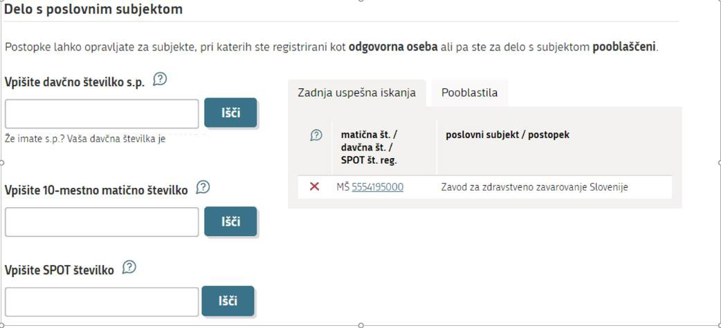
Figure 2: Selection of business entity
Help
‘Delo s poslovnim subjektom’ - Working with a business entity:
'Vpišite davčno številko s.p.' - Enter the tax identification number:
Enter the tax identification number of the sole trader (s.p.). If you are a sole trader and wish to carry out SPOT procedures for your company, enter your tax identification number. You may also use the link to your tax identification number under the search window. If you are authorised by SPOT to carry out procedures on behalf of another sole trader, enter the VAT identification number for which you wish to carry out the SPOT operations. In the ‘Authorisations’ tab, you can find the tax identification numbers of all sole traders for which you are currently authorised.
'Vpišite 10-mestno matično številko' - Enter the 10-digit company registration number:
If you wish to perform SPOT operations for a sole trader, use the tax identification number search engine. If you are the legal representative of a company registered in the AJPES Digital Certificate Register (EDP) and wish to carry out SPOT operations for your company, enter the company registration number. If you are authorised by SPOT to carry out procedures on behalf of another sole trader, enter the VAT identification number of the company for which you wish to carry out the SPOT operations. The ‘Last Search’ tab contains a list of the business entities you last successfully accessed. The ‘Authorisations’ tab contains a list of all registration numbers of the companies for which you are authorised by SPOT.
'Vpišite SPOT številko' - Enter the SPOT number:
If you wish to search for a contact application, enter its SPOT number. It is not possible to search for sole trader applications by SPOT application number.

Selection of the ‘Application to change information in compulsory social security insurances (M-3)’ procedure

Select the 'Prijava sprememb podatkov v obveznih socialnih zavarovanjih (M-3)' – the ‘Application to change information in compulsory social security insurances (M‑3)’ procedure from among the procedures for the selected business.

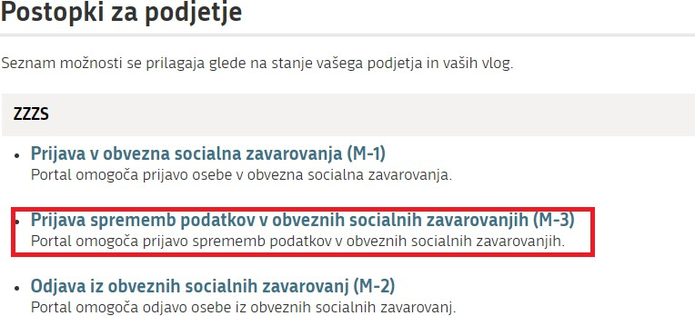
Figure 3: Selection of the “Application to change information in compulsory social security insurances (M-3)” procedure

Selection of insurance

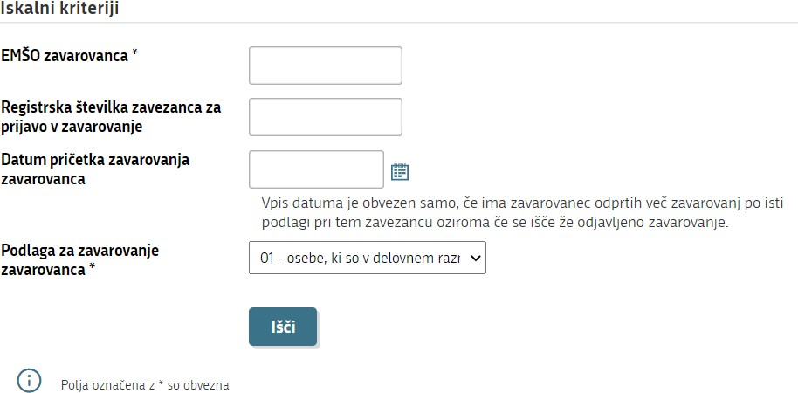
Figure 4: Selection of insurance

Before starting to complete the application, use the search criteria to find the insurance that will be deregistered from the compulsory social security insurances.

You must enter the insured person’s EMŠO (personal identification number) and select the insurance basis code ('Podlaga za zavarovanje zavarovanca') under which the person is insured.

The date on which the insured person’s insurance started ('Datum pričetka zavarovanja zavarovanca') is not mandatory. You are only required to enter this information if the insured person has more than one insurance under the same insurance basis code with the same person liable for registration (employer) or if you look for already closed (completed) insurance. In this case, enter the date of the start of the insurance that you wish to change information.

Completion of application

Based on the selection of the business entity (point 2.1.1) and the search criteria entered (point 2.1.3), the information in the sections of the application are already displayed as recorded in the ZZZS records (most recent status).

Mandatory information is marked with an asterisk (*) at the end of the information title. If you do not enter any of these details, you will not be able to close and submit your application.

By clicking on a cloudlet with a question mark () in a particular field, instructions for entering information in Slovenian will be displayed. In the following, these instructions in English are referred to as "Help" for each section.

Details of liable person and insured person

The details of the liable person and insured person have already been entered and cannot be changed.

Information on change to insurance

Block 13 – Vzrok spremembe zavarovanja - Reason for change to insurance

If you wish to make changes to open (uncompleted) insurance, select reason code 01.
If you wish to make changes in Block 22 (date of expiry of insurance conditions based on the certificates demonstrating that a request for the extension of a permit was submitted in due time), select reason code 06.
If you wish to annul (cancel) already closed (completed) insurance, select reason code 16.

Help
‘Vzrok spremembe zavarovanja’ – Reason for change to insurance:
01 - ‘Sprememba in popravek podatkov’ is selected if the information in Sections 19 to 29 is changed or corrected;
16 - 'Razveljavitev (storno) zaključenega zavarovanja’ is selected if already deregistered insurance has to be annulled (cancelled).
06 - ‘Spremmeba in popravek podatkov v rubriki 22 na podlagi predloženega potrdila o pravočasno vloženi prošnji za podaljšanje dovoljenja’ is selected if the information in Block 22 is changed or corrected based on the certificates demonstrating that a request for the extension of a permit was submitted in due time;

Block 14 – Datum spremembe zavarovanja - Date of change to insurance
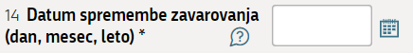

Enter the date of change to insurance. Write the date in DD.MM.YYYY format, or select the date in the calendar in the column.

If a change to information is being reported, enter the date on which the change to the information whose change is being reported occurred.

If a correction to information is being reported, enter the date on which the person liable for registration became aware of the error.

If annulment (cancellation) is being reported, enter the date on which the reason for annulment arose (e.g. the date of enforceability of the decision, date of warning from the authority, etc.).

Help
‘Datum spremembe zavarovanja (dan, mesec, leto)’ – Date of change in insurance (day, month, year): Enter (DD.MM.YYYY) the date of the change to or correction of the information, or select it from the calendar. If a change to information is being reported, enter the date on which the change to the information whose change is being reported occurred. If a correction to information is being reported, enter the date on which the person liable for registration became aware of the error. If the extension of a work permit (Block 20) is being reported, enter the date from which the extended work permit is valid as the date of the change of insurance.

Information on insurance that is not being changed

Blocks 15, 16 and 17 – – Datum pričetka zavarovanja, podlaga za zavarovanje in delovni/zavarovalni
čas zavarovanca - Date of start of insurance, insurance basis and insured person’s working/insurance hours

The details have already been entered as per the ZZZS records and cannot be changed in this procedure.

Block 18 – Polni delovni/zavarovalni čas zavezanca - Liable person’s full-time working/insurance hours
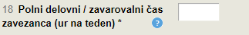

The information was introduced into the M‑1, M‑2 and M‑3 forms on 1 July 2011. The column is therefore already filled in if this information has already been provided to the ZZZS.

If the information in the column is not displayed, enter the information in accordance with the following instructions:
Enter the liable person’s full-time working/insurance hours in number of full hours per week (whole number).
The liable person’s full-time working/insurance hours are equal to the full-time working hours for insured employees, as defined in the Employment Relationships Act (Zakon o delovnih razmerjih - ZDR-1). This amounts to 36 to 40 hours a week. Groups of posts or individual insured persons may have differing full-time working hours at the same employer.
The number of full-time working/insurance hours of a liable person for individual insurance basis codes have the following possible values:
Insurance basis code | Liable person’s full-time working/insurance hours
001, 002, 013, 029, 084, 085 | 36 - 40
005, 019, 034, 101, 104 | 40
036 | 08

Information on insurance that is being changed

The person liable for registration only corrects or change information only in those blocks where correction or change is required. Other information is not deleted.
Block 19 – Matična številka enote poslovnega subjekta - Company registration number of business unit
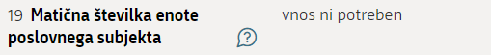

The information is already displayed in the block, if it exists in the ZZZS records. If the information is not displayed, enter it.
Report a change to information if the insured person has changed or will change his/hers place of work for more than three months.
Enter the last three digits of the company registration number (the first seven digits have already been entered) of the business unit from the PRS (at which the insured person actually works or will work. By business unit is meant every part that has been assigned a company registration number in the PRS.
If the insured person works at the head office, enter three zeros.
Help
‘Matična številka enote poslovnega subjekta’ – Company registration number: If the insured person has changed the location of the work, enter the last three numbers of the business unit at which the insured person is currently working. If it is currently carried out at the head office of the business entity, enter three zeros.
Block 21 – Številka enotnega dovoljenja - Single permit number
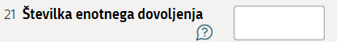

The information is already displayed in the block if it applies to a foreign person whose information has been provided in a previous M‑1 or M‑3 form.
If a foreign person no longer requires a work permit (free access to the labour market) under the provisions of the Employment, Self-Employment and Work of Aliens Act (Zakonu o zaposlovanju, samozaposlovanju in delu tujcev - ZZSDT), the liable person deletes the work permit number displayed. In that case, state under NOTES the legal basis on which the foreign person acquired the right to free access to the labour market (e.g. point 4 of Article 6(2) of the ZZSDT).
If the foreign person still requires a permit to enable him/her to work in Slovenia, report the change as follows:
Extension of a single permit, EU Blue Card or temporary residence permit containing the right to access the labour market:
If one of these permits has been extended, the new permit number must be entered, in accordance with the rules as set out for the completion of Block 21 on the M‑1 form, in Block 22 (Expiry of insurance conditions), along with the expiry date of the new permit.
If the insured person has not yet had their permit extended and the administrative unit has issued confirmation demonstrating that a request for the extension of a permit was submitted in due time, the liable person arranges the extension of insurance on the basis of this confirmation, as this confirmation is valid as an employment permit until the decision on the request to extend a single permit or EU Blue Card becomes final or until the decision on a request to extend a temporary residence permit not issued for employment, self-employment or work, with a right to access the labour market, becomes final. In this case, the number of the permit whose validity has expired is entered in Block 21, and the date, extended by four months from the first day following the termination of the previously valid permit, is entered in Block 22 (Expiry of insurance conditions). After four months have elapsed, the liable person is required to submit: a valid permit, if the procedure has already been concluded, or confirmation from the administrative unit that the procedure is still ongoing. In the latter case, the date, extended by four months, is re-entered in Block 22.
Help
‘Številka enotnega dovoljenja’ – Single permit number:
If the insured person has obtained a new single permit, an EU Blue Card or a temporary residence permit containing the right to access the labour market, enter the nine-digit number of this new permit.
If the insured person has not yet obtained a new permit but has submitted an application for renewal in due time and holds a certificate demonstrating that an application for the extension was submitted in due time, enter the number of the old permit, as explained in the Instructions for making changes to information in compulsory social security insurances on the M-3 form via the SPOT portal.
If the insured person has obtained a seasonal work permit for up to 90 days, enter the 11-digit permit number.
If the insured person has acquired the right to free access to the labour market and the work permit number is already displayed in this block, delete it and enter, under NOTES, the legal basis on which the foreign national acquired the right to free access to the labour market (e.g. point 1 of Article 6(2) of the ZZSDT).
Block 22 – Iztek zavarovalnih pogojev - Expiry of insurance conditions
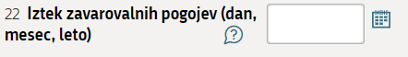

Enter the date (in DD.MM.LLLL format or select the date from the calendar), as explained in Block 21.
Help
‘Iztek zavarovalnih pogojev (dan, mesec, leto)’ - Expiry of insurance conditions (day, month, year):
Enter the expiry date of the single permit, EU Blue Card, seasonal work permit for up to 90 days or temporary residence permit containing the right to access the labour market.
If the insured person has not yet obtained a new permit but has submitted an application for renewal in due time and holds a certificate demonstrating that an application for the extension was submitted in due time, enter a date four months older than the expiry date of the previous permit. More detailed explanations can be found in the Instructions for changing information in compulsory social security insurances using the M‑3 form via the SPOT portal.
Blocks 23 and 24 – Vrsta izobrazbe (KLASIUS-SRV) in Področje izobrazbe (KLASIUS-P-16) - Type of education (KLASIUS-SRV) and Field of education (KLASIUS-P-16)

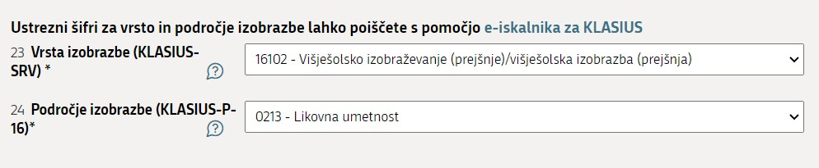

These two pieces of information are already displayed if they exist in the ZZZS records. They were introduced into the M‑1 and M‑3 forms on 1 July 2011.
If they are not displayed or have been changed, enter or change them.
Enter the code for type of education (KLASIUS-SRV) in Block 23 and the code for field of education in Block 24 (KLASIUS‑P‑16). You may also search for the appropriate codes with the help of the online search engine for KLASIUS, and then select from the code table in Blocks 23 and 24.
Classifications and codes in English: https://www.stat.si/statweb/en/Methods/Classifications > Social Classifications > KLASIUS - Classification System of Education and Training
If you require help in determining the type of education (KLASIUS-SRV) and field of education (KLASIUS‑P‑16), you may address a question, with a brief description of the problem, to the Slovenian Statistical Office (SURS) at: klasius-skp.surs@gov.si .
The question/brief description of the problem should state:
- the classification (e.g. KLASIUS-SRV; KLASIUS‑P‑16) to which the question relates;
- the key information on the publicly recognised education of the person for whom a KLASIUS code is being determined, i.e. information such as:
  - name of education/study programme;
  - title conferred by education/study programme, or professional or academic title conferred;
  - if possible, the year in which this publicly recognised education was obtained;
  - the school or educational institution;
  - the type and/or level of education, if this is stated on the document, etc.;
- the contact person and his/hers telephone number . This will enable SURS to get in touch if they require any further clarifications.
Help
‘Vrst izobrazbe (KLASIUS-SRV)’ – Type of education: Enter the code for type of education or select it from the code table.
‘Področje izobrazbe (KLASIUS-P-16)’ - Field of education: Enter the code for field of education or select it from the code table.

Block 25 – Poklic, ki ga opravlja - Occupation

If the ZZZS has the information in its records, that information is already displayed. The Standard Classification of Occupations code table has been changed. The previous SKP‑V2 code table had seven-digit codes, while the current SKP‑08 has four-digit codes. The information on the occupation pursued by the insured person began to be entered in the M‑1 and M‑3 forms, in accordance with the new code table, on 1 July 2011.
If the information is not displayed or has changed, enter or change it.
The appropriate code for the occupation pursued by the insured person is selected from the code table. You may also search for the appropriate code with the help of the online search engine for SKP‑08 and then select from the code table in Block 25.
Classification and codes in English: https://www.stat.si/statweb/en/Methods/Classifications > Social Classification > SKP - Standard Classification of Occupation
If you require help in determining the group of occupations under SCO‑08, you may address a question, with a brief description of the problem, to the Slovenian Statistical Office (SURS) at: klasius-skp.surs@gov.si.
The question/brief description of the problem should state:
- the classification (e.g. SKP‑08) to which the question relates;
- the title or name of the work, post or occupation to which you wish to assign a four-digit SKP‑08 code;
- a brief description of the work (post) and the education/qualification conditions applying to performance of this work (post);
- the contact person and his/hers telephone number . This will enable SURS to get in touch if they require any further clarifications.
Help
‘Poklic, ki ga opravlja (SKP-08)’ – Occupation performed: Enter the four-digit code of the appropriate group of occupations under the Standard Classification of Occupations 2008 (SCO‑08) or select it from the code table.
Block 26 – Delovno razmerje - Employment

The column is only completed if there is a change to employment type from fixed-term to permanent, or vice versa.
The appropriate code for the insured person’s type of employment is selected from the code table.
Code | Name
1 | for a person who has entered into permanent employment;
2 | for a person who has entered into fixed-term employment;
3 | for a trainee who has entered into permanent employment;
4 | for a trainee who has entered into fixed-term employment.
Help
‘Delovno razmerje’ – Employment: Enter the appropriate code for the insured person’s type of employment or select it from the code table.
Block 27 – Izmensko delo - Shift work

The appropriate code for the distribution of the insured person’s working hours (shift work) is selected from the code table.
Code | Name
1 | for an insured person who works in a single shift (work and functions are performed by a single person, most commonly for seven or eight hours within a 24-hour period, regardless of the time of day and regardless of whether the work is performed in unsplit or split shifts);
2 | for an insured person who works in two shifts (work and functions are performed by two people, each most commonly working for seven or eight hours within a 24-hour period);
3 | for an insured person who works in three shifts (work and functions are performed by three people within a 24-hour period);
4 | for an insured person who works in four or more shifts (work and functions are performed by four or more people within a 24-hour period);
5 | for an insured person who performs work and functions in rotating shifts of between 12 and 24 hours or under another time distribution system, followed by 24 or more hours free.

Help
‘Izmensko delo’ – Shift work: Enter the appropriate code for the distribution of working hours (shift work) or select it from the code table.
Block 29 – Vrsta invalidnosti - Type of disability

If information on whether the insured person has become disabled has to be changed or corrected, the appropriate disability code is selected from the code table.
If the insured person is still disabled, the information is not deleted. If it is deleted, it will also be deleted from the ZZZS records.
Help
‘Vrsta invalidnosti’ – Type of disability: Enter the appropriate code for the insured person’s disability or select it from the code table.

Notes

This block is intended mainly to enable a person liable for registration to provide additional explanations regarding the circumstances that form the basis for the registration.

Date

The date is entered automatically. The date displayed is the date on which the application was submitted.

Contact details of user
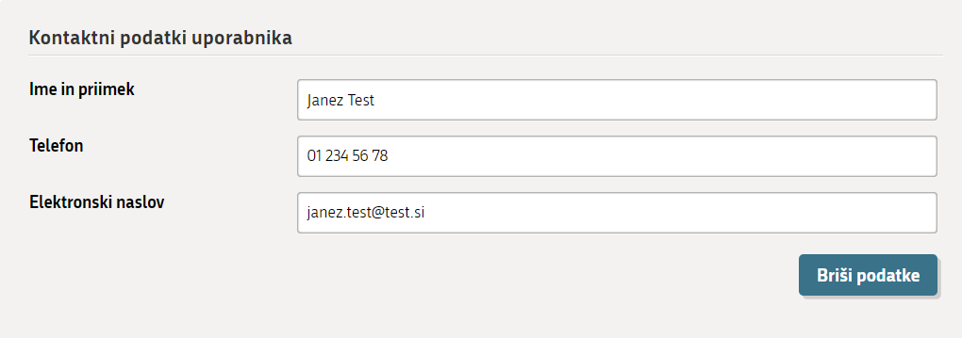
Figure 5: User’s contact details

The contact details you entered when registering on the SPOT website are displayed. The contact details are important for the ZZZS, as they enable it to contact you and sort things out if there is a problem with your application or if something is unclear.
At the end of this stage (Step 1), the application may also be saved for later completion. Save your entries by clicking (‘Save application’). If the application is saved, it receives a SPOT number. If not, it does not receive a SPOT number until Step 3 - Preview of information (3. korak - Predogled podatkov).
Click (‘Next’) to continue the process.

Selection of attachments
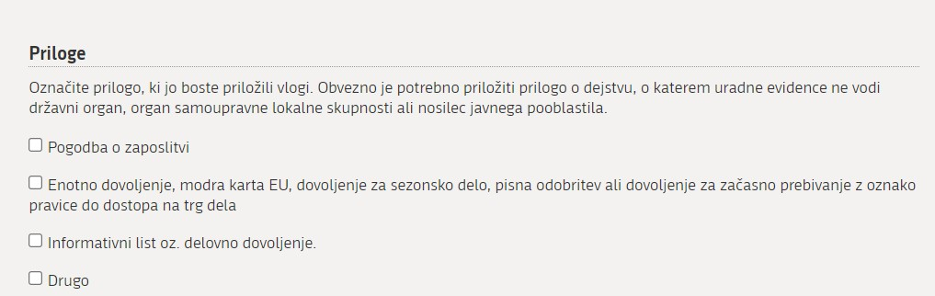

At this stage (Step 2 – 2. korak), mark the documents that you will be attaching to the application.
At the end of this stage (Step 2 – 2. korak), you may:
- save the application for later completion with clicking (‘Save application’),
- return to Step 1 – Completion of application (1. Korak – Izpolnjevanje vloge) with clicking on (‘Back’), or
- move forward with clicking (‘Next’) to Step 3 – Preview of information (3. korak – Predogled podatkov).

Preview of information

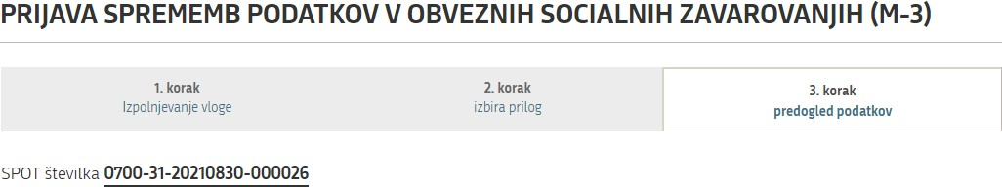
A preview of the information entered in the application, as well as an indication of which documents have been marked for attachment, is available at this step.
If any information needs to be corrected or any attachment selected or deleted, you may return to Step 2 – Selection of attachments (2. Korak – Izbira prilog) and, for the selection of attachments, further back to Step 1 (Completion of application). You may also do this by clicking on a step at the top of the page.
Clicking (‘Next’) at the bottom of the page takes you on to the attachment of documents.

Attachment of documents

This step involves attaching the documents you have previously selected (point 2.3).
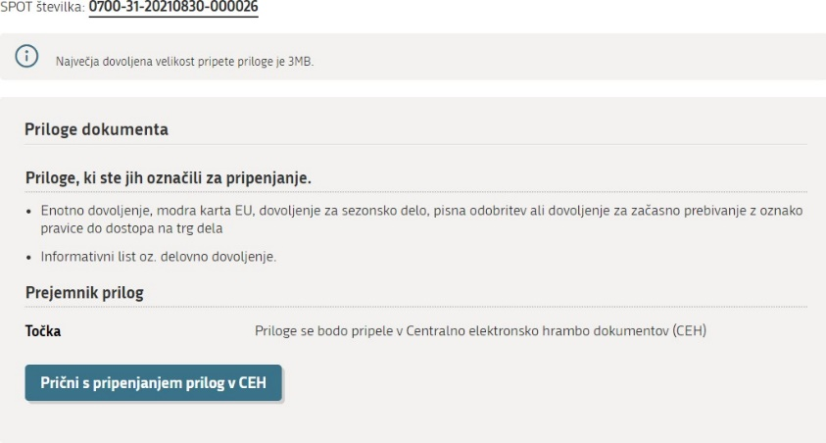
Figure 6:Start attaching documents in the CEH

After you click (‘Start by attaching the documents to the CEH’), the steps are as follows:

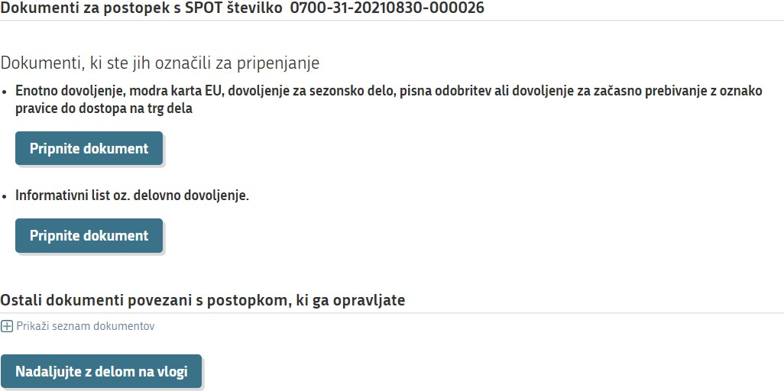
Figure 7: Attaching mandatory documents for the selected procedure

To attach a specific document, click (‘Attach document’).

The next page opens:

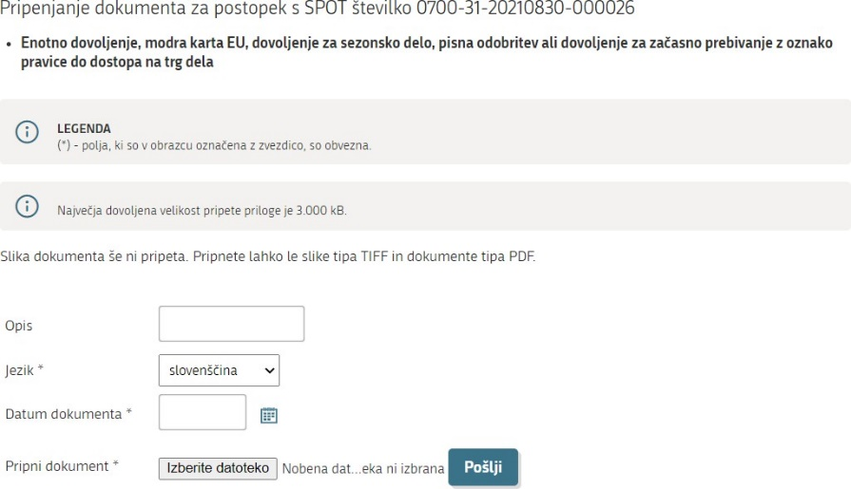
Figure 8: Attaching individual document

During the document attachment process, complete the required fields ‘Jezik’ (‘Language’) and ‘Datum dokumenta (‘Date of document’). The field ‘Opis’ (‘Description’) is not mandatory and is mostly used for attachments marked as ‘Drugo’ (‘Other’). Attach the document by clicking (‘Browse’) (after clicking on this button, search for the document on the computer on which you saved it), then click (‘Send’).
The attached document can then be viewed by clicking (‘Show image of attached document’). The attached document should then be electronically signed by clicking (‘Sign document electronically’).

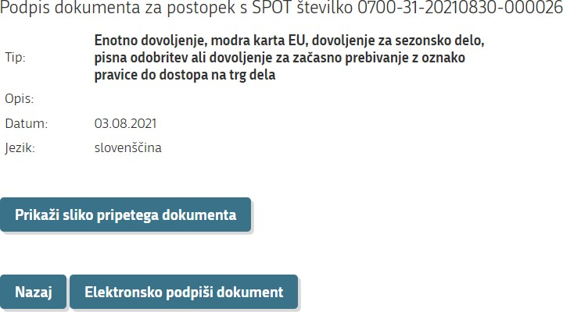
Figure 9: Electronic signing of the attached document

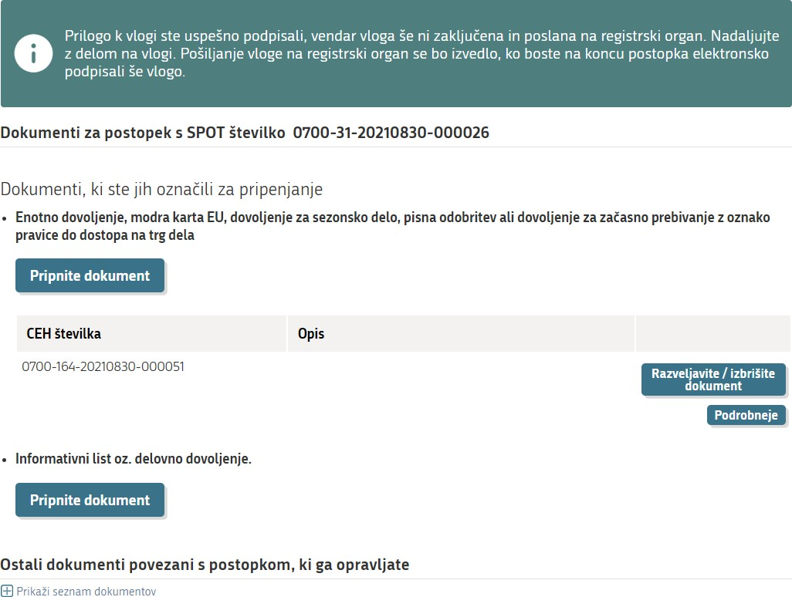

Figure 10: Warning window stating that the application has not yet been sent to the relevant authority
Note:
You are required to electronically sign every document attached. After the attachment is signed, the application submission procedure is still not yet complete. The application itself (M form) must be signed at the end.
After the document has been electronically signed, it may also be deleted at this step by clicking 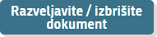 (‘Annul/delete document’), if you find that you have attached the wrong document, etc. By clicking (‘Details’), you can view the attached document, with the following page being opened:

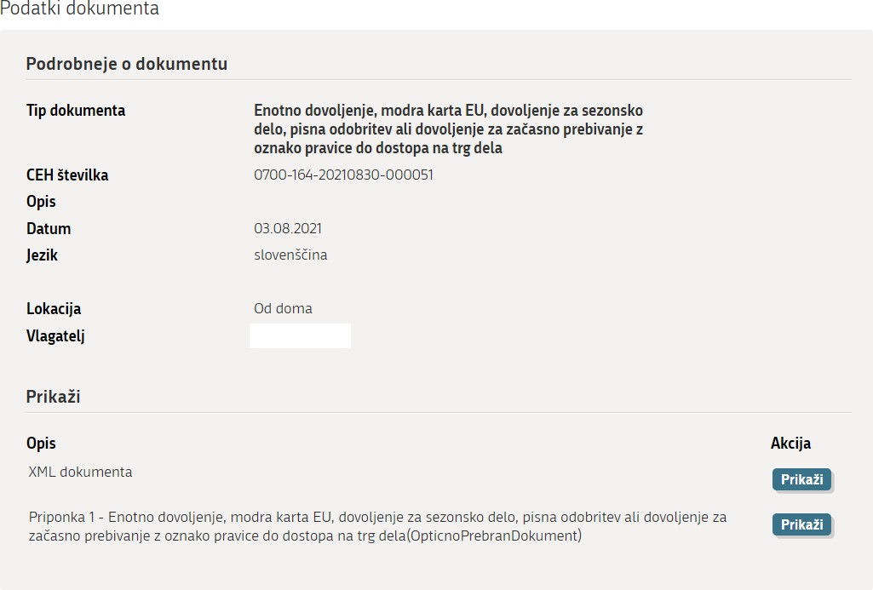
Figure 11:More details of attached document

To view the attached document, click ('Show') where 'Priponka ….' ('Attachment') is written.

Clicking 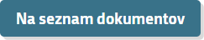 (‘To the list of documents’) takes you away from this page.
If you need to attach another document that was not marked during Step 2 - Selection of attachments (2. korak – Izbira prilog), you can also do this on the page:
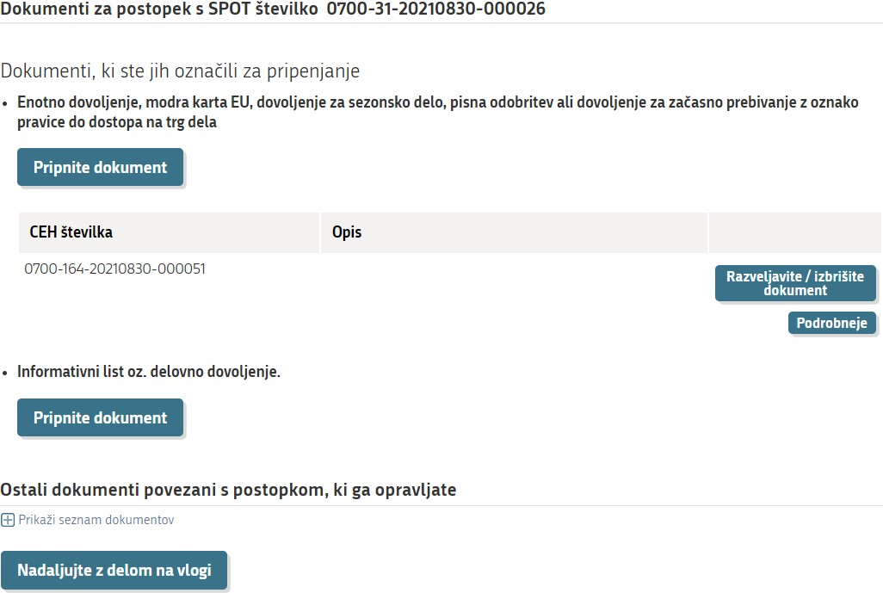
Figure 12: Selection of other documents relating to the procedure you are conducting

By clicking (‘Show list of documents’), which allows you to attach other documents::

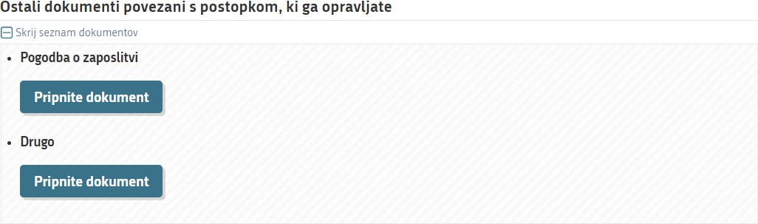
Figure 13: Attachment of other documents relating to the procedure you are conducting

Once the document attachment process is complete, click 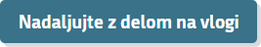 (‘Continue working with an application’), which takes you back to the document attachment step.
From there, clicking 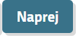 (‘Next’) takes you to the last step, Step 3 – Signing (3. korak - Podpisovanje).

Signing

At this last stage (Step 3 – 3. korak) the application is signed electronically by clicking 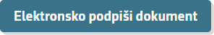 (‘Sign document electronically’). This also submits the application.

Status of the application

After signing the application electronically, you may track its status on the SPOT website and view the history of the application you have submitted. You may also view the application with attachments in the central electronic storage database (CEH).

An application can have one of the following statuses:
- Vloga je v delu in še ni bila poslana na registrski organ – Application is in progress and has not yet been sent to the registering authority – this status means that you have not yet submitted the application. You must open the application, complete it fully and, if you have not yet done so, sign it electronically and submit it.
- ‘loga je v vrsti za pošiljanje – Application is queued for sending – this status means that the application is waiting to be placed on the list of applications waiting to be sent to the ZZZS. Applications are placed on the list every few minutes.
- Vloga je bila vnešena v vrsto in čaka na pošiljanje – Application has entered the queue and is awaiting transmission – this status means that the application has been placed on the list of applications waiting to be sent to the ZZZS. Applications are placed on the list every few minutes.
- Registrski organ je prejel vlogo – Registering authority has received the application – this status means that the ZZZS has received the application.
- Vloga ni popolna, zato jo je treba vsebinsko dopolniti – Application is incomplete and must therefore be supplemented – this status means that the application is incomplete and the ZZZS has returned the application to you to supplement it. The system annuls the application if you fail to supplement the application and resend it within 15 days.
- Vloga je bila negativno rešena – Application rejected – this status means that the ZZZS has rejected the application (the supplement to the application is not possible).
- Postopek je bil uspešno zaključen – Procedure successfully concluded – this status means that the ZZZS has approved the application.
- Razveljavljena – Annuled – this status means that the user has not corrected and re-sent the application that was sent to him to be supplemented within 15 days, leading to annulment of the application by the system.

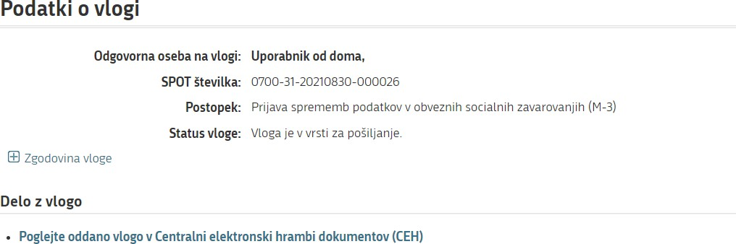

Figure 14: Details of application

If there are no errors in the application, the ZZZS approves it (application receives ‘Procedure successfully concluded’ status). In this case, you can print or save the confirmation of registration from the CEH. You can access a specific application in the CEH using the same procedure as described for access to application errors.

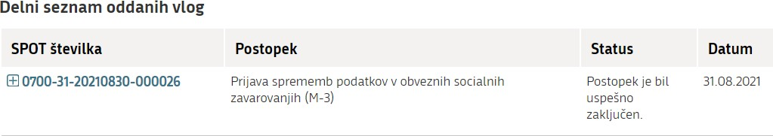
Figure 15:Partial list of submitted applications

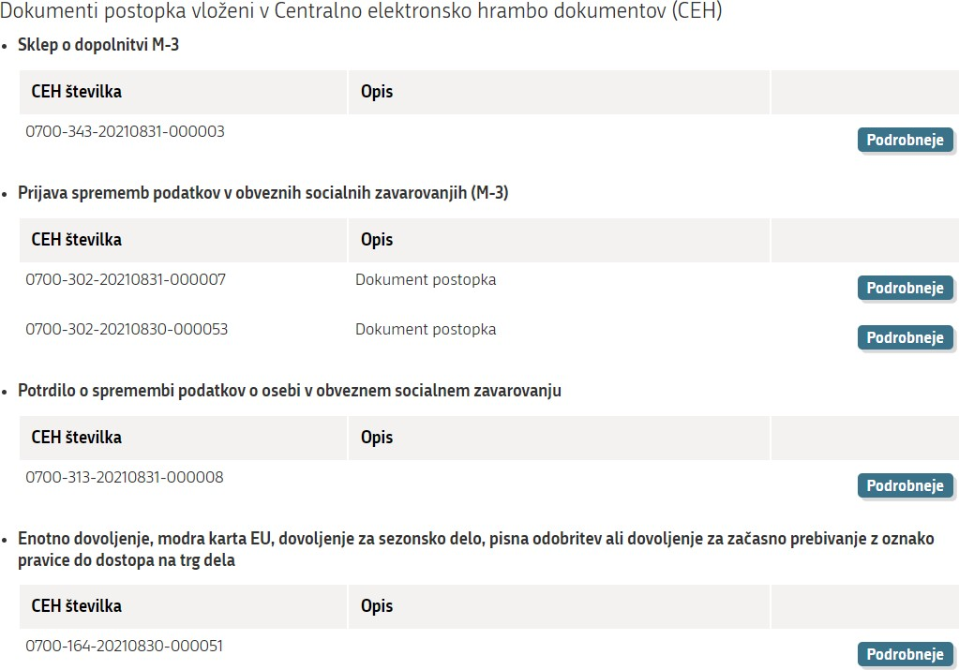
Figure 16: Submitted documents of the selected procedure in the CEH

When you access documents in the CEH, click (‘Details’) in the ‘Potrdilo o spremembi podatkov o osebi v obveznem socialnem zavarovanju’ (‘Confirmation of change... ’) section.
This opens the page where you click (‘Show’) in the selection ‘Vizualizacija…’ (‘Visualisation’) to see a PDF visualization of the application or a document in XML format if you click (‘Show’) in the selection ‘XML dokumenta’.
If you click (‘Show’) in the section ‘Referent ZZZS, ki je obravnaval vlogo’ (‘ZZZS case officer who processed the application’), the details of the case officer (first name, surname, telephone number) are displayed.
If there are errors in the application and because of those errors the application cannot be supplemented or corrected, or if the conditions applying to insurance are not met, the ZZZS rejects the application (the application receives status: ‘Vloga je bila negativno rešena’ - ‘Application rejected’).

Application returned for additional information

If the application is deficient or has been completed incorrectly, the ZZZS returns it for supplementation or correction. If you wish to access the application, you must log on to the SPOT website and enter the application number in the search criteria, as marked in red below.

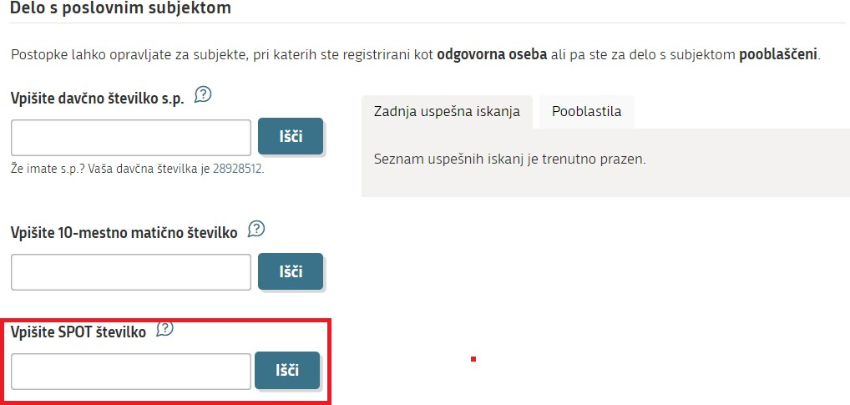

Figure 17: Search for application by SPOT number

You can access the application requiring supplementation or correction via this search criterion.

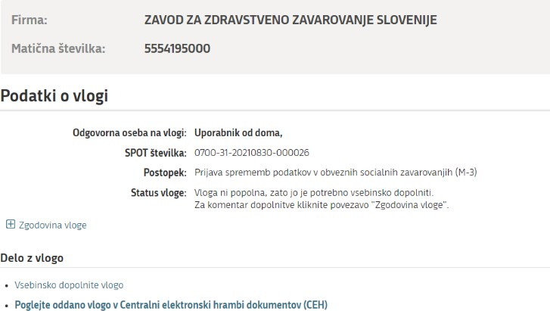
Figure 18: Details of an application to be amended or corrected

You can also access an application requiring additional information by selecting ‘business entity’ (point 2.1.1). After you have selected business entity, the list of applications in the procedures is opened (‘Seznam vlog v postopkih’).

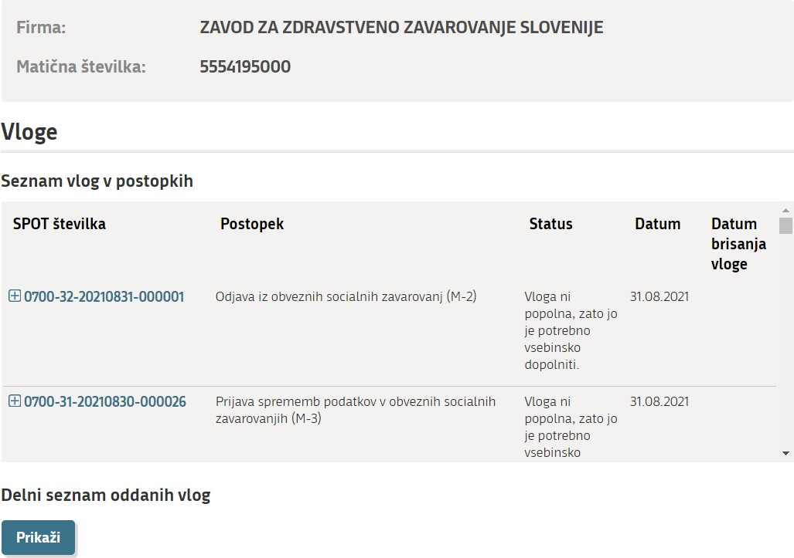
Figure 19: List of applications in procedures

Clicking on an application’s SPOT number opens that application.

Figure 20: Details of application

You can see the reason why the application has been deemed deficient or has been completed incorrectly in the CEH, which can be accessed by clicking (‘View submitted application in the Central electronic document collection CEH’) and then (‘Details’) at the ‘Sklep o dopolnitvi M-2’ (‘Decision on supplementing M-2’).

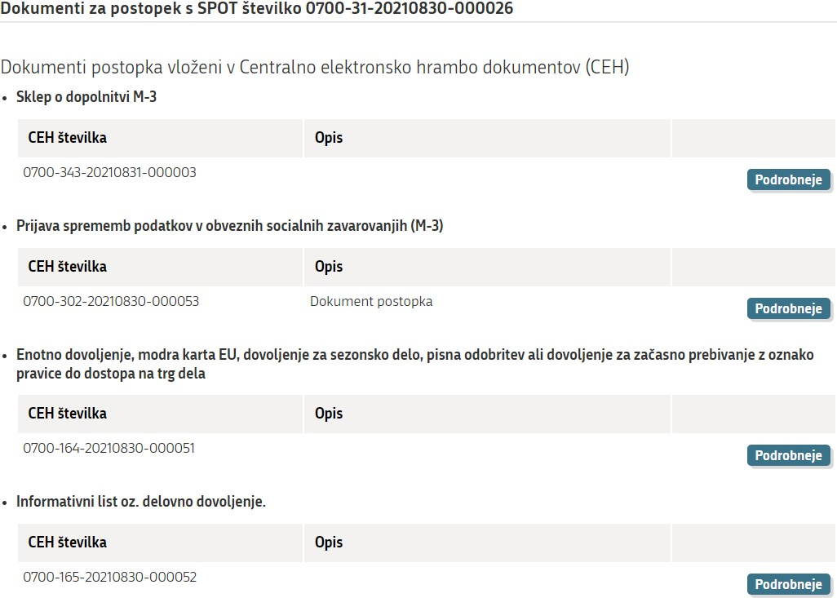

Figure 21: You can find an eplanation of a deficient application in the CEH by clicking on the ‘Podrobneje’ button

The window ‘Podrobneje o dokumentu” (‘Details of document’) opens, where you click (‘Show’) at the ‘Seznam napak’ (‘List of errors’).

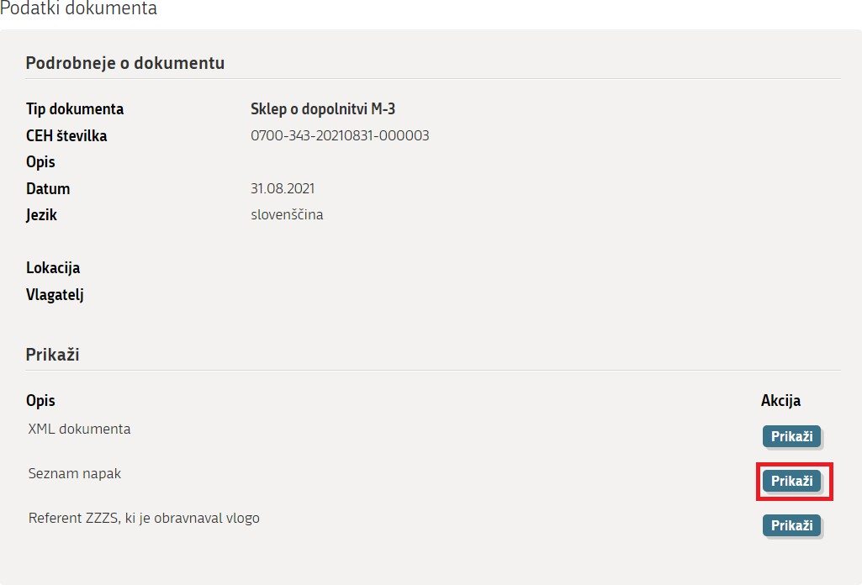
Figure 22: Display of the error list

If you click (‘Show’) in the section ‘Referent ZZZS, ki je obravnaval vlogo’ (‘ZZZS case officer who processed the application’), the details of the case officer (first name, surname, telephone number) are displayed. You may contact the officer if you need an application error to be explained to you.

Click (‘Supplement the application’) if you merely wish to supplement or correct the application.

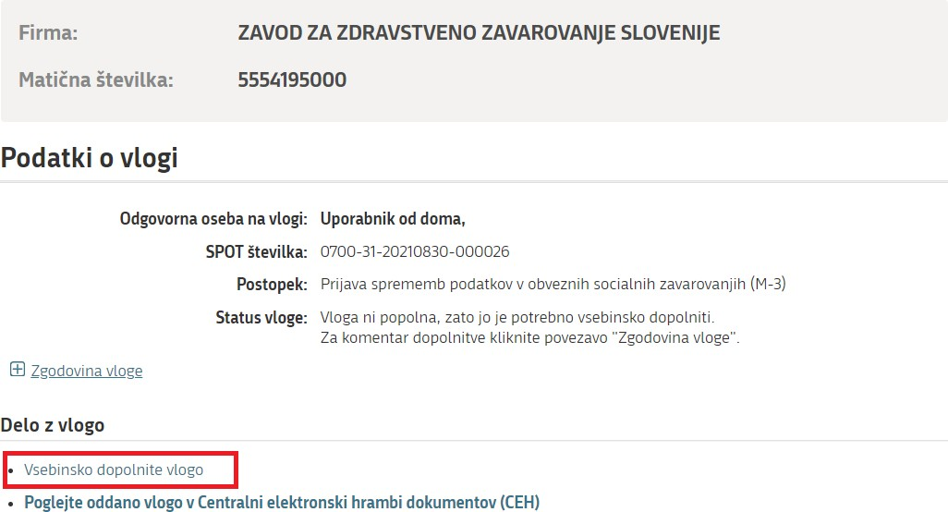

NOTE:
If you do not supplement the application within 15 days, the SPOT system annuls it.

Option to search completed applications

To search completed applications, click the section on the right-hand side of the page ‘Iskanje zaključenih vlog poslovnega subjekta’ (Search a company’s completed applications’):

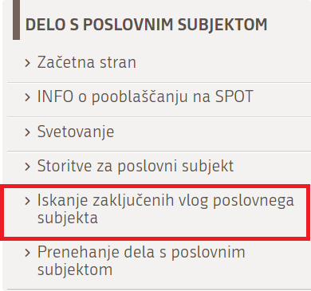
Figure 23: Search for a business entity’s closed applications

This page below (Figure 24) opens, allowing you to search by period and/or personal identification number (EMŠO) of the person for whom you were arranging insurance.

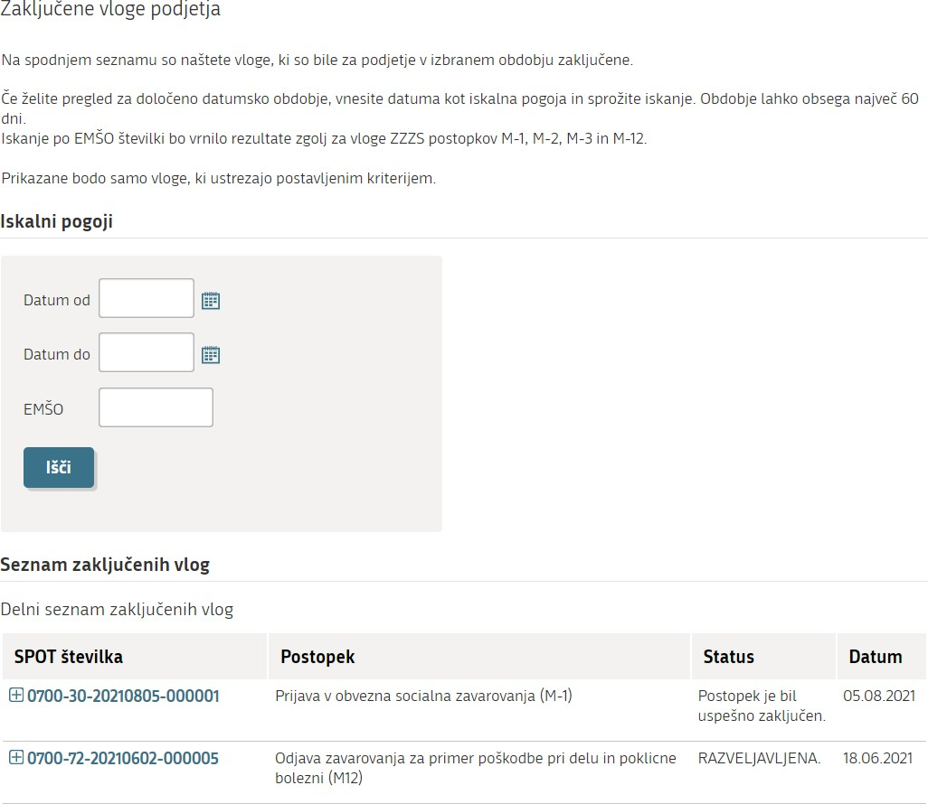
Figure 24: Search for closed company applications by date or EMŠO number

Pension and Disability Insurance Act - Zakon o pokojninskem in invalidskem zavarovanju (ZPIZ-2); Healthcare and Health Insurance Act – Zakon o zdravstvenem varstvu in zdravstvenem zavarovanju (ZZVZZ); Parental Protection and Family Benefits Act - Zakon o starševskem varstvu in družinskih prejemkih (ZSDP-1); Labour Market Regulation Act - Zakon o urejanju trga dela (ZUTD); Rules on compulsory health insurance – Pravila obveznega zdravstvenega zavarovanja.

