Instructions for deregistering from compulsory social security insurances

on M-2 form via the SPOT portal

Document history

Version | Amendment | Author | Description of amendments
1.0 | 31. 08. 2021 | ZZZS | Document preparation
1.1 | 17. 09. 2021 | MJU | Editing of document
1.2 | 26. 11. 2021 | MJU and ZZZS | Completion of document

Contents
1. Form for deregistration from compulsory social security insurances and the SPOT 5
2. Instructions for deregistration from compulsory social security insurance via SPOT website 7
2.1 Selection of the business, the procedure and the insurance being deregistered 8
2.1.1 Selection of the business entity that is liable for registration 8
2.1.2 Selection of the procedure “Deregistration from compulsory social security insurances” (M-2) 9
2.1.3 Selection of the insurance to be deregistered 10
2.2 Completion of application 11
2.2.1 Details of liable person and insured person 11
2.2.2 Details of insurance 11
2.2.3 Notes 12
2.2.4 Date 12
2.2.5 Contact details of the user 12
2.3 Selection of attachments 13
2.4 Preview of information 14
2.5 Attachments of documents 14
2.6 Signing 18
2.7 Status of application 18
2.7.1 Application returned for additional completion 20
2.8 Option to search completed applications 23

List of figures

Figure 1: Login to the SPOT poral 9
Figure 2: Work with a business entity 9
Figure 3: : Selection of procedure for the company: M-2 deregistration from compulsory social insurances 10
Figure 4: Selection of the insurance to be deregistered from 10
Figure 5: Marking of attachments 13
Figure 6: Start of attachment of the documents to the CEH 14
Figure 7: Selection of documents to be attached to the selected application 14
Figure 8: Attaching and describing the document 15
Figure 9: Attached documents for the selected application 15
Figure 10: Details of an attached document 17
Figure 11: Attachment of additional attachments to the application 17
Figure 12: Display of list of documents 18
Figure 13: Details of application 19
Figure 14: Overview of application and attachments 19
Figure 15: More details of document 20
Figure 16: Search by application number 20
Figure 17: Details of application – Application status 21
Figure 18: More details of document 21
Figure 19: Display of the error list 22
Figure 20: Substantive amending of an application 22
Figure 21: Search of closed applications 23
Figure 22: You can search for closed applications by date or by EMŠO number 23

Form for deregistration from compulsory social security insurances and the SPOT
The form for deregistration from compulsory social security insurance “obrazec M-2 - odjava pokojninskega in invalidskega ter zdravstvenega zavarovanja, zavarovanja za starševsko varstvo in zavarovanja za primer brezposelnosti” (M‑2 form – deregistration from pension and disability insurance, health insurance, parental care insurance and unemployment insurance) is prescribed by the Rules on registration forms for pension and disability insurance, health insurance, parental care insurance and unemployment insurance – Pravilnik o obrazcih prijav podatkov o pokojninskem in invalidskem ter zdravstvenem zavarovanju, zavarovanju za starševsko varstvo in zavarovanju za primer brezposelnosti.

Via the SPOT website, businesses entities registered in the Slovenian Business Register (PRS) arrange compulsory social security insurances for the following insurance basis codes:

Code | Description | Legal basis
001 | persons who are employed in Slovenia at an undertaking, institution, other organisation, or employer, or at branches of foreign businesses, or who are elected or appointed holders of public office | - pension and disability insurance – paragraphs one and two of Article 14 of the Pension and Disability Insurance Act  - health insurance – point 1 of paragraph one of Article 15 of the Healthcare and Health Insurance Act  - parental care insurance – point 1 of Article 8 of the Parental Protection and Family Benefits Act  - unemployment insurance – indent one and three of paragraph one of Article 54 of the Labour Market Regulation Act
002 | persons who are employed by an employer established in Slovenia and who are posted abroad for work or workplace training, unless they have compulsory health insurance in the country to which they have been sent | - pension and disability insurance – paragraph three of the Article 14 of the Pension and Disability Insurance Act  - health insurance – point 2 of paragraph one of Article 15 of the Healthcare and Health Insurance Act  - parental care insurance – point 2 of Article 8 of the Parental Protection and Family Benefits Act  - unemployment insurance – indent one of paragraph one of Article 54 of the Labour Market Regulation Act
005 | sole traders who independently pursue a gainful or economic activity in Slovenia | - pension and disability insurance – Article 15 of the Pension and Disability Insurance Act  - health insurance – point 5 of paragraph one of Article 15 of the Healthcare and Health Insurance Act  - parental care insurance – point 4 of Article 8 of the Parental Protection and Family Benefits Act  - unemployment insurance – indent five of paragraph one of Article 54 of the Labour Market Regulation Act
013 | persons employed in Slovenia by persons who independently pursue a gainful or economic activity | - pension and disability insurance – paragraph one and two of the Article 14 of the Pension and Disability Insurance Act  - health insurance – point 1 of paragraph one of Article 15 of the Healthcare and Health Insurance Act  - parental care insurance – point 1 of Article 8 of the Parental Protection and Family Benefits Act  - unemployment insurance – indent one and three of paragraph one of Article 54 of the Labour Market Regulation Act
019 | persons who independently pursue a professional activity in Slovenia | - pension and disability insurance – Article 15 of the Pension and Disability Insurance Act  - health insurance – point 5 of paragraph one of Article 15 of the Healthcare and Health Insurance Act  - parental care insurance – point 4 of Article 8 of the Parental Protection and Family Benefits Act  - unemployment insurance – indent five of paragraph one of Article 54 of the Labour Market Regulation Act
029 | persons employed in Slovenia by persons who independently pursue a professional activity | - pension and disability insurance – paragraph one and two of the Article 14 of the Pension and Disability Insurance Act  - health insurance – point 1 of paragraph one of Article 15 of the Healthcare and Health Insurance Act  - parental care insurance – point 1 of Article 8 of the Parental Protection and Family Benefits Act  - unemployment insurance – indent one and three of paragraph one of Article 54 of the Labour Market Regulation Act
034 | persons taking part in public works schemes | - pension and disability insurance – paragraph one and two of the Article 14 of the Pension and Disability Insurance Act  - health insurance – point 1 of paragraph one of Article 15 of the Healthcare and Health Insurance Act  - parental care insurance – point 1 of Article 8 of the Parental Protection and Family Benefits Act  - unemployment insurance – indent one and three of paragraph one of Article 54 of the Labour Market Regulation Act
036 | persons who perform supplementary work in accordance with Article 147 of the Employment Relationships Act | - pension and disability insurance – paragraph one and two of the Article 14 of the Pension and Disability Insurance Act  - health insurance – point 1 of paragraph one of Article 15 of the Healthcare and Health Insurance Act  - parental care insurance – point 1 of Article 8 of the Parental Protection and Family Benefits Act  - unemployment insurance – indent one and three of paragraph one of Article 54 of the Labour Market Regulation Act
084 | persons undergoing vocational rehabilitation during employment | - pension and disability insurance – paragraph three of the Article 14 of the Pension and Disability Insurance Act  - health insurance – point 13 of Article 9 of the Rules on compulsory health insurance  - parental care insurance – point 2 of Article 8 of the Parental Protection and Family Benefits Act  - unemployment insurance – indent one of paragraph one of Article 54 of the Labour Market Regulation Act
085 | mothers with children who work part-time under special regulations | - pension and disability insurance – Article 14 of the Pension and Disability Insurance Act  - health insurance – point 1 of paragraph one of Article 15 of the Healthcare and Health Insurance Act  - parental care insurance – point 1 of Article 8 of the Parental Protection and Family Benefits Act  - unemployment insurance – indent one and three of paragraph one of Article 54 of the Labour Market Regulation Act
101 | persons who pursue a gainful or professional activity in Slovenia, after the onset of a Category I disability | - pension and disability insurance – Article 15 of the Pension and Disability Insurance Act

For all the above-mentioned insurance basis codes, it is also possible to carry out the process of registering for compulsory social security insurance using the personnel (staff) interface (eHRS).

At SPOT points , of the above referred insurance basis codes, the procedure of registering for compulsory social security insurance can only be carried out for insurance basis codes 001, 005 and 013.

Instructions for deregistration from compulsory social security insurances via SPOT website

A person who no longer meets the conditions for compulsory social security insurance is deregistered from the insurance using the M‑2 form.

Using the M‑2 form, the liable person also annuls (cancels) existing uncompleted (open) insurance. Insurance is cancelled if it is subsequently found that the conditions applying to the insurance are not met or that the liable person provided incorrect information in the following sections of the M‑1 form:
- Block 2 – Registration number,
- Block 6 - Insured person’s personal identification number (EMŠO),
- Block 15 - Date of start of insurance,
- Block 16 - Insurance basis,
- Block 17 - Insured person’s working/insurance hours,
- Block 18 - Liable person’s full-time working/insurance hours, or
- Block 28 – Posted to another country.

A liable person who provided incorrect information must submit a new application to register for insurance (M‑1) containing the correct information, along with an M‑2 form at the same time.

Using the M‑2 form, and with the simultaneous submission of the M‑1 form, the liable person also makes changes to information in the following columns:
- Block 6 - Insured person’s personal identification number (EMŠO),
- Block 16 - Insurance basis,
- Block 17 - Insured person’s working/insurance hours, or
- Block 18 - Liable person’s full-time working/insurance hours.

NOTE!

Deregistration from compulsory social security insurance may not take place via the SPOT website if the business entity liable for registration has already been deleted from the companies register or the PRS. As it is also possible to submit an application to deregister up to eight days prior to the day of termination of the insurance, a person liable for registration shall, in such cases, submit an application to deregister via the SPOT website prior to the intended date of deletion from the register.

You must log on to the system in order to carry out electronic procedures via the SPOT website.

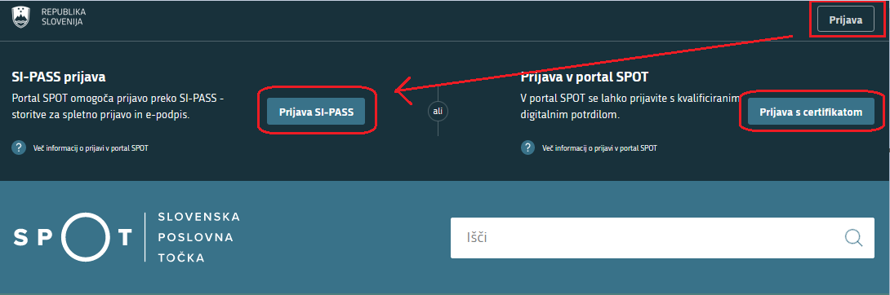
Figure 1: Login to the SPOT poral

Selection of the business, the procedure and the insurance being deregistered

The following must be selected before a start is made on completing the application:
- the business that is liable for registration;
- the ‘deregistration from compulsory social security insurance (M‑2)’ procedure; and
- the insurance that will be deregistered.

Selection of the business entity that is liable for registration

The business entity is selected by entering the tax number, if the person liable for registration is a sole trader (s.p.), or the company registration number, if the liable person is any other business entity (company, institute, person pursuing an independent professional activity, etc.). The business entity can also be selected from the list. Only a business entity can be selected where the user of the SPOT portal is registered as a responsible person (legal representative) or has the relevant authorisation from the responsible person to conduct this procedure for the selected business entity.

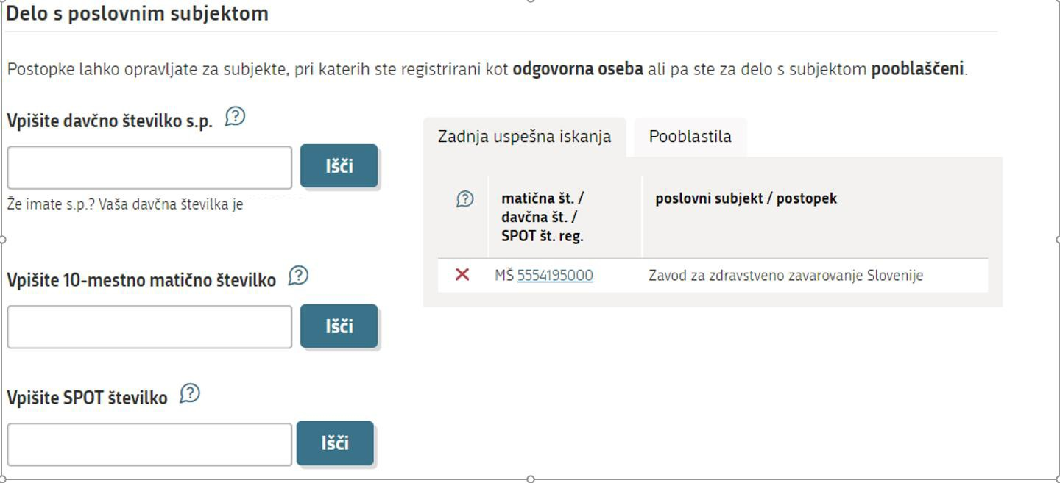
Figure 2: Work with a business entity

Help
‘Delo s poslovnim subjektom’ - Working with a business entity:
'Vpišite davčno številko s.p.' - Enter the tax identification number:
Enter the tax identification number of the sole trader (s.p.). If you are a sole trader and wish to carry out SPOT procedures for your company, enter your tax identification number. You may also use the link to your tax identification number under the search window. If you are authorised by SPOT to carry out procedures on behalf of another sole trader, enter the VAT identification number for which you wish to carry out the SPOT operations. In the ‘Authorisations’ tab, you can find the tax identification numbers of all sole traders for which you are currently authorised.
'Vpišite 10-mestno matično številko' - Enter the 10-digit company registration number:
If you wish to perform SPOT operations for a sole trader, use the tax identification number search engine. If you are the legal representative of a company registered in the Ajpes Digital Certificate Register (EDP) and wish to carry out SPOT operations for your company, enter the company registration number. If you are authorised by SPOT to carry out procedures on behalf of another sole trader, enter the VAT identification number of the company for which you wish to carry out the SPOT operations. The ‘Last Search’ tab contains a list of the business entities you last successfully accessed. The ‘Authorisations’ tab contains a list of all registration numbers of the companies for which you are authorised by SPOT.
'Vpišite SPOT številko' - Enter the SPOT number:
If you wish to search for a contact application, enter its SPOT number. It is not possible to search for sole trader applications by SPOT application number.

Selection of the procedure “Deregistration from compulsory social security insurances” (M-2)

Select the ‘Odjava iz obveznih socialnih zavarovanj (M-2)’ – the ‘Application to deregister from compulsory social security insurance (M‑2)’ procedure from among the procedures for the selected business.

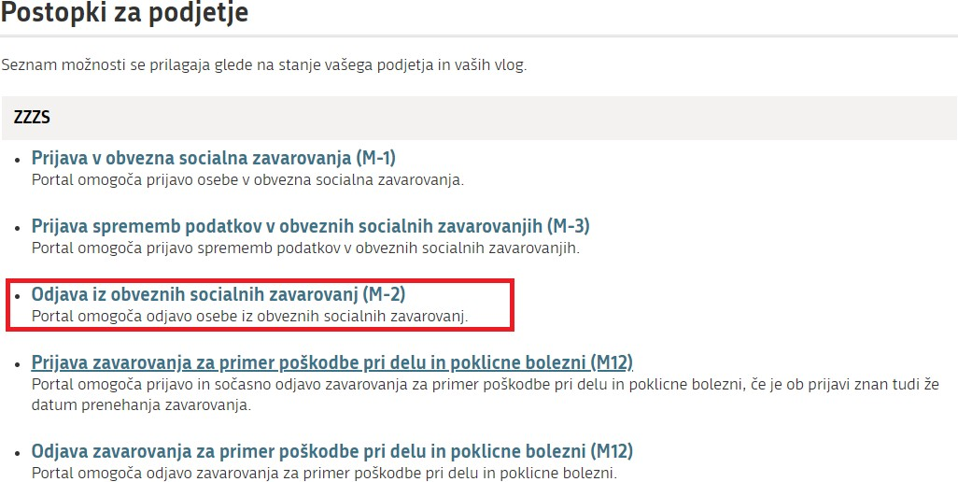

Figure 3: : Selection of procedure for the company: M-2 deregistration from compulsory social insurances

Selection of the insurance to be deregistered

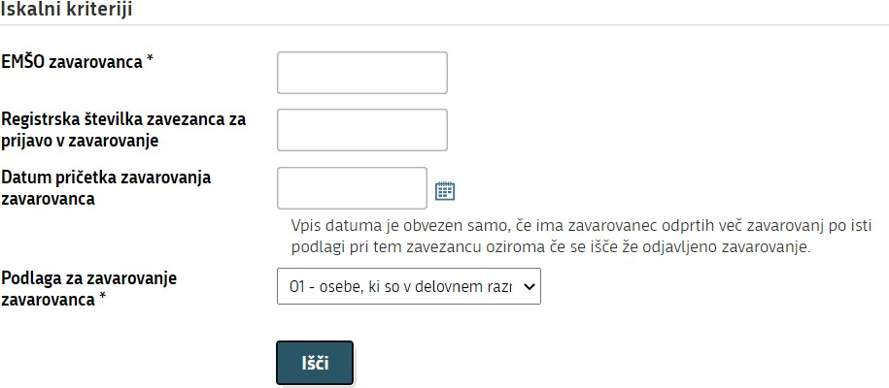
Figure 4: Selection of the insurance to be deregistered from

Before starting to complete the application, use the search criteria to find the insurance that will be deregistered from the compulsory social security insurances.

You must enter the insured person’s personal identification number (‘EMŠO zavarovanca’) and select the insurance basis code ('Podlaga za zavarovanje zavarovanca') under which the person who is to be deregistered from insurance is insured.

The date on which the insured person’s insurance started ('Datum pričetka zavarovanja zavarovanca') is not mandatory. You are only required to enter this information if the insured person has more than one insurance under the same insurance basis code with the same person liable for registration (employer), or if you want to find already closed insurance. In this case, enter the date of the start of the insurance that you wish to deregister.

Completion of application

Based on the selection of the business entity (point 2.1.1) and the search criteria entered (point 2.1.3), the information in the sections of the application are already displayed as recorded in the ZZZS records (most recent status).

Details of liable person and insured person

The details of the liable person and insured person have already been entered and cannot be changed.

Details of insurance

Bloks 15, 16, 17 and 18 – Date of start of insurance, insurance basis, insured person’s working/insurance hours, and liable person’s full-time working/insurance hours.

The details have already been entered as per the ZZZS records.
Block 31 – Vzrok prenehanja zavarovanja - Reason for termination of insurance

Select the appropriate code for the reason for termination of insurance from the code table. Choose one of the codes below:
Code | Name
01 | all types of termination of insurance except for those listed below
06 | expiry date of work permit
10 | death
16 | annulment (cancellation) of an incorrect application to register
17 | deregistration because of a change to the information in Bloks 17 or 18
18 | deregistration because of a change to the person liable for registration (Article 75 of the Employment Relationships Act - Zakon o delovnih razmerjih, Articles 152 or 153 of the Civil Servants Act - Zakon o javnih uslužbencih)

Block 32 – – Datum prenehanja zavarovanja - Date of termination of insurance
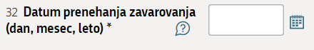

Enter the date of termination of insurance (DD.MM.YYYY) or select the date of termination in the calendar in the column.
If an application to withdraw is made because of a change to the information in Block 17 (Insured person’s working/insurance hours) or Block 18 (Liable person’s full-time working/insurance hours), the date of termination of insurance is the last day before the change to the insured person’s working hours and/or liable person’s full-time working hours. A new application to register for insurance (M‑1 form) shall be submitted at the same time as an application to withdraw from insurance (M‑2 form).
An application to deregister may be submitted no more than 30 days prior the date of termination of the insurance.

Notes

This block is intended mainly to enable a liable person to provide additional explanations regarding the circumstances that form the basis for an insured person’s deregistration.

Date

The date is entered automatically. The date displayed is the date on which the application was submitted.

Contact details of the user
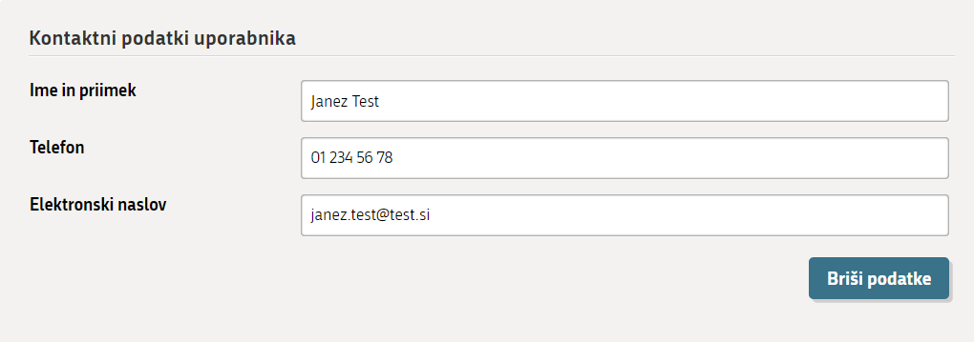

The contact details you entered when registering on the SPOT website are displayed. The contact details are important for the ZZZS, as they enable it to contact you and sort things out if there is a problem with your application or if something is unclear.

At the end of this stage (Step 1 – 1. korak), the application may also be saved for later completion. Save your entries by clicking (‘Save application’). If the application is saved, it receives a SPOT number. If not, it does not receive a SPOT number until Step 3 - Preview of information (3. korak - Predogled podatkov).

Click (‘Next’) to continue the process.

Selection of attachments

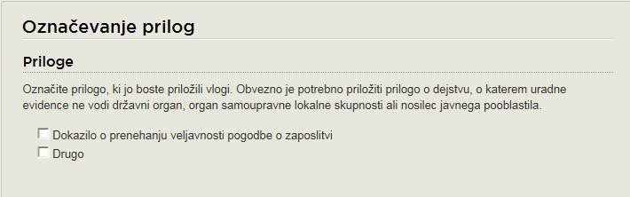

Figure 5: Marking of attachments

In this stage (Step 2 – 2. korak), mark the documents that you will be attaching to the application:
- Proof on termination of an employment contract – ‘Dokazilo o prenahanju veljavnosti pogodbe o zaposlitvi’,
- Other – ‘Drugo’.

It is mandatory to attach an attachment on a fact on which official records are not kept by a competent authority, a self-governing local community body or a holder of public authority.

DEREGISTRATION FROM INSURANCE (EMPLOYEE)

If an employee is being deregistered from insurance, proof of termination of the employment contract (e.g. ordinary or extraordinary termination, agreement on termination of an employment contract, fixed-term employment contract showing the precise date on which it ends, proof that the employment contract was terminated by law itself – decision establishing a disability of category I or on acquiring the right to a disability pension) must be enclosed with the application to withdraw.

If the employment contracts of a large number of employees are being terminated because of bankruptcy or compulsory liquidation (Article 104 of the Employment Relationships Act – Zakon o delovnih razmerjih), compulsory settlement (Article 105 of the Employment Relationships Act) or another case involving the winding-up of an employer (Article 107 of the Employment Relationships Act), the employer may, instead of enclosing notice of termination of employment contracts, enter a note on the M‑2 form to the effect that termination is occurring as a result of bankruptcy, compulsory liquidation, compulsory settlement or on other grounds (with an indication of those grounds).

If withdrawal is the result of the transfer of employees because the change of employer (Article 75 of the Employment Relationships Act, Article 152 or 153 of the Civil Servants Act – Zakon o javnih uslužbencih), proof of the termination of an employment contract shall not be enclosed with the application (as the employment contract is not being terminated). Instead, the article of the law that forms the basis for the transfer of employees (e.g. Article 75 of the ZDR‑1) shall be entered in the notes for the application to register in the M‑1 form.

DEREGISTRATION FROM INSURANCE OF PERSONS INDEPENDENTLY PURSUING AN ECONOMIC OR PROFESSIONAL ACTIVITY

If an application to deregister is being made because an insured person intends to become partly retired, a certificate from the Pension and Disability Insurance Institute (Zavod za pokojninsko in invalidsko zavarovanje) showing the date on which the conditions for entitlement to an early-retirement or old-age pension are met shall be enclosed with the application, along with the number of hours of performance of the activity per week.

If an application to deregister is being made because a person insured under insurance basis code 005 or 019 has become a person with the disability of category I, the final decision establishing a category I disability shall be enclosed with the application.

At the end of this stage (Step 2 – 2. korak), you may:
- save the application for later completion with clicking (‘Save application’),
- return to Step 1 – Completion of application (1. Korak – Izpolnjevanje vloge) with clicking on (‘Back’) or
- move forward with clicking (‘Next’) to Step 3 – Preview of information (3. korak – Predogled podatkov).

Preview of information

A preview of the information entered in the application, as well as an indication of which documents have been marked for attachment, is available at this step.

If any information needs to be corrected or any attachment selected or deleted, you may return to ‘2. korak – Izbira prilog’ (‘Step 2 – Selection of attachments) and at this selection of attachments, further back to ‘1. korak – Izpolnjevanje vloge’ (‘Step 1 – Completion of application’). You may also do this by clicking on a step at the top of the page:
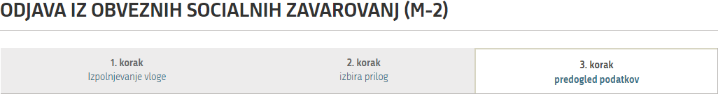

Clicking (‘Next’) at the bottom of the page takes you on to the attachment of documents.

Attachments of documents

This step involves attaching the documents you have previously selected (point 2.3).
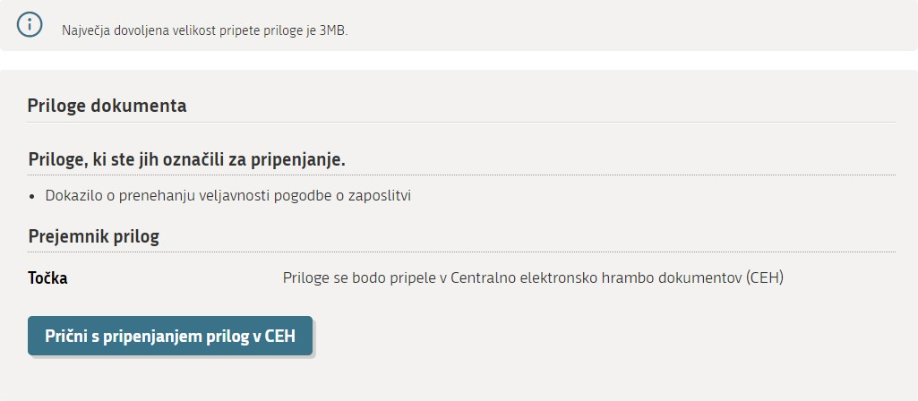
Figure 6: Start of attachment of the documents to the CEH

After you click ('Start by attaching the documents to the CEH’), the steps are as follows:

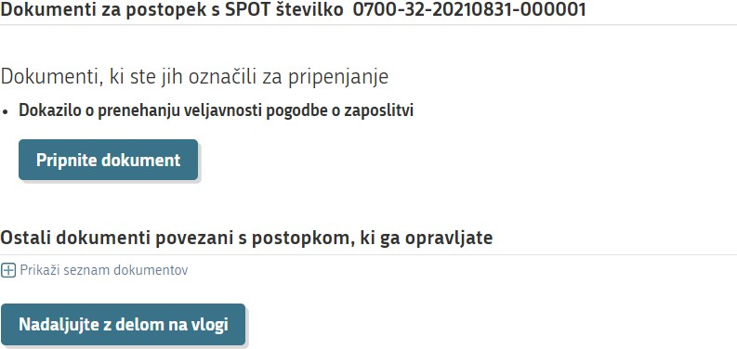
Figure 7: Selection of documents to be attached to the selected application

To attach a document, click (‘Attach document’). The next page opens:

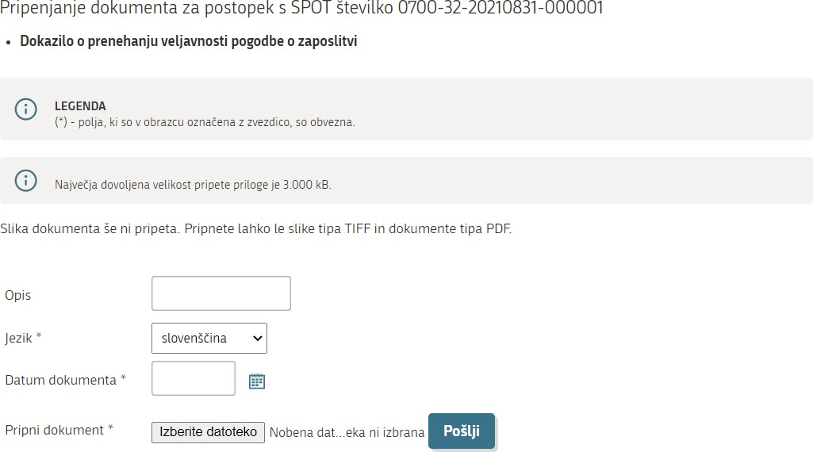

Figure 8: Attaching and describing the document

During the document attachment process, complete the required fields 'Jezik' (‘Language’) and 'Datum dokumenta’ (‘Date of document’) (the fild 'Opis' - ‘Description’ is not mandatory and is mostly used for attachments marked as 'Drugo' - ‘Other’), attach the document by clicking (‘Browse’) (after clicking on this button, search for the document on the computer on which you saved it), then click (‘Send’).
The attached document can then be viewed by clicking (‘Show image of attached document’). The attached document should then be electronically signed by clicking (‘Sign document electronically’).
Note:
You are required to electronically sign every document attached. After the attachment is signed, the application submission procedure is still not yet complete. The application itself (M form) must be signed at the end.

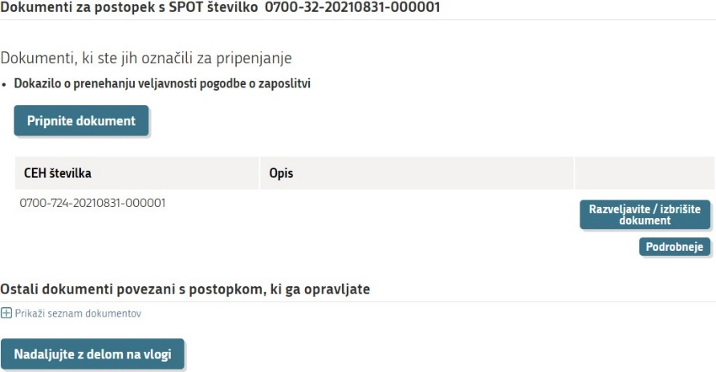
Figure 9: Attached documents for the selected application

After the document has been electronically signed, it may also be deleted at this step by clicking (‘Annul/delete document’), if you find that you have attached the wrong document, etc.,
By clicking you can view the attached document, with the following page being opened:

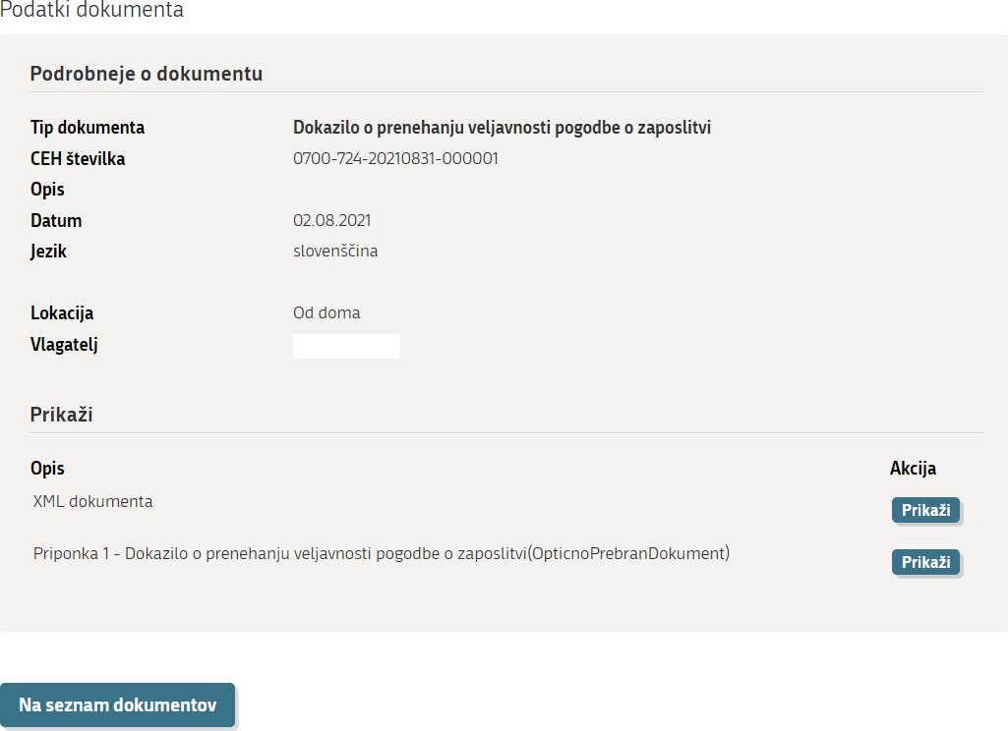
Figure 10: Details of an attached document

To view the attached document, click ('Show') where 'Priponka ….' ('Attachment') is written.

By clicking (‘To the list of documents’) you leave this page.

If you need to attach another document that was not marked during Step 2 - Selection of attachments (2. korak – Izbira prilog), you can also do this on the page:

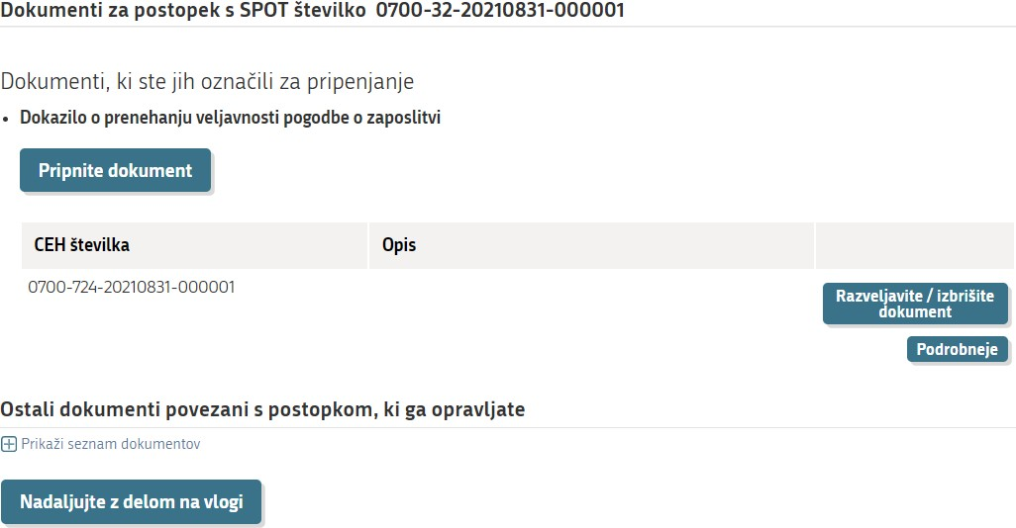
Figure 11: Attachment of additional attachments to the application

Clicking (‘Show list of documents’) allows you to attach other documents.

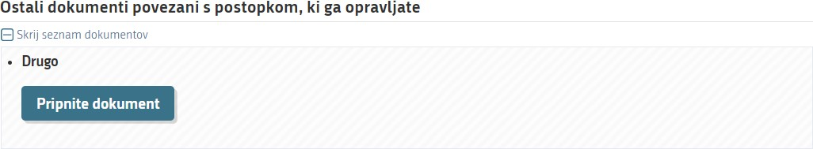
Figure 12: Display of list of documents

Once the document attachment process is complete, click (‘Continue working with an application’), which takes you back to the document attachment step. From there, clicking (‘Next’) takes you to the last step, Step 3 – Signing (3. korak - Podpisovanje).

Signing
At this last stage (Step 3 – 3. korak) the application is signed electronically by clicking (‘Sign document electronically’). This also submits the application.

Status of application

After signing the application electronically, you may track its status on the SPOT website and view the history of the application you have submitted. You may also view the application with attachments in the central electronic storage database (CEH).

An application can have one of the following statuses:
- Vloga je v delu in še ni bila poslana na registrski organ – Application is in progress and has not yet been sent to the registering authority – this status means that you have not yet submitted the application. You must open the application, complete it fully and, if you have not yet done so, sign it electronically and submit it.
- ‘loga je v vrsti za pošiljanje – Application is queued for sending – this status means that the application is waiting to be placed on the list of applications waiting to be sent to the ZZZS. Applications are placed on the list every few minutes.
- Vloga je bila vnešena v vrsto in čaka na pošiljanje – Application has entered the queue and is awaiting transmission – this status means that the application has been placed on the list of applications waiting to be sent to the ZZZS. Applications are placed on the list every few minutes.
- Registrski organ je prejel vlogo – Registering authority has received the application – this status means that the ZZZS has received the application.
- Vloga ni popolna, zato jo je treba vsebinsko dopolniti – Application is incomplete and must therefore be supplemented – this status means that the application is incomplete and the ZZZS has returned the application to you to supplement it. The system annuls the application if you fail to supplement the application and resend it within 15 days.
- Vloga je bila negativno rešena – Application rejected – this status means that the ZZZS has rejected the application (the supplement to the application is not possible).
- Postopek je bil uspešno zaključen – Procedure successfully concluded – this status means that the ZZZS has approved the application.
- Razveljavljena – Annuled – this status means that the user has not corrected and re-sent the application that was sent to him to be supplemented within 15 days, leading to annulment of the application by the system.

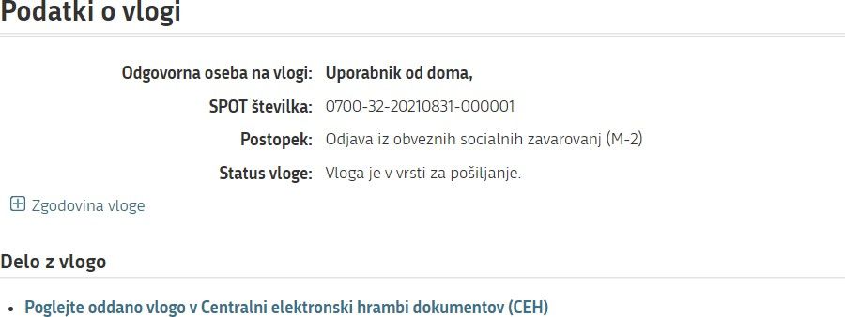

Figure 13: Details of application

If there are no errors in the application, the ZZZS approves it (application receives ‘Procedure successfully concluded’ status). In this case, you can print or save the confirmation of registration from the CEH. You can access a specific application in the CEH using the same procedure as described for access to application errors.

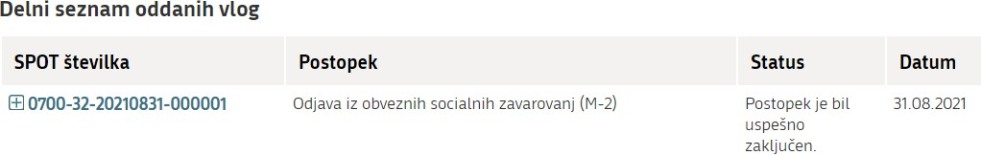

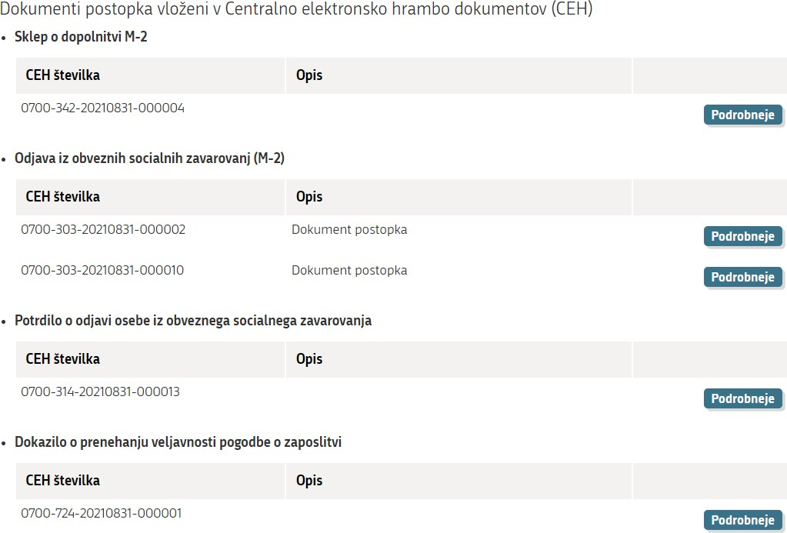

Figure 14: Overview of application and attachments

When you access documents in the CEH, click (‘Details’) in the ‘Potrdilo o odjavi iz obveznega zavarovanja’ (‘Confirmation of deregistration... ’) section.

This opens the below page (Figure15) where you click (‘Show’) in the selection ‘Vizualizacija …’ (‘Visualisation’) to see a PDF visualization of the application or a document in XML format if you click (‘Show’) in the selection ‘XML dokumenta’.

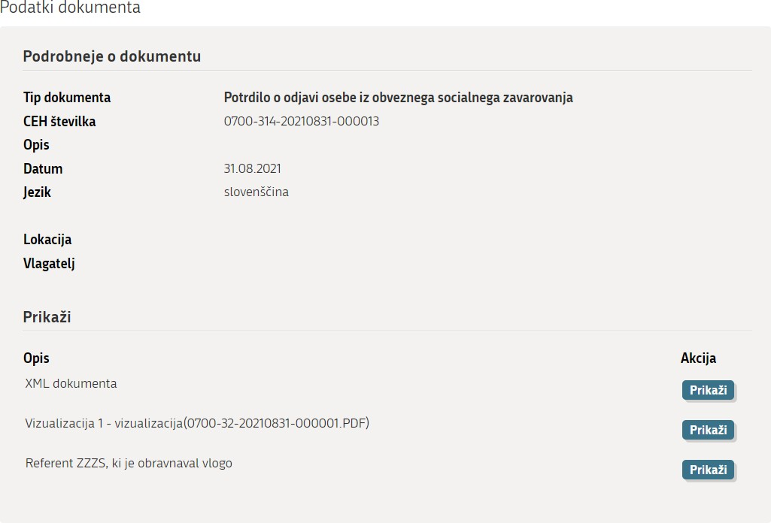

Figure 15: More details of document

If there are errors in the application and because of those errors the application cannot be supplemented or corrected, or if the conditions applying to insurance are not met, the ZZZS rejects the application (the application receives status: ‘Vloga je bila negativno rešena’ - ‘Application rejected’).

Application returned for additional completion

If the application is deficient or has been completed incorrectly, the ZZZS returns it for supplementation or correction. If you wish to access the application, you must log on to the SPOT website and enter the application number in the search criteria, as marked in red below.

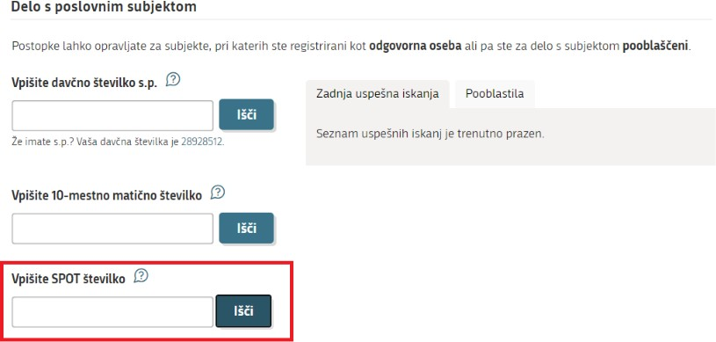
Figure 16: Search by application number

You can access the application requiring supplementation or correction via this search criterion.

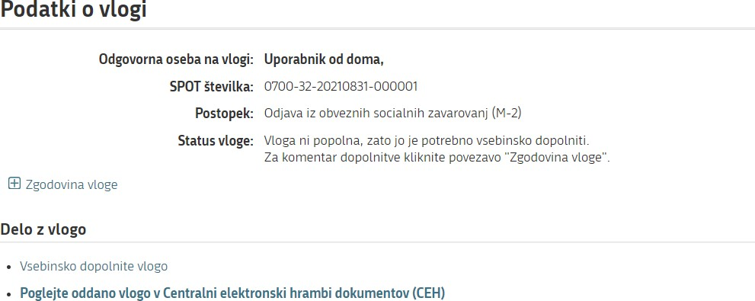

Figure 17: Details of application – Application status

You can also access an application requiring additional information by selecting ‘business entity’ (point 2.1.1). After you have selected business entity, the list of applications in the procedures is opened (‘Seznam vlog v postopkih’). Clicking on an application’s SPOT number opens that application.

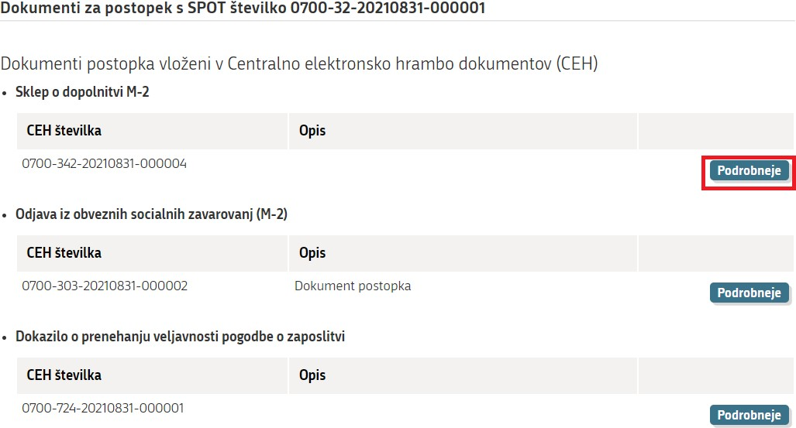
Figure 18: More details of document

You can see the reason why the application has been deemed deficient or has been completed incorrectly in the CEH, which can be accessed by clicking (‘View submitted application in the Central electronic document collection CEH’) and then (‘Details’) at the ‘Sklep o dopolnitvi M-2’ (‘Decision on supplementing M-2’).

The window ‘Podrobneje o dokumentu” (‘Details of document’) opens, where you click (‘Show’) at the ‘Seznam napak’ (‘List of errors’).

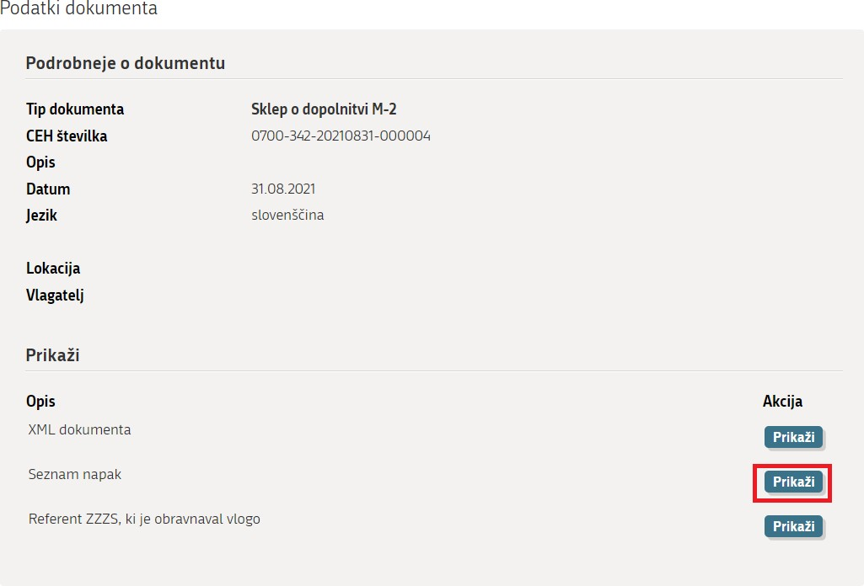
Figure 19: Display of the error list

If you click (‘Show’) in the section ‘Referent ZZZS, ki je obravnaval vlogo’ (‘ZZZS case officer who processed the application’), the details of the case officer (first name, surname, telephone number) are displayed. You may contact the officer if you need an application error to be explained to you.

Click (‘Supplement the application’) if you merely wish to supplement or correct the application.

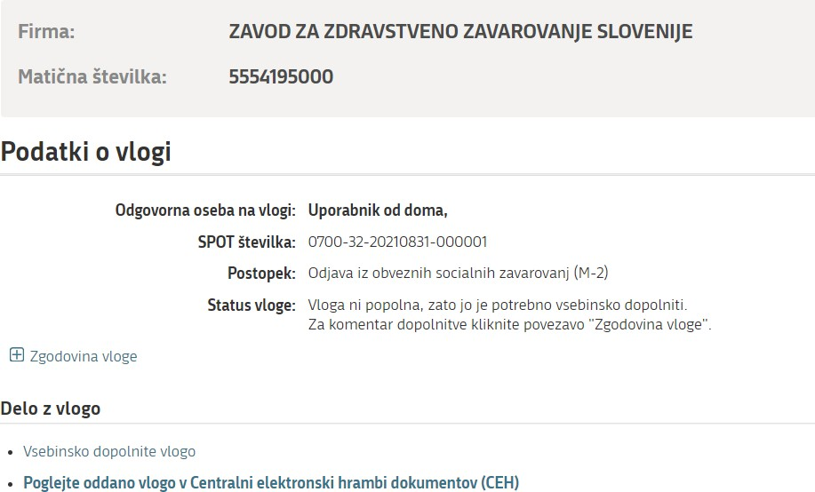

Figure 20: Substantive amending of an application

NOTE:
If you do not supplement the application within 15 days, the SPOT system annuls it.

Option to search completed applications

To search completed applications, click the section on the right-hand side of the page ‘Iskanje zaključenih vlog poslovnega subjekta’ (Search a company’s completed applications’):

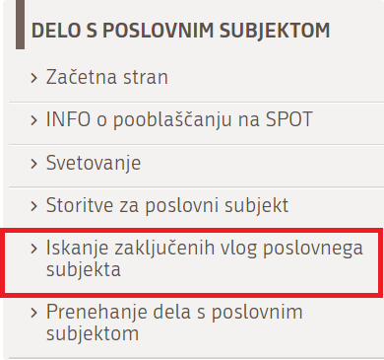

Figure 21: Search of closed applications
The page below (Figure 22) opens, allowing you to search by period and/or personal identification number (EMŠO) of the person for whom you were arranging insurance.

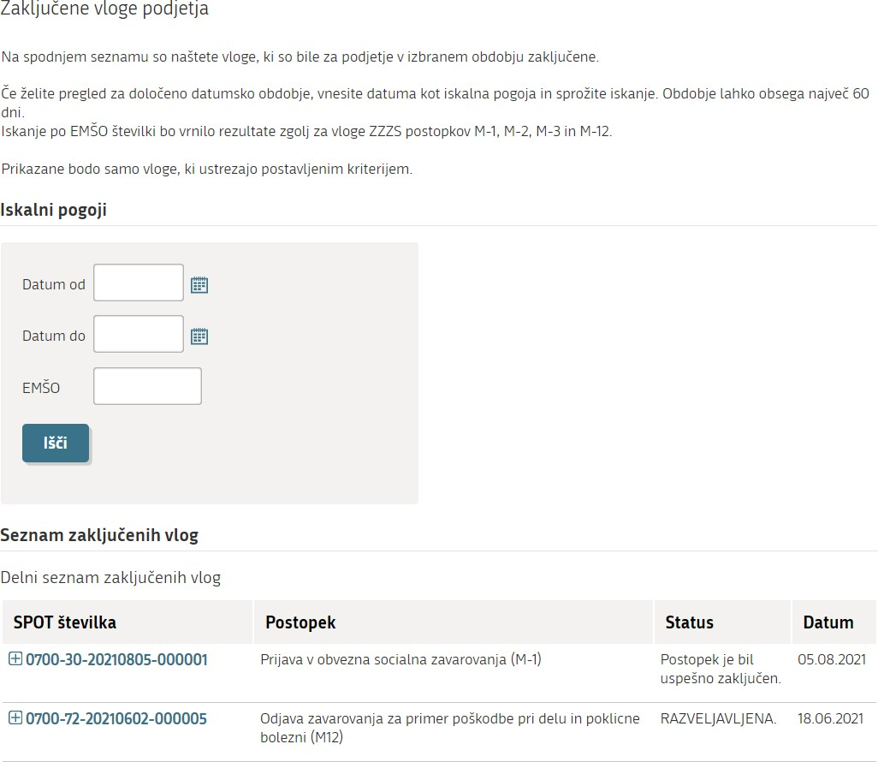

Figure 22: You can search for closed applications by date or by EMŠO number

Pension and Disability Insurance Act - Zakon o pokojninskem in invalidskem zavarovanju (ZPIZ-2); Healthcare and Health Insurance Act – Zakon o zdravstvenem varstvu in zdravstvenem zavarovanju (ZZVZZ); Parental Protection and Family Benefits Act - Zakon o starševskem varstvu in družinskih prejemkih (ZSDP-1); Labour Market Regulation Act - Zakon o urejanju trga dela (ZUTD); Rules on compulsory health insurance – Pravila obveznega zdravstvenega zavarovanja.

