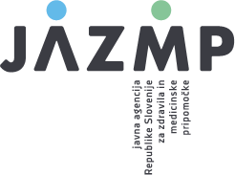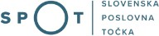

Instructions for completing the application for registration of an economic operator established in the Republic of Slovenia performing an activity in the field of medical devices

Registration of a distributor and/or importer of medical devices

Paper history

Version | Change | Author | Description of changes
1.0 | 14 June 2021 | Vane Savinek | Paper created
1.1 | 12 July 2021 | Denis Fajt | Paper edited
1.2 | 13 June 2022 | Ministry of Public Administration | Image changed
1.3 | 9 June 2023 | Carmen Klun | Updated

The following instructions are intended to assist in the completion of the electronic application on the SPOT portal, which is used to register economic operators dealing with medical devices in the Republic of Slovenia with the Public Agency of the Republic of Slovenia for Medicinal Products and Medical Devices (JAZMP). The document also serves as a clarification of which is which entity under the new Medical Devices Regulation (EU) 2017/745 (MDR), Regulation (EU) 2017/746 on in vitro diagnostic medical devices and the Medical Devices Act, (Official Gazette of the Republic of Slovenia [Uradni list RS], No 98/09), which is still in force regarding the registration procedure.

To facilitate the understanding of the provisions concerning the transition from the regulatory framework of the Directives transposed into Slovenian law by the Medical Devices Act (Official Gazette of the Republic of Slovenia, No 98/09; ZMedPri) to the Medical Devices Regulation (EU) 2017/745 (MDR) and Regulation (EU) 2017/746 on in vitro diagnostic medical devices (IVDR), this document highlights the differences between the basic concepts introduced by the MDR and IVDR and the definitions that applied to the field of medical devices until the application of the MDR and IVDR.

Definitions and terms

MDR - Medical Device Regulation - Regulation (EU) 2017/745 of the European Parliament and of the Council of 5 April 2017 on medical devices, amending Directive 2001/83/EC, Regulation (EC) No 178/2002 and Regulation (EC) No 1223/2009 and repealing Council Directives 90/385/EEC and 93/42/EEC.
The unofficial consolidated version can be found here: Slovene | English

IVDR - In Vitro Medical Device Regulation - Regulation (EU) 2017/746 of the European Parliament and of the Council of 5 April 2017 on in vitro diagnostic medical devices and repealing Directive 98/79/EC and Commission Decision 2010/227/EU (Regulation (EU) 2017/746 (IVDR))
The unofficial consolidated version can be found here: Slovene | English

ZMedPri - Medical Devices Act (Official Gazette of the Republic of Slovenia, No 98/09)

EUDAMED - is the European database established under Regulation (EU) 2017/745 on Medical Devices (MDR) and Regulation (EU) 2017/746 on In Vitro Diagnostic Devices (IVDR), developed by the European Commission. The purpose of the database is to provide transparency on devices on the EU market and strengthen market surveillance, identification of devices and easier traceability. It is an online portal for the exchange of information between economic operators, national competent authorities, notified bodies and the European Commission.

Official launch of EUDAMED - six months after publication in the Official Journal of the European Union that Eudamed is fully functional, it will become mandatory for the use and registration of economic operators.

JAZMP - Public Agency of the Republic of Slovenia for Medicinal Products and Medical Devices. JAZMP is the competent authority for medical devices in Slovenia.

Instructions:

All boxes marked with an asterisk * in the application are mandatory. The applicant will not be allowed to proceed without inserting the appropriate data in such field.

Table of contents
- Instructions for completing the form on the SPOT portal 4
- Basic data 5
- Distributors 7
- Importers 9
- Data on medical device manufacturer with which the economic operator is engaged in
business …….......................................................................................................................………… 10
- Declaration 11

Table of figures
Figure 1: Logging in to the system 4
Figure 2: Business Entity Section 4

Instructions for completing the form on the SPOT portal for the registration of a distributor or importer of medical devices with the JAZMP

Logging in to the SPOT portal

Before filling in the form, please log in to the SPOT portal at https://spot.gov.si/

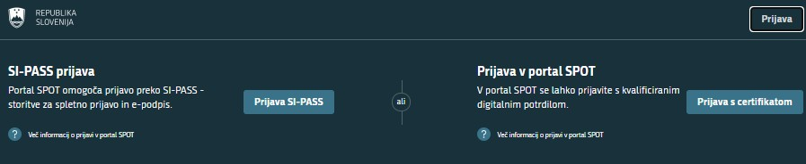
Figure 1: Logging in to the system
Log in to the system via SI-PASS. Registration instructions are available here.

Selection of business entity

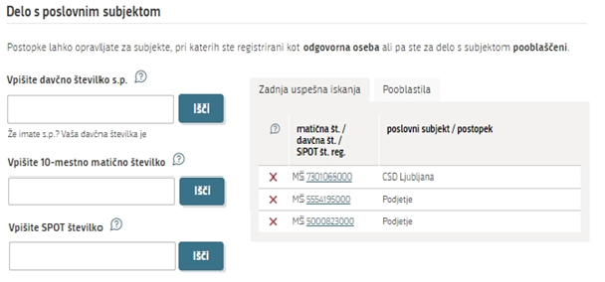
Figure 2: Business Entity Section

Basic data

Basic data:
The basic data about the company is transferred from the Business Register of Slovenia (AJPES). You only need to enter the general contact e-mail address of the company, to which the JAZMP will send you a certificate of registration of the economic operator in the activity registers.
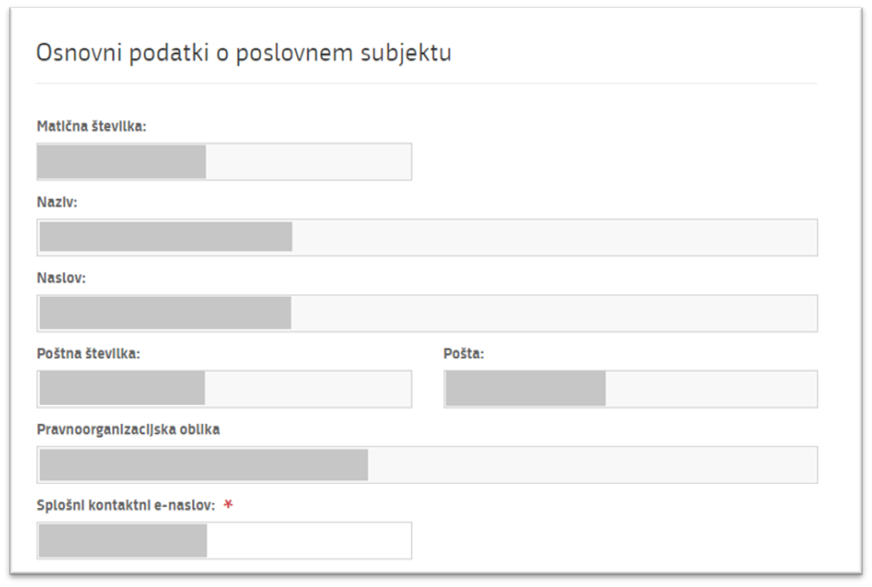

Activity code:
The activity codes of the company are transferred from the Business Register of Slovenia (AJPES). To carry out the activities of distribution and import of medical devices, a company must have registered the following activity codes:
46.460 - Wholesale of pharmaceutical goods
47.410 - Retail sale of medical and orthopaedic goods in specialised stores
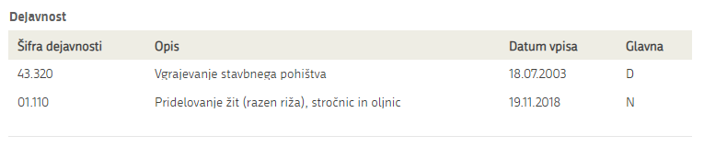
47.781 - Activities of opticians

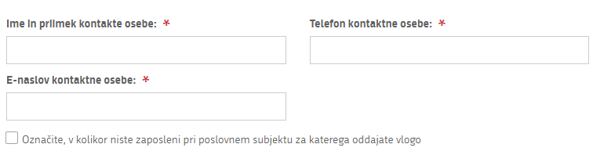
Contact data:
Enter the contact data of the person responsible for communication with the JAZMP.
Tick if you are not an employee of the economic operator for which you are submitting the application.

Activity:
Select the activity you wish to register and which the economic operator performs in the field of medical devices. You may select more than one activity.
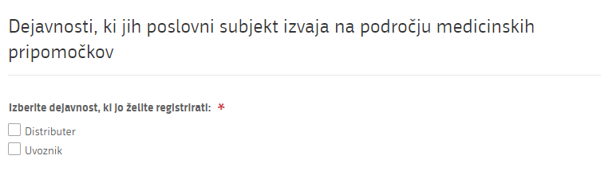

  - Distributors

According to the definitions in the Regulations, a "distributor" means any natural or legal person in the supply chain, other than the manufacturer or the importer, that makes a device available on the market, up until the point of putting it into service.
An entity that supplies or markets devices (see also the definition of making devices available on the market in the MDR or IVDR) as part of its business activity is therefore a distributor of devices. The definition of distributor is important from the point of view of distinguishing between entities according to the actual activities they carry out with their devices: a company that imports devices in its sales programme from a third country for placing on the Union market has the obligations of an importer (it is an importer) and not of a distributor. The same company may also have in its product range devices which it purchases from another company (e.g. manufacturer or other supplier) established in the European Economic Area and Turkey for the purpose of making them available on the market. In such case, it is the distributor for the latter devices and has the obligations of a distributor, including registration.

The ZMedPri offered no definition of a distributor; it was introduced by the two Regulations. Economic operators that wholesale and/or retail devices, other than those who only import devices, are distributors as defined by the Regulations. Other stores which, under the ZMedPri, marketed certain medical devices (which in accordance with paragraph 4, Article 33 of the ZMedPri, are not required to include instructions for use in the sales packaging and medical devices intended to protect against the transmission of infectious diseases), provided that they are not importers of the same devices, are also distributors under the Regulations and are required to register with the JAZMP.

We would like to point out in particular that pharmacies are also distributors under the MDR and IVDR if they make (rather than import) the device available on the market. The same applies to most opticians.

The distributor must provide the following data:

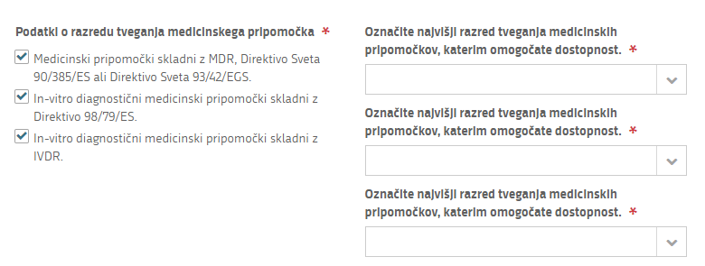
Risk class data:
Select which is the highest risk class of the device you are placing on the market in terms of whether the medical device complies with the Directives or with the MDR or IVDR Regulations.

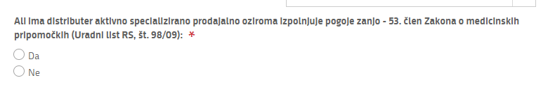
Data on specialised store:
Indicate here whether the economic operator has a specialised device store or whether it meets the requirements laid down in the Rules on the manufacturing and trade in medical devices (Official Journal of the Republic of Slovenia, No 37/10) - in particular Article 10 of the Rules, which is based on Article 53 of the ZMedPri. This is a notification in accordance with the ZMedPri for entry in the register of economic operators carrying out retail trade in medical devices, except that you do not list all the store units.

Importers

In accordance with the definitions in the Regulations, an "importer" means any natural or legal person established within the Union that places a device from a third country on the Union market. Therefore, if a company supplies devices from a third country for onward distribution or directly to end-users, it has the status of importer for those devices. As we have pointed out in the case of distributors, a company cannot be both a distributor and an importer for the same devices, but it can have dual status if it imports certain devices and distributes others. The obligations and requirements for importers are set out in Article 13 of both Regulations. In accordance with the Regulations, importers must register with EUDAMED and comply with their obligations in relation to it. Unlike the ZMedPri, imports under the MDR and the IVDR are no longer defined according to whether they are traded wholesale or retail and are not linked to the mode of supply, but rather to where these devices come from to the Union market. The status of importer under the Regulations can therefore be held both by operators which under the ZMedPri had the status of a wholesale operator and by entities which had the status of a retail operator, including any "other stores" as defined by the ZMedPri.

A business entity that is both an importer and a distributor (for some devices an importer, for others a distributor) must be registered with EUDAMED (as importer) and at the same time registered with JAZMP as distributor.

The importer must provide the following data:
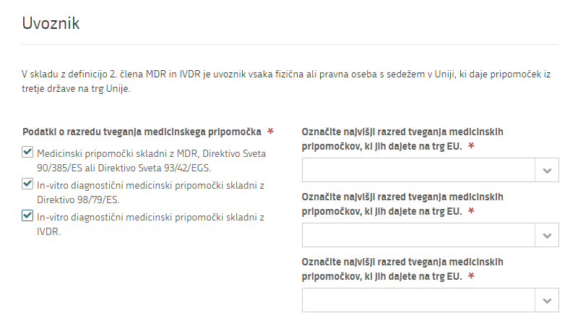
Risk class data:
Select which is the highest risk class of the device you are placing on the market and select whether the medical device complies with the Directives or the MDR or IVDR Regulations.

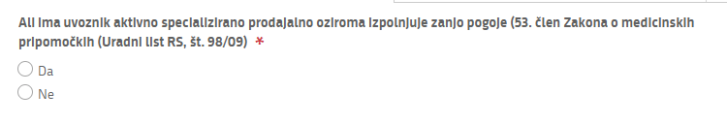
Data on specialised store:
Indicate here whether the economic operator has a specialised device store or whether it meets the requirements laid down in the Rules on the manufacturing and trade in medical devices (Official Journal of the Republic of Slovenia, No 37/10) - in particular Article 10 of the Rules, which is based on Article 53 of the ZMedPri. This is a notification in accordance with the ZMedPri for entry in the register of economic operators carrying out retail trade in medical devices, except that you do not list all the store units.

Data on medical device manufacturer with which the economic operator is engaged in business
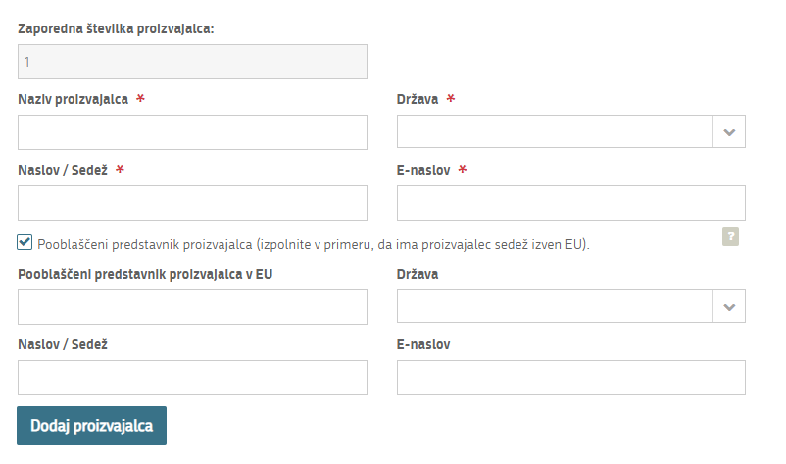
If the manufacturer is based in countries outside the EU, please also indicate the manufacturer's authorised representative in the EU, including his/her data.
Data on medical device manufacturer with which the economic operator is engaged in business.
In the event the economic operator is engaged in business with more than one manufacturer, click on the "Add manufacturer" button.

  - Declaration
By registering or submitting an application, the economic operator declares that it performs a regulated activity or activities subject to the relevant legislation and that it is aware of its obligations as an economic operator in relation to these regulations.
