USER GUIDE FOR ONLINE APPLICATION

SUBMISSION OF APPLICATION FOR OFFICIAL CONTROL ON SHIPMENTS FROM
THIRD COUNTRIES

ONLINE APPLICATION
The application needs a web browser to work. We recommend using Microsoft Edge browser. The web application can be found at ZIRS Vnos vlog (gov.si).

When you enter the address, the introductory page of the web application will appear:
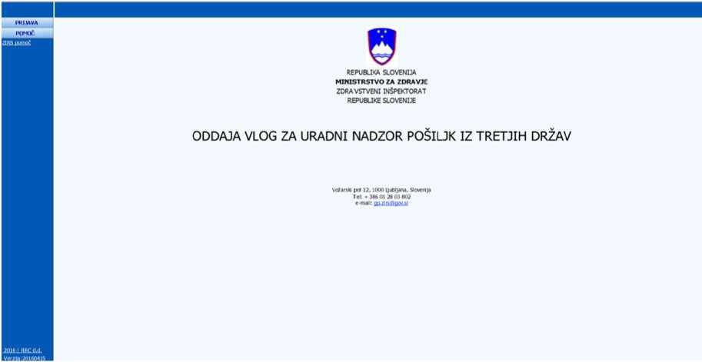

  - Log in to the online application
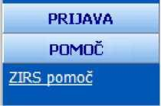

After clicking the (PRIJAVA) LOG IN menu item, you will be taken to the login on the system page, where you enter (Uporabniško ime) your username and (Geslo) password and click the (Prijava) Log in button.

LIST OF APPLICATIONS

Upon successful entry, a page listing the applications submitted by the applicant will open:
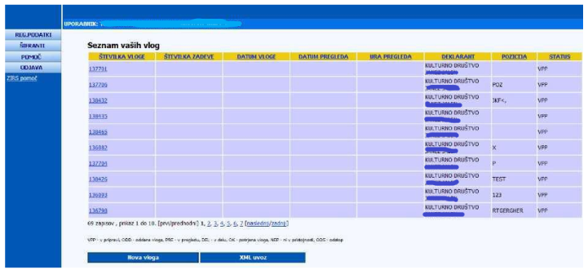

In the (ŠTEVILKA VLOGE) APPLICATION NUMBER column, there are application numbers with a link that you can click on to view or edit the application. Applications are grouped by STATUS (v pripravi) pending, (oddane) submitted, (v pregledu) under review, (v delu) in progress, (potrjene) approved, (ni v pristojnosti) not within competence and (v odstopu) withdrawn.
On the bottom of the page, you can see two more buttons: (Nova vloga) New application and (XML uvoz) XML import. After clicking the (Nova vloga) New application button, a new page used for entering general information on the application appears. By clicking the (XML uvoz) XML import button, you import the details for the application concerned or for new applications from the XML file (there may be multiple applications in the XML file).

Top left on the page, you see four buttons: (REG. PODATKI) REGISTER DATA, (ŠIFRANTI) CODEBOOKS, (POMOČ) HELP and (ODJAVA) SIGN OUT.

By clicking on the (REG. PODATKI) REGISTER DATA button, a new page opens containing completed information on the applicant and information on the declarant. Only the fields containing the applicant’s details, (Geslo) the password, (Ime) the first name and (Priimek) the surname can be changed. Every change needs to be saved.
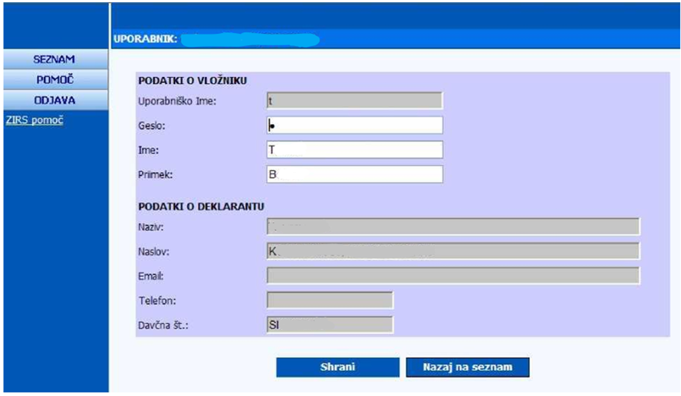

(ŠIFRANTI) The CODEBOOKS button appears when you have successfully logged in to the system. By clicking on the (ŠIFRANTI) The CODEBOOKS button, a new page with the following buttons will appear: (Države) Countries, (Vrsta Blaga) Type of goods, (Tipi prilog) Types of attachments, (Vrsta vloge) Food sub-sectors, (Vrsta prevoza) Means of transport (Pošte) Post and (Izpostave) Branches. Clicking on one of the buttons will bring up a page with the codebook information in xml format.

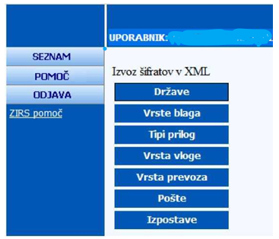

Clicking the (POMOČ) HELP button will open a new page with a link that opens a new window with instructions on how to use this website in Slovenian language.

Clicking the (ODJAVA) SIGN OUT button opens the start page.

- FILLING IN AN APPLICATION
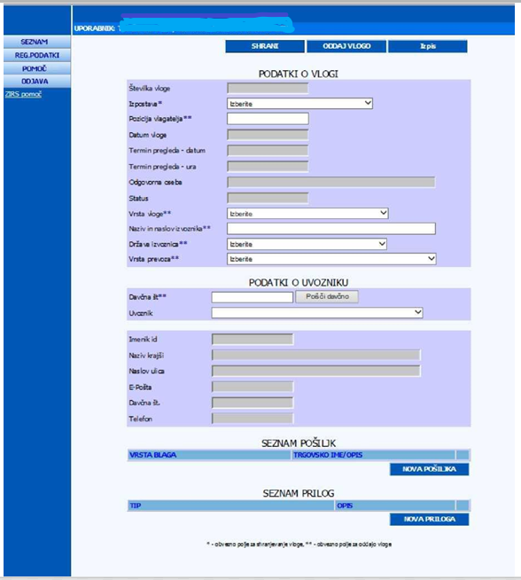

  - (Podatki o vlogi) Application’s data

You need to fill in the details of the application. If you want to save the application without the details, select (Izpostava*) the branch from the list.
Do not enter anything in the fields (Številka vloge) Application number, (Datum vloge) Application date, (Termin pregleda – datum) Review date – date, (Termin pregleda – ura) Review date – time, (Odgovorna oseba) Responsible person and ‘Status’.
Choose (Izpostava*) the branch, (Vrsta vloge**) the type of application, (Država izvoznica**) the exporting country and (Vrsta prevoza**) the means of transport from the list.
You can enter (Pozicija vlagatelja**) the position of the applicant and (Naziv in naslov izvoznika**) the name and address of the exporter yourself.
Once you have done this, you can save the application by clicking the (SHRANI) SAVE button (the application is not yet submitted, it is in review status). The application is saved at the beginning of the list of your applications. Click on to the first application in the table, and the page where the data is completed will appear. The fields (Številka vloge) Application number, (Odgovorna oseba) Responsible person and Status are completed automatically. The application number is displayed relative to the previous number. The responsible person is the person who grants access to the application view.
On this page, you also see (PODATKI O UVOZNIKU) the IMPORTER’S DATA.

  - (Seznam pošiljk) List of shipments

To enter a new shipment, click the (NOVA POŠILJKA) NEW SHIPMENT button. A new page appears with the shipment entry form.
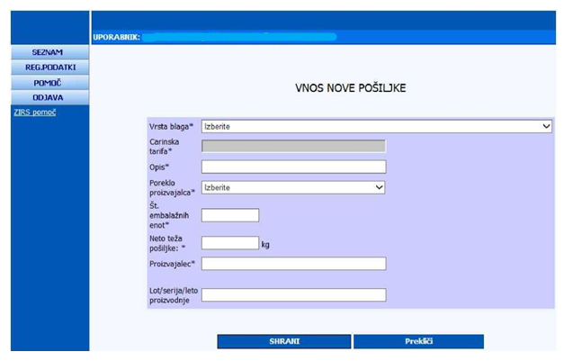

Select (Vrsta blaga*) the type of goods and (Poreklo proizvajalca*) the origin of the manufacturer from the list. Enter the data in the fields (Opis*) Description, (Št. embalažnih enot*) No. of packing units, (Neto teža pošiljke*) Net weight of shipment, (Proizvajalec*) Manufacturer, (Lot/serija/leto proizvodnje/rok uporabe) Lot /Batch/ year of production /Best before date and then save with button (SHRANI).
The (Prekliči) Cancel button moves you back to the form containing general information about the application. You return to the page of the form containing the general information on the application. The shipment you entered is added to (SEZNAM POŠILJK) the list of shipments.
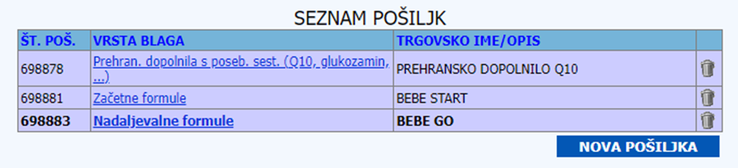

The list shows the type of goods, the trade name / description and the sign . In the (VRSTA BLAGA) TYPE OF GOODS column, you can click the link to correct the shipment details. Clicking on the sign deletes the shipment. When submitting an application at least one shipment is mandatory.

(Seznam prilog) List of annexes

To enter a new attachment, click the (NOVA PRILOGA) NEW ATTACHMENT button. A new page appears with the annexes entry form.
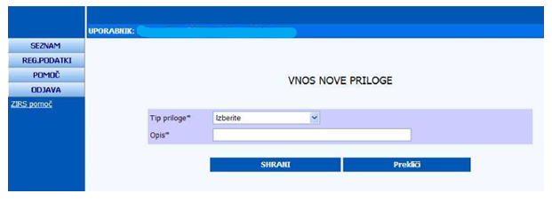

Choose (Tip priloge*) the Type of attachment from the list and enter the information in (Opis*) Description. The description does not need to be entered except when selected from the (Tip priloge*) Type of attachment list item (drugo – 12) other – 12. You move back to the page of the form containing the general information on the application. You also move back to the form containing the general information on the application by clicking on the (Prekliči) Cancel button. The attachment you entered is added to the list of shipments.
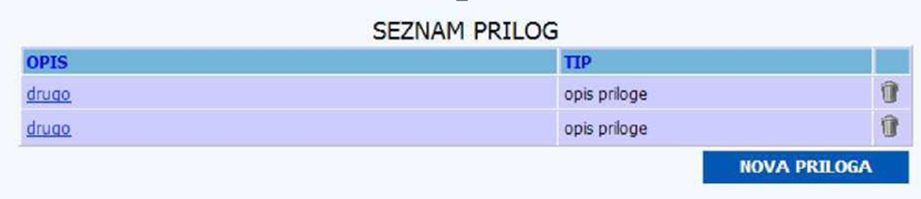
The (OPIS) description, (TIP) type and sign are displayed. In the (TIP) type column, you can click the link and edit the information for the attachment. Click on the sign deletes the attachment.

Finally, save your application by clicking the (SHRANI) SAVE button and / or submit it by clicking the (ODDAJ VLOGO) SUBMIT APPLICATION button. To submit an application, all data must be entered in (PODATKI O VLOGI) DETAILS OF THE APPLICATION and (PODATKI O UVOZNIKU) DETAILS OF THE IMPORTER. There must also be at least one shipment in the shipment list. Once the application is submitted, you can no longer make corrections or enter data, you can only print the data by clicking on the (Izpis) Print or (XML izvoz) XML export button. The status of the application is changed.

Below, you can see some minor remarks with asterisk (*).: ** mandatory field for saving application, * mandatory field for submitting application.

An XML export enables the application to be re-imported into the list, where it can be changed. Upon import, the application is given a new number.

Example of an application with some data:

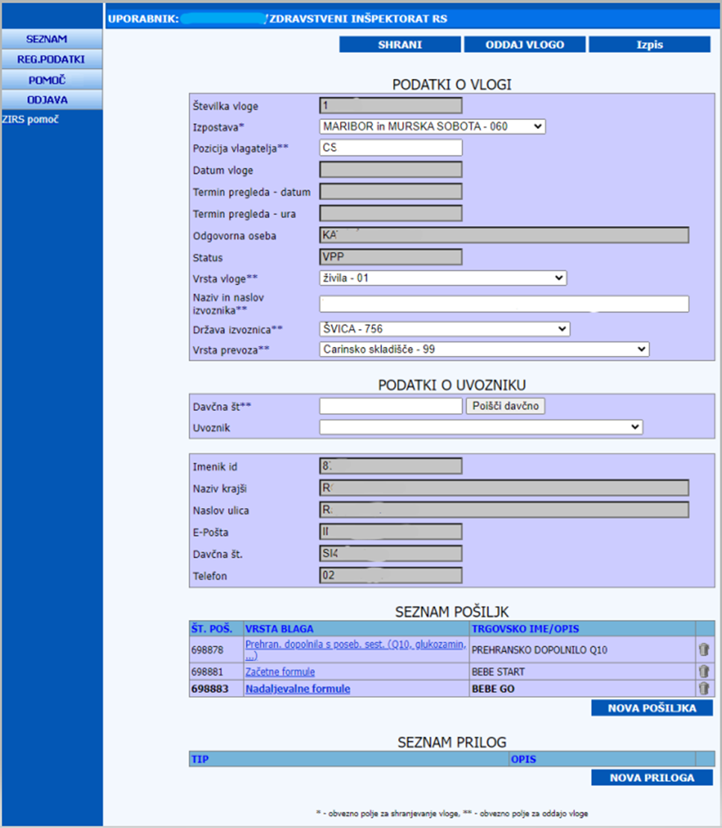

By clicking the (XML izvoz) XML export button, a new page with the data in xml format will be displayed.
Clicking the (Izpis) Display button will open the pdf file.

(XML UVOZ) XML IMPORT
Clicking on the (XML Uvoz) XML import button opens a new (Uvoz xml datoteke) Import xml file page. To import a new xml file, click the Browse button and select the path to the selected file.
Then click the (Uvozi datoteko) Import file button. By clicking the Shema xsd link, you can see how an xml file should be created.
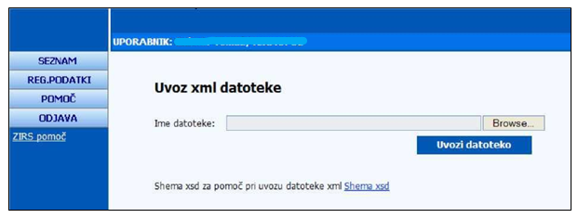

After a successful import, a new page appears, informing us that the xml import has been successful and which applications have been made. To see or modify the applications added to the list of applications, click the (Seznam vlog) List of application link.

