USER GUIDE FOR ONLINE APPLICATION
REGISTRATION OF FOOD BUSINESS ESTABLISHMENTS IN RELATION TO FOOD SUPPLEMENTS AND FOOD FOR SPECIFIC GROUPS

GUIDANCE NOTES ON THE REGISTRATION OF FOOD ESTABLISHMENTS at the Health Inspectorate of the Republic of Slovenia are available at http://www.zi.gov.si/si/storitve/gospodarski_subjekti/registracija_zivilskih_obratov/ .

The Health Inspectorate of the Republic of Slovenia’s web application is intended for the registration of food establishments and for updating information on establishments carrying out any activity related to food supplements and food for specific groups.
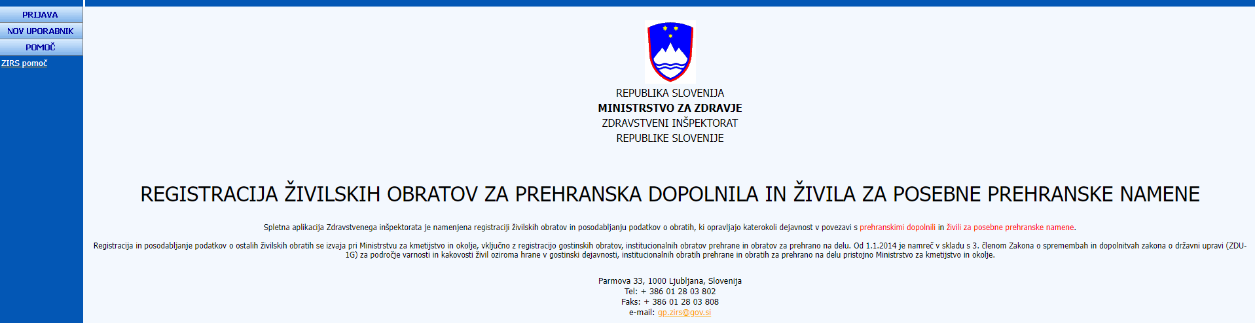

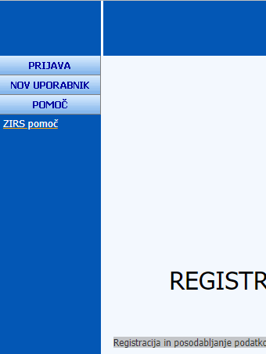
HELP WITH THE REGISTRATION OF A FOOD ESTABLISHMENT
ENTERING A NEW USER
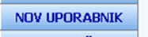
If you are completing an application for the first time, you must send a request to obtain a new username and password. On the top left-hand side, click the button (NOV UPORABNIK) NEW USER.
To enter a new user, you need to fill in some basic information about your facility. All fields are required.
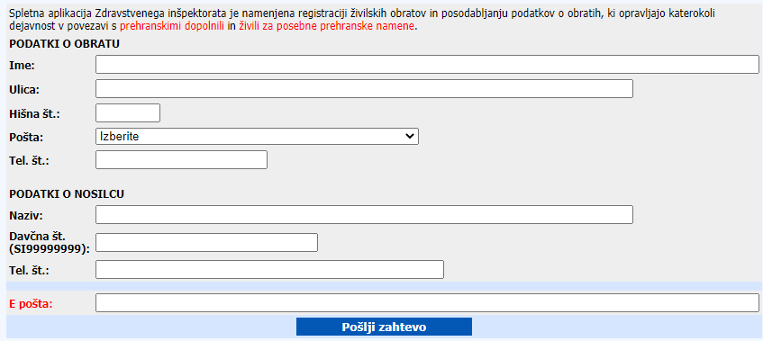
Once you have completed all the fields:
(PODATKI O OBRATU) DETAILS OF THE ESTABLISHMENT: (Ime) Name, (Ulica) Street, (Hišna št.) House No., (Pošta) Post Office, (Tel.št.) Telephone number and

(PODATKI O NOSILCU) DETAILS OF THE OPERATOR: (Naziv) Name, (Davčna št.) Tax No., (Tel.št.) Telephone number and (E pošta) Email, click the (Pošlji zahtevo) Send request button.

This will inform the central exchange that you want a new username and password to enter your food establishment.
You will receive a reply to your request within a few days to the email address you have provided. Each food establishment has its own username and password.

LOGGING IN TO THE ONLINE APPLICATION

All pre-existing owners of food establishments that have received (Uporabniško ime) a username and (Geslo) password to access the application completion page by email should log in to the application by clicking the (PRIJAVA) LOG IN button:

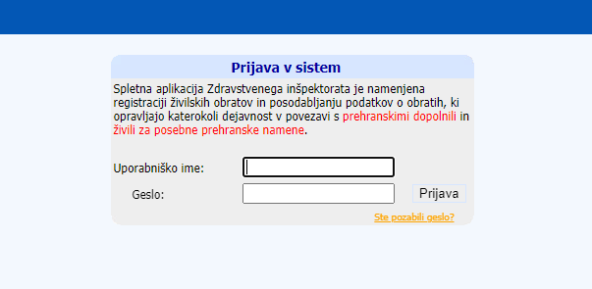

When you have successfully logged in, you will see a sign-in sheet on the screen with some of the information you have already entered about your facility.
If you are a new user, the data you provided when requesting your password will be visible.
You will see your latest information on the condition of the facility at the time of any subsequent notification or modification of the facility information.

COMPLETING AN APPLICATION

You must enter all the details of your food establishment. The fields where data entry is mandatory are marked with an asterisk (*).

- (NAMEN VLOGE*) PURPOSE OF THE APPLICATION*
Select one of the possible options in the entry fields:
- (datum pričetka obratovanja*) registration, indicating the date of the start of the operation*
- (datum spremembe) a dated amendment
- (datum prenehanja delovanja) termination of the operation
Enter all the date fields using the (Koledar) Calendar button.

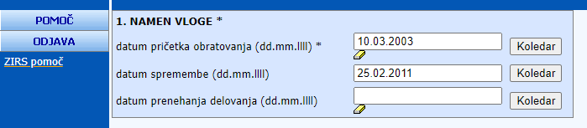

- (PODATKI O ŽIVILSKEM OBJEKTU) INFORMATION ON FOOD BUSINESS ESTABLISHMENT
The fields to be filled in:
- ime obrata* (the name of the establishment*)
- (naslov obrata) the address of the establishment: (ulica*) street*, (hišna številka*) house number*, (pošta*) post office*, (občina*) municipality
- (telefon*) the telephone number
- faks (leave the field empty)
- (živilska dejavnost, ki jo opravlja obrat) the food business pursued by the establishment (according to the standard classification of activities), (ime/naziv živilske dejavnosti) name/type of food business activity*, (šifra kategorije) category code
- (število oseb, ki pri delu prihaja v stik z živili v tem obratu) the number of persons who come into contact with food at work at that establishment
- (odgovorna oseba) the responsible person
- (obdobje obratovanja pri sezonskem obratovanju) in the case of seasonal operation the operating period (date fields can be entered via the (Koledar) Calendar button)

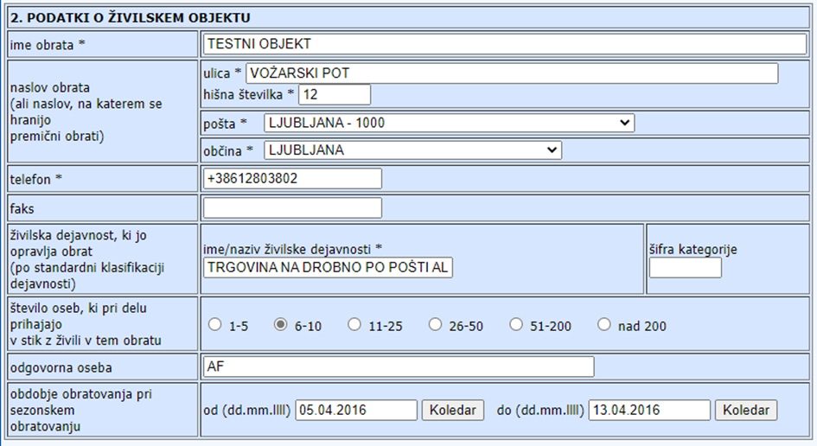

- (PODATKI O NOSILCU ŽIVILSKE DEJAVNOSTI) INFORMATION ON THE FOOD ACTIVITY OPERATOR
The fields to be filled in:
- (ime / naziv nosilca dejavnosti*) the name/title of the operator*
- (sedež nosilca dejavnosti) the place of establishment of the operator: (ulica*) street name*, (hišna št*) house number*, (pošta*) post office*, (občina*) municipality*
- (davčna številka*) the tax number*
- (telefon*) the telephone number*
- faks (leave the field empty)
- (elektronski naslov*) the email address*
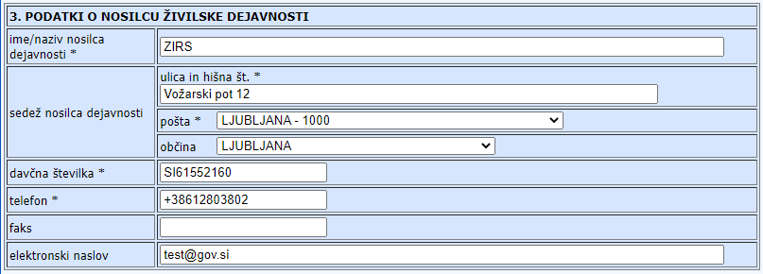

- (AKTIVNOSTI, KI JIH IZVAJA OBRAT) ACTIVITIES CARRIED OUT BY THE ESTABLISHMENT
Indicate all activities carried out by the establishment under the control of the food business operator referred to in point 3. In the last field, under number 26, please indicate the serial number of the main activity of the establishment.

You can choose from:
1 production/manufacturing/processing
2 packaging
3 imports
4 wholesale trade
5 storage
6 transport
7 distribution
8 retail trade
9 sales at a market
11 sales from a mobile facility
12 food-stand sales
22 intermediary services
23 internet sales
24 sales by mail order
25 other – please specify and enter in the text field yourself

26 indicate the number of the main activity of the establishment

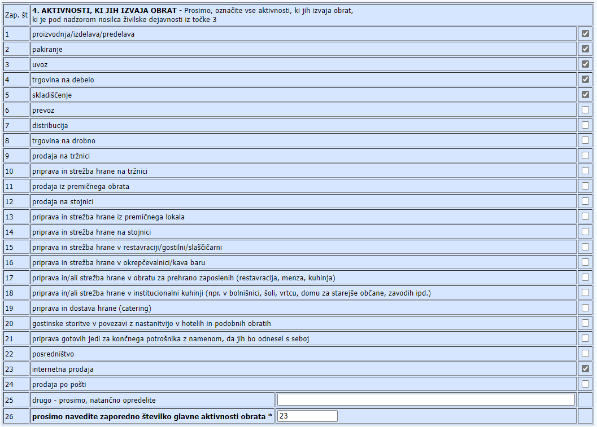
- (ŽIVILA IN POSTOPKI PRI AKTIVNOSTI OBRATA) FOODSTUFF AND PROCEDURES RELATING TO THE ACTIVITIES OF THE ESTABLISHMENT
Indicate all foods and processes involved in the establishment’s activities.
You can choose from:
14 foodstuffs intended for particular nutritional uses**
25 food supplements
26 other – please specify and enter in the text field yourself

**food products that, due to their specific composition or method of processing, differ significantly from conventional foods corresponding to the declared nutritional purposes and placed on the market in such a way that their suitability is marked separately. Due to their specific nutritional properties, they are intended for the diet of certain groups of persons with digestive and metabolic disorders, persons whose physiological condition requires a controlled and targeted diet with specific substances in the food, and healthy infants and young children.
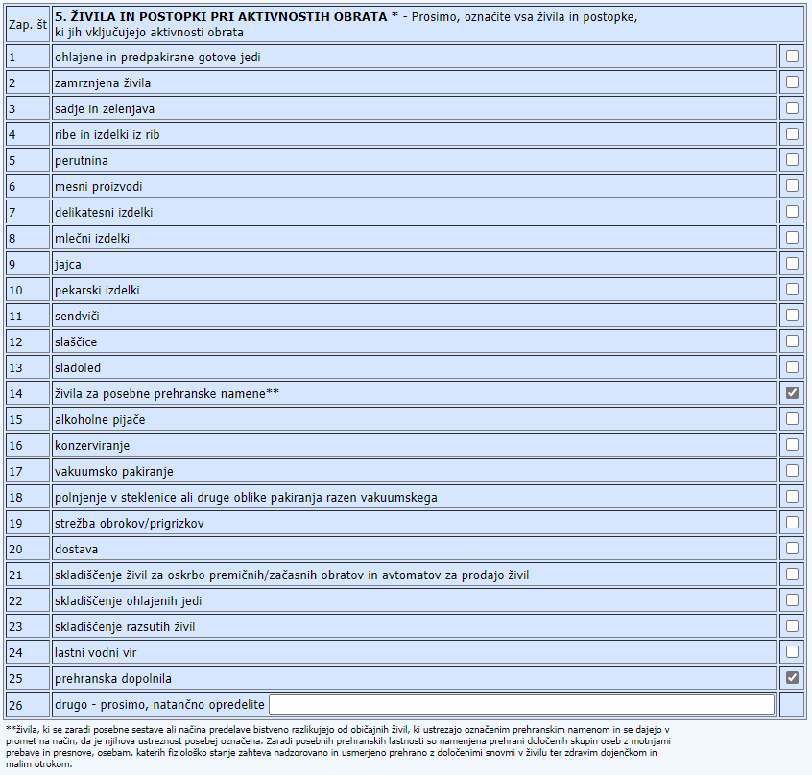
- (PODATKI O PREVOZNIH SREDSTVIH, PREMIČNIH OBRATIH, STOJNICAH IN PRODAJNIH AVTOMATIH) INFORMATION ON MEANS OF TRANSPORT, MOBILE FACILITIES, SALES STALLS AND VENDING MACHINES
Please enter the number of:
- (prevozna sredstva) means of transport
- (premični obrati) mobile facilities
- (stojnice) sales stalls
- (prodajni avtomati) vending machines
held by the establishment and/or used for the transport, preparation, or sale of food.
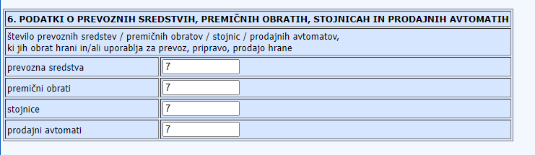

- (INTERNETNA PRODAJA) INTERNET SALES
Click either (DA) YES or (NE) NO to indicate whether or not you perform online sales.
If YES, please provide the internet address of your online shop.

(VLAGATELJ) APPLICANT
Indicate the name and surname of the applicant and his role in the establishment:
- (odgovorna oseba) the responsible person
- (lastnik/ca obrata) the owner of the establishment
- (najemnik/ca) the tenant of the establishment

DECLARATION:
I hereby declare that the above-mentioned data is truthful and accurate.
I assume full criminal and material responsibility for this declaration.
I agree that the personal data contained in this application may be processed in accordance with the
Personal Data Protection Act.

After entering the details, click the (Shrani) Save button, located at the bottom of the application.
If you fail to enter any of the required information you will be notified by the software at the top of the page.
Complete the data accordingly and repeat the saving process.
When you have successfully completed all entries, you will receive a notification that the data has been saved in the system.
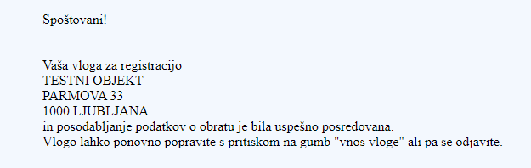
You can print your saved application by clicking on the (Natisni) Print button.

If you have made an error while entering the application and wish to correct the details, you can return to the application entry page by clicking the (VNOS VLOGE) COMPLETE AN APPLICATION button in the menu and repeat the procedure.
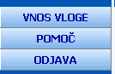
By clicking the (POMOČ) HELP button, the web app will redirect you to a page with brief instructions on how to complete the application in Slovenian. The brief instructions are a summary of these instructions.
You may leave the application at any time by clicking the (ODJAVA) SIGN OUT button, and the information will remain unchanged.
All changes are recorded only when you click (Shrani) Save button on the application form.

For any further information, please email pomoc.zirs@gov.si

