INSTRUCTIONS FOR THE WEB APPLICATION

REGISTRATION OF FOOD ESTABLISHMENTS RELATED TO FOOD SUPPLEMENTS AND FOODS FOR SPECIFIC GROUPS or
REGISTRATION OF COMPANIES THAT MANUFACTURE, PROCESS AND FIRST PLACE ON THE MARKET MATERIALS AND ARTICLES INTENDED TO COME INTO CONTACT WITH FOOD

ABOUT THE WEB APPLICATION
The web application is intended for the registration and updating of data on food establishments involved in activities related to food supplements and foods for specific groups, as well as companies that manufacture, process and first place on the market materials and articles intended to come into contact with foods.
To use the web application, you need a web browser. Microsoft Edge is recommended.
The web application is available at the following link: https://e-storitve-zirs.gov.si/oz/r/zirs_splet/registracija-obratov/ .

Access to the web application is provided through the SI-PASS system. If you do not yet have an account, you can create one at: SI-PASS portal.
When you enter the web application URL: https://e-storitve-zirs.gov.si/oz/r/zirs_splet/registracija-obratov/, the introductory page of the web application opens.
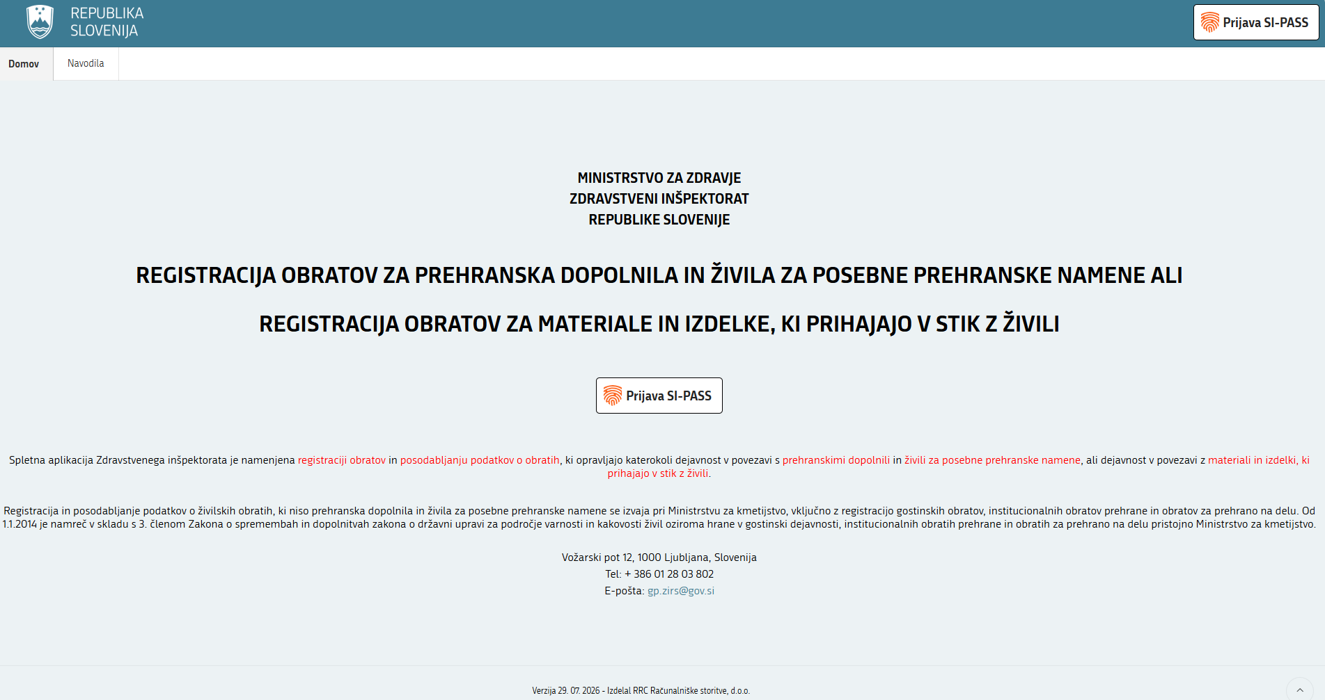

USER REGISTRATION OR LOGIN

Logging in to the web application via the SI-PASS system



After clicking the menu item ''Prijava SI-PASS (SI-PASS Login)'', a dialog box appears. Here, select your preferred login method.
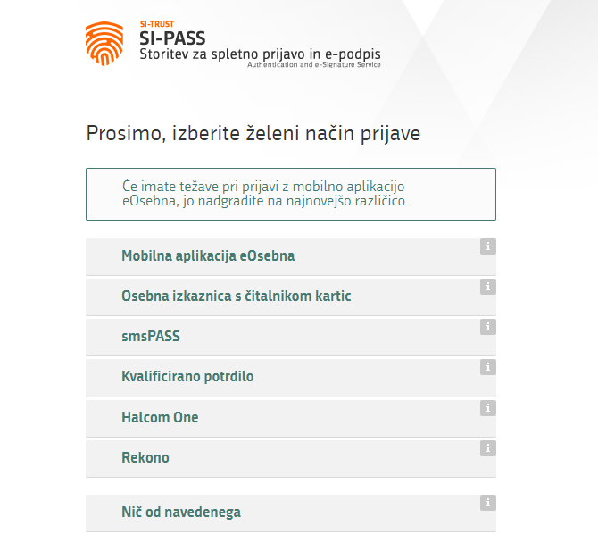
  - New user and new establishment

If you are registering for the first time, click the ''Nov uporabnik in nov obrat (New user and new establishment)’’.
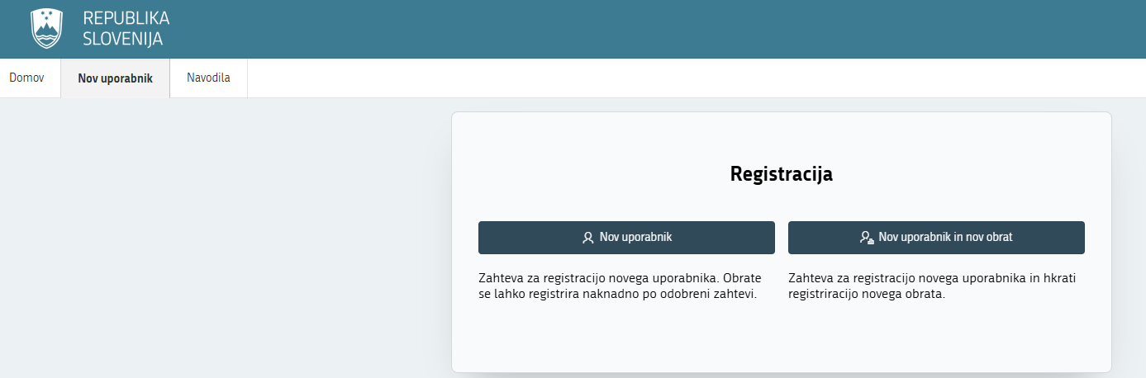
After clicking the button, a form with three sections opens.

In the left-hand section "Podatki o uporabniku (User data)’’, fill in only the ''E-pošta (E-mail)’’ field. This is the e-mail address to which all notifications for the user will be sent. The remaining fields are automatically filled with the data from SI-PASS.

In the middle section "Podatki o nosilcu (Operator information)", select the operator from the list by name or tax number). The remaining fields are automatically filled. If the ''E-pošta (E-mail)’’ field is empty, enter an email address.
The email address (E-pošta) automatically displayed in this field (retrieved from the AJPES register) can be changed and replaced with the email address (E-pošta) to which you wish to receive messages concerning the establishment.

In the right-hand section ''Podatki o obratu (Establishment information)", enter the establishment details and select the type of registration (establishments operating in relation to food supplements and foodstuffs for specific groups or companies operating in relation to materials and articles intended to come into contact with food). If you are registering the establishment for both areas, select the option ''Oboje (Both)".

Fields marked with a red indicator in the upper-left corner are mandatory in order to save the application.

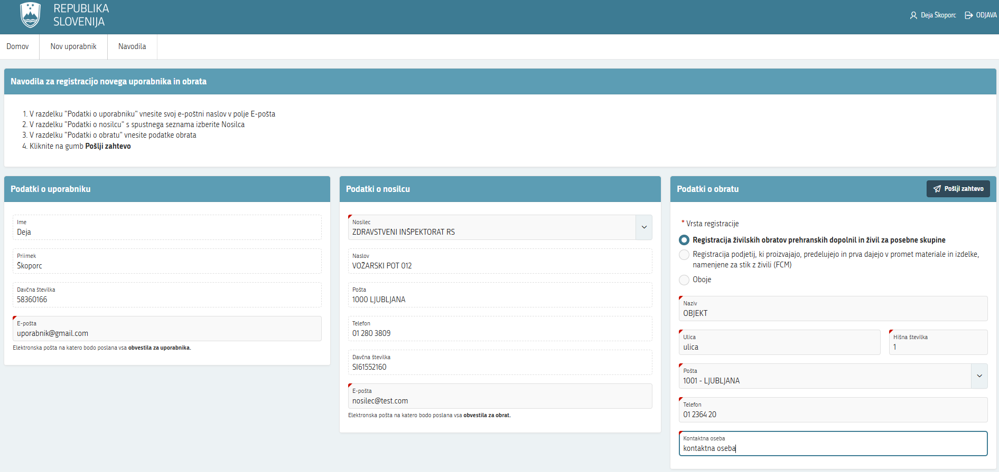

After clicking the "Pošlji zahtevo (Submit request)" button, a notification appears on the screen.
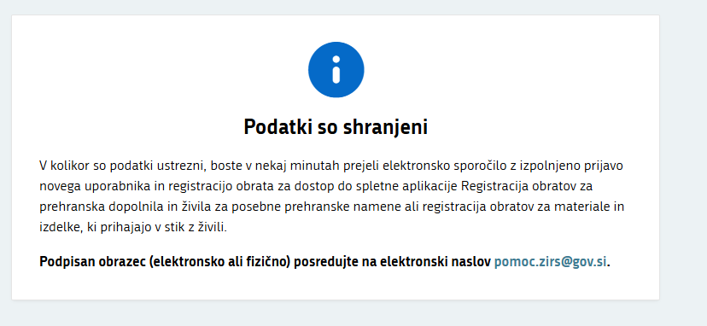
The user receives an e-mail at the address entered in the "Podatki o uporabniku (User information)’’ with an attachment containing the information provided in the request.
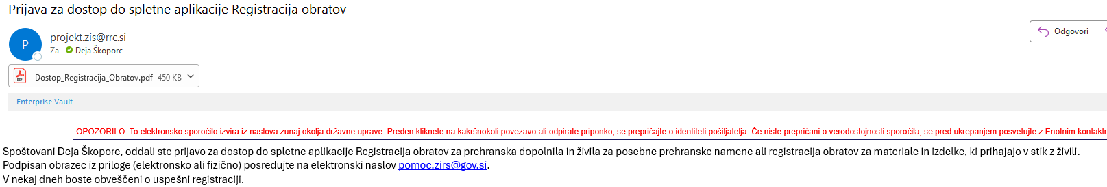
Once the user has signed the application and sent it to e-mail address: pomoc.zirs@gov.si , the Inspectorate processes it by activating the user, registering the establishment and completing the request. The user is then notified of the activation by email sent to the address entered in the “User information” section
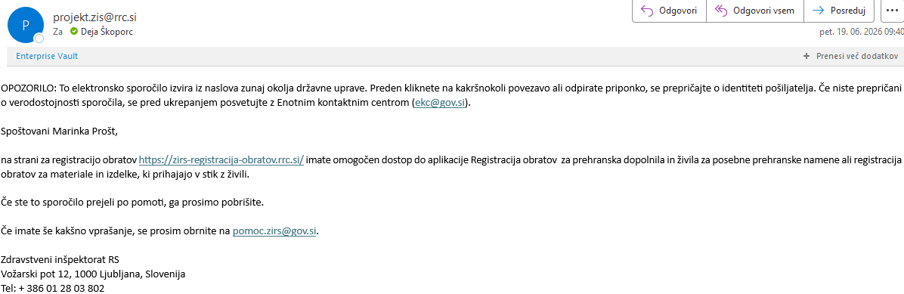
The user can then view the application for the establishment of the operator for which they have been activated. If the operator has several establishments, the user can view the applications for all of them.

New user

If you are a new user for an operator that already has registered establishments, click the "Nov uporabnik (New User)" button. Passwords used in the old web application are no longer active. Therefore, anyone who fulfilled the legal registration obligation using the old web application and wishes to update the information about their establishment/company must register as a new user the new web application.
After clicking the button, a form with two sections opens.
In the left-hand section "Podatki o uporabniku (User information)", fill in only the ''E-pošta (E-mail)’’ field. This is the e-mail address to which all notifications for the user will be sent. The remaining fields are in automatically filled with data from SI-PASS.

In the right-hand section "Podatki o nosilcu (Operator information)", select the operator from the list by name or tax number). The remaining fields are automatically filled. If the ''E-pošta (E-mail)’’ field is empty, enter an e-mail address.
The email address automatically displayed in this field (retrieved from the AJPES register) can be changed and replaced with the email address to which you wish to receive messages concerning the establishment.

Fields marked with a red indicator in the upper left are mandatory in order to save the request.
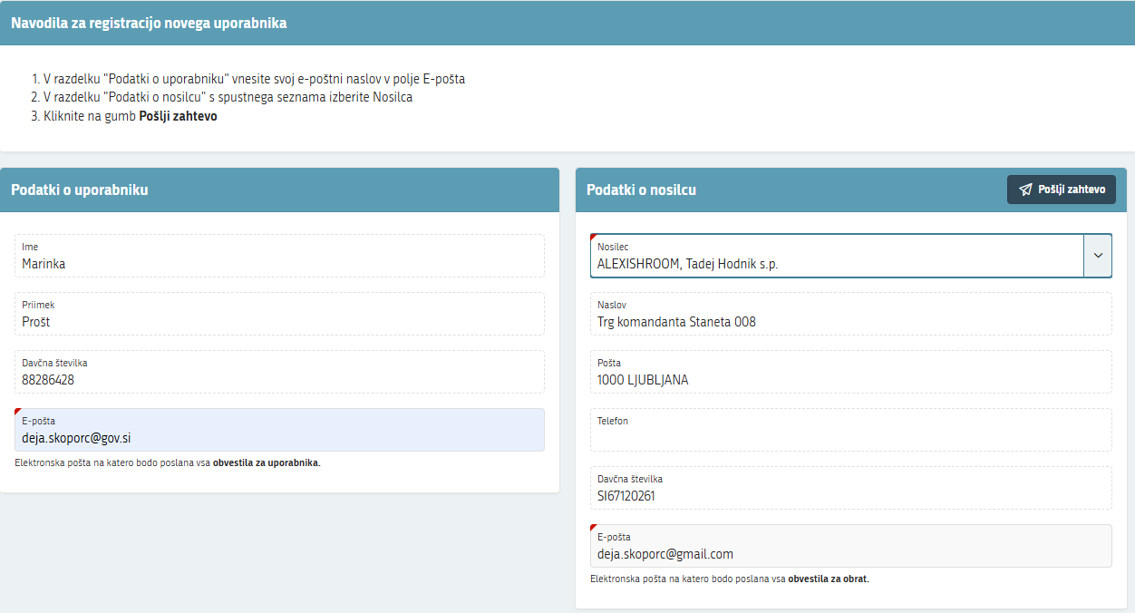

After clicking the "''Pošlji zahtevo (Send request)" button, a notification appears on the screen.
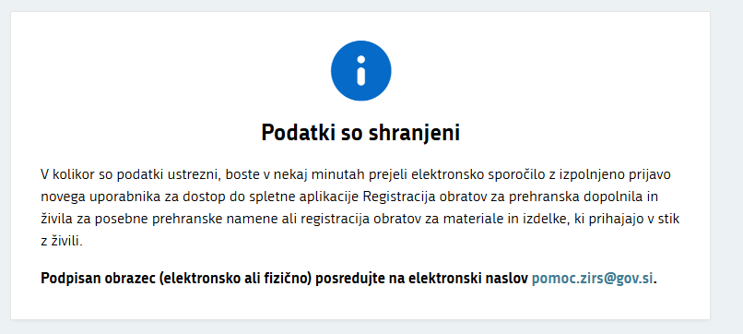
The user receives an email at the address entered in the "Podatki o uporabniku (User information)" section.
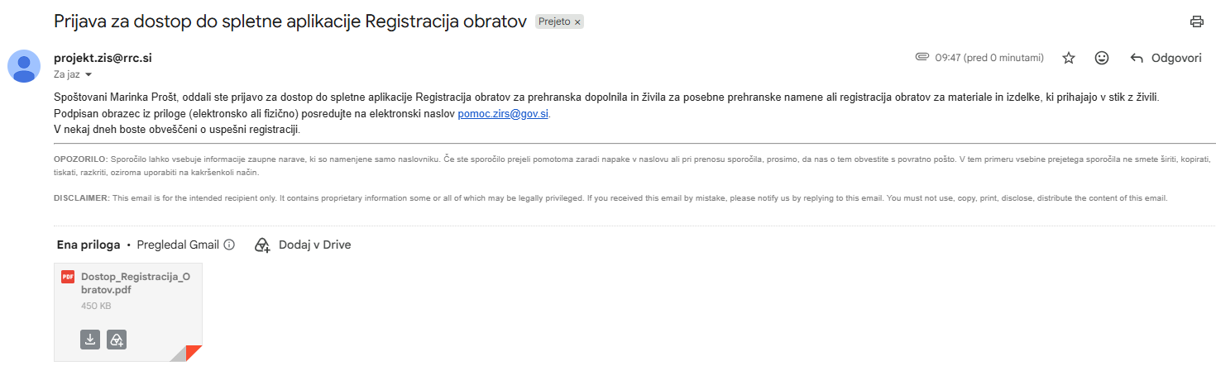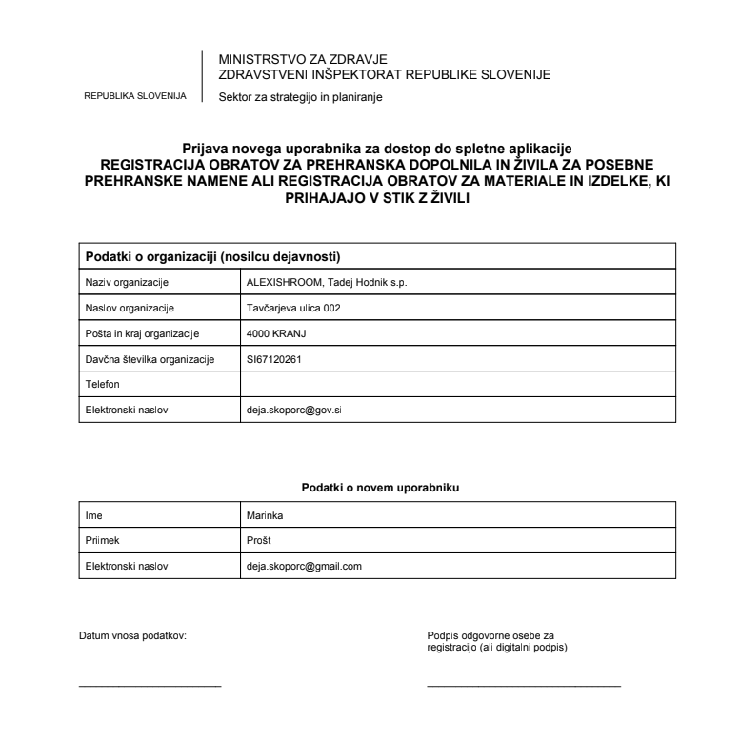
Once the user has signed the application and send it to pomoc.zirs@gov.si, the Inspectorate processes it by activating the user and notifying them of the activation by email sent to the address entered in the "Podatki o uporabniku (User information)" section.
The user can then view the web applications for all establishments belonging to the operator for which they have been activated.

LIST OF ESTABLISHMENTS AND REGISTRATION OF NEW ESTABLISHMENTS

Once the user receives the notification, they log in to the web application and gain access to the establishments belonging to the business operator for whom they completed the registration.

The list of establishments may contain three sections:
- ''Zahteve za registracijo novih obratov (Requests for registration of new establishment)". This section displays new registration requests for establishments that have not yet been processed and that the user has submitted to the Inspectorate.
- ''Vloge za spremembo podatkov o obratih za prehranska dopolnila in živila za posebne skupine (Applications for amendment of data on establishment handling food supplements and foodstuffs for special food groups)’’. This section contains all applications for the initial entry and amendment of information on establishments handling food supplements and foods for specific groups associated with a single food business operator.
- ''Vloge za spremembo podatkov za podjetja, ki proizvajajo, predelujejo in prva dajejo v promet materiale in izdelke, namenjene za stik z živili (Applications for changes to information on companies manufacturing, processing and first placing on the market materials and articles intended to come into contact with food)".
This section contains applications for the initial entry and amendment of information on companies manufacturing, processing and first placing on the market materials and articles intended to come into contact with food.

If an establishment is registered only in one area the empty section is not displayed.

Application statuses (unprocessed, unconfirmed, confirmed)

Each application for the registration of a new establishment appears in the ''Zahteve za registracijo novih obratov (Requests for registration of new establishment) section.
When the Inspectorate processes an application for the first time, its status is set to ''Neobdelana (Unprocessed)’’ and the application appears in the web application under either ''Vloge za spremembo podatkov o obratih za prehranska dopolnila in živila za posebne skupine (Applications for change to information on establishments handling food supplements and food for specific groups)’’ or ''Vloge za spremembo podatkov o obratih za materiale in izdelke, ki prihajajo v stik z živili (Applications for changes to information on establishments handling materials and articles intended to come into contact with food)’’.
''Neobdelana (Unprocessed)’’application means that the user has not yet completed all the required fields and submitted the application to the inspectorate for conformation.
''Nepotrjena (Unconfirmed) application,
is one that has been completed by the user and submitted to the Inspectorate for confirmation.
''Potrjena (Validated)’’ application is one that has been confirmed by the Inspectorate, and the information provided in the application has been entered into the register. The registration process is complete.

  - Registration of a new establishment / company

If the user wants to register a new establishment for a business operator, they click ''+Registriraj obrat (+Register establishment)''button in the upper-right corner.
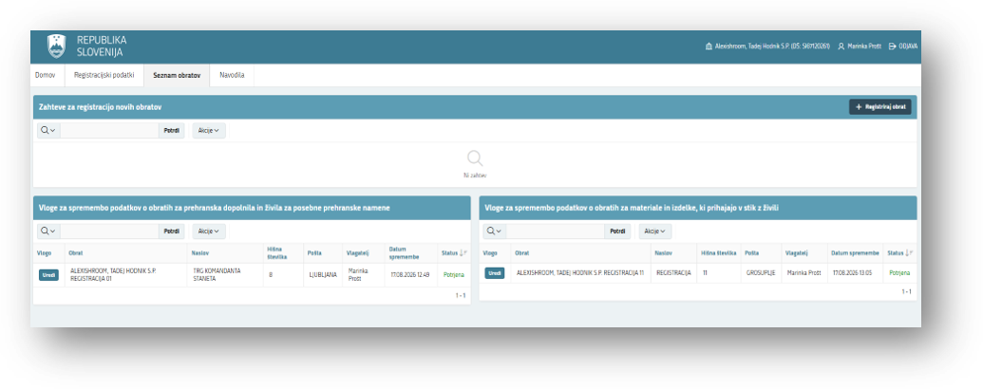

The user selects one of the areas: Registration of food facilities in relation to food supplements and foods for specific groups or Registration of companies which manufacture, process and first place on the market materials and articles intended to come into contact with foodstuffs (FCM). However, if they want to register an establishment for both areas, they select the "Oboje (Both)" option.
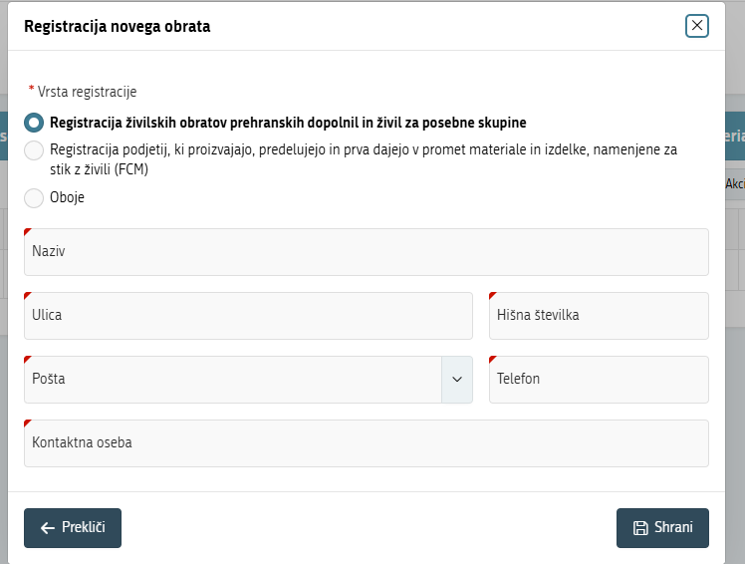
User enters the required information and saves it. After clicking the ''Shrani (Save)’’ button, a notification appears.

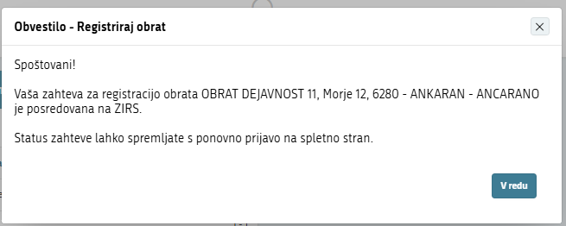

The request is then displayed in the ''Zahteve za registracijo novih obratov'' (Requirements for registration of new facility) list.
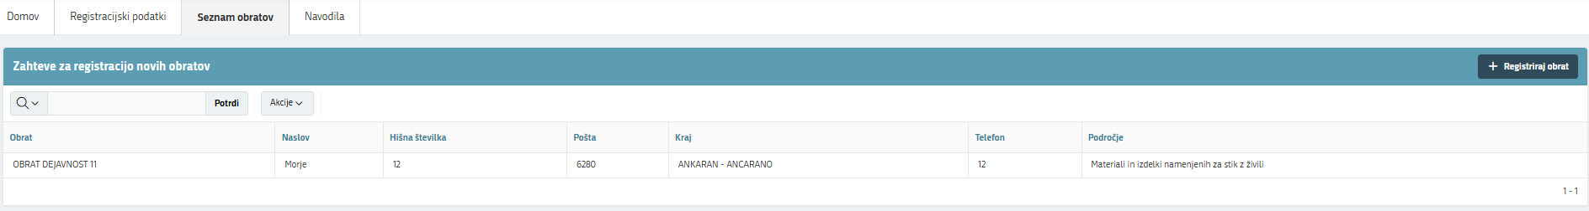

Editing applications for the registration of establishment/company

Once the Inspectorate accept the registration request, it is converted into an application and appears in the relevant list. Its status is ''Neobdelana (Unprocessed)’’. If the request was submitted for both areas, two unprocessed applications will appear, one in the "Vloge za spremembo podatkov o obratih za prehranska dopolnila in živila za posebne skupine (Applications for amendment of information on establishments handling food supplements and food for specific groups)" list and the other in the "Vloge za spremembo podatkov za podjetja, ki proizvajajo, predelujejo in prva dajejo v promet materiale in izdelke, namenjene za stik z živili (Applications for amendment of information on companies manufacturing, processing and first placing on the market materials and articles intended to come into contact with food)" list.

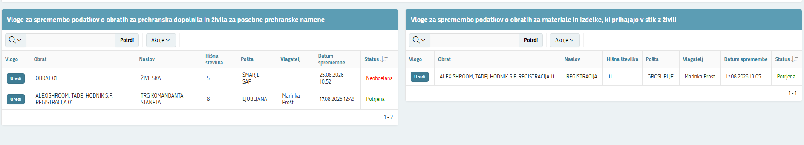
Applications for amendments of the information on establishments handling food supplements and food for specific groups

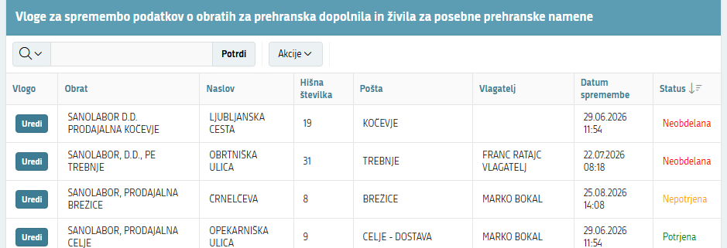
By clicking the "Uredi (Edit)" button, the user can start completing or amending the application.
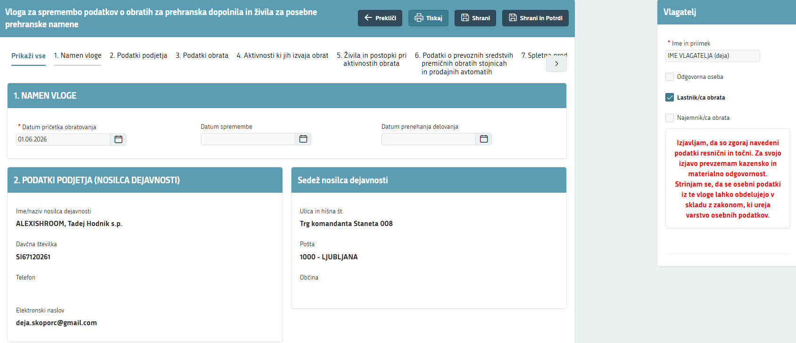
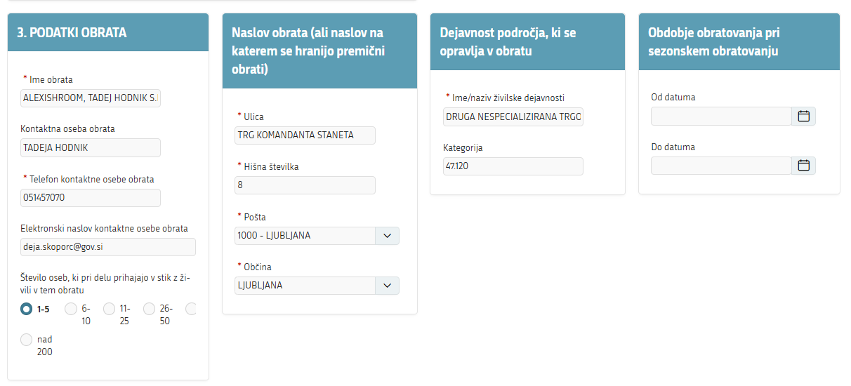
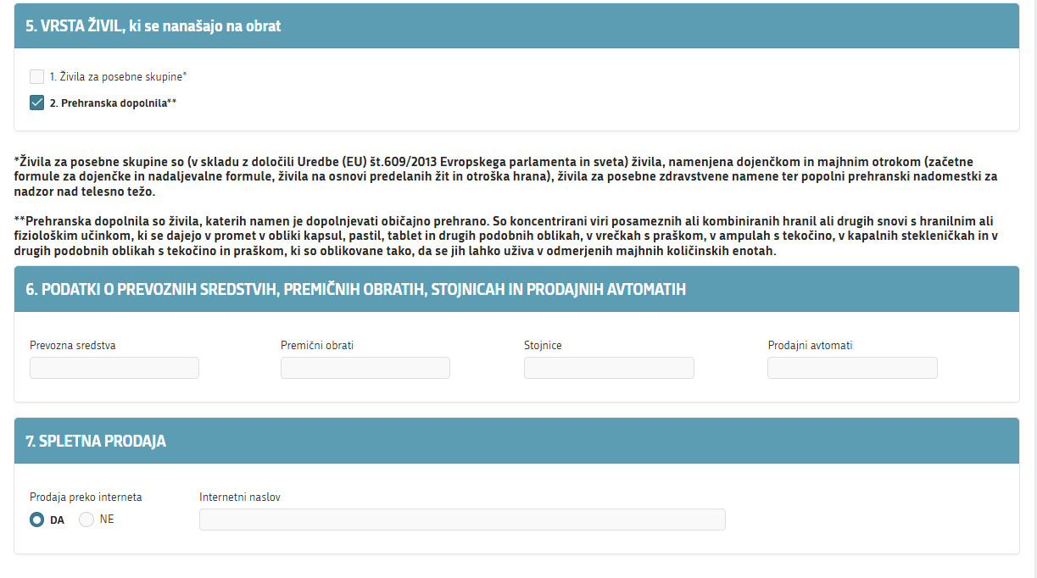
The user can print the application by clicking the "Tiskaj (Print)" button or save it by clicking the "Shrani (Save)" button. Both buttons are located in the upper-right corner.
When the user saves the application, it is also submitted to the Inspectorate for conformation, and a notification appears on the screen.

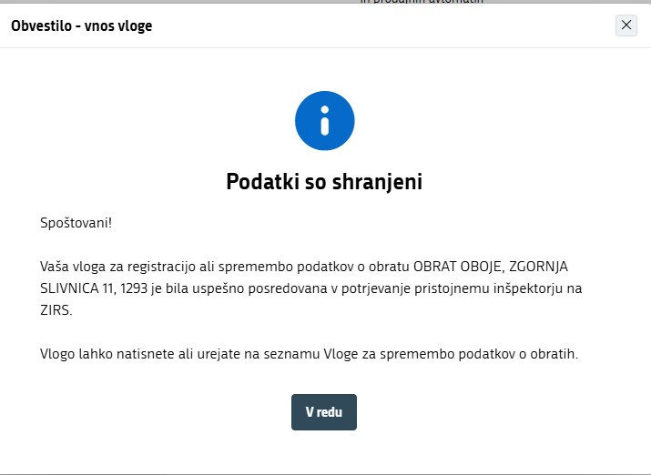

Once the inspector has reviewed and approved the application, its status changes from "Nepotrjena (Unconfirmed)" to ‘’Potrjena (Confirmed)". The user receives a conformation e-mail at the address entered in the "Podatki o nosilcu (Company information)" section. The registration process is complete.
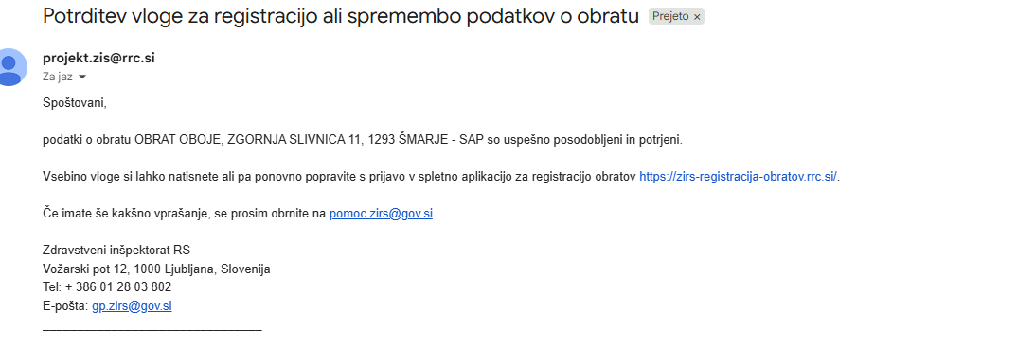

Applications for amending information on companies that manufacture, process and first place on the market materials and articles intended to come into contact with food

Once the application for registration of a new establishment has been edited and the user has been activated, it is converted into an application for the initial entry or amendment of information on companies that manufacture, process and first place on the market materials and articles intended to come into contact with food. The application appears on the list. The application appears in the relevant list with the status "Nepotrjena (Unconfirmed)".
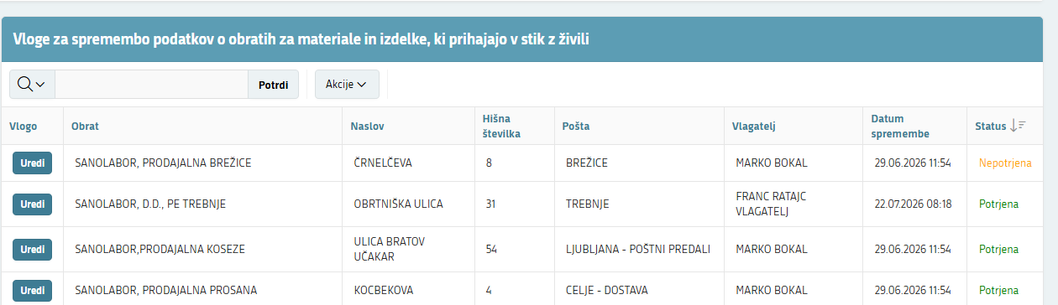

By clicking the "Uredi (Edit)" button, the user can start completing or amending the application.
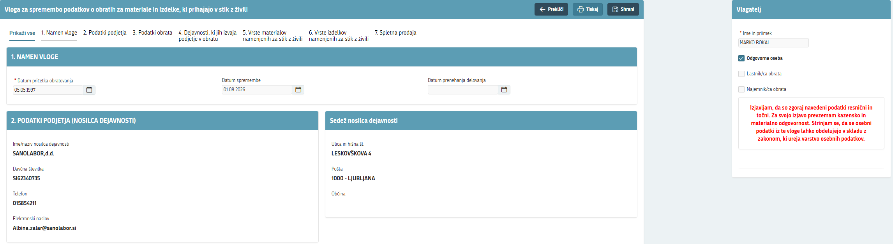
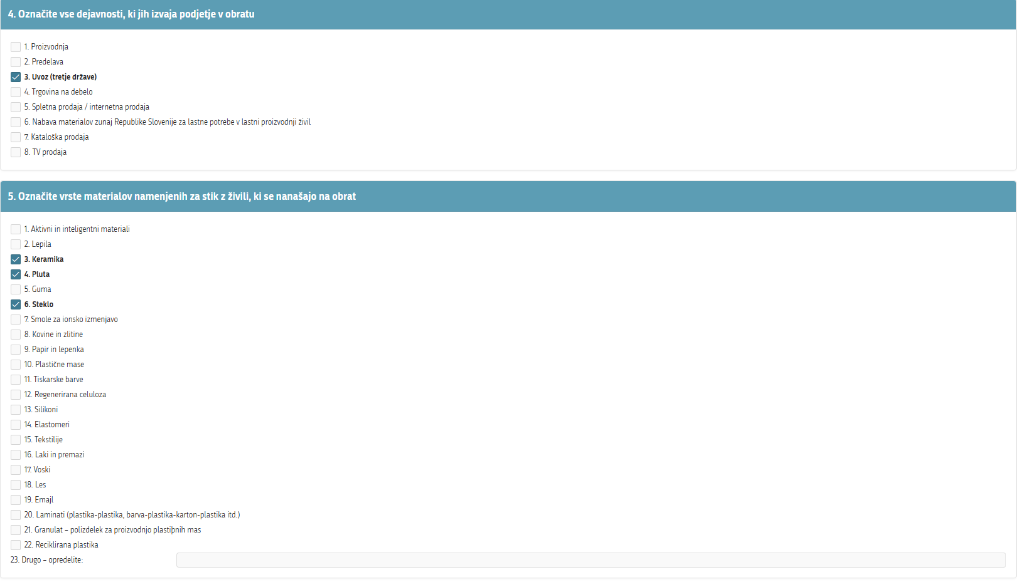
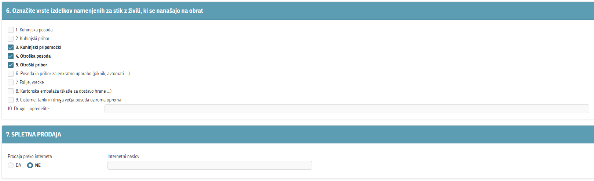

The user can print the application by clicking the " Tiskaj (Print)" button or save it by clicking the "Shrani (Save)" button. Both buttons are located in the upper-right corner.
When the user saves the application, it is also submitted to the Inspectorate for conformation, and a notification appears on the screen.

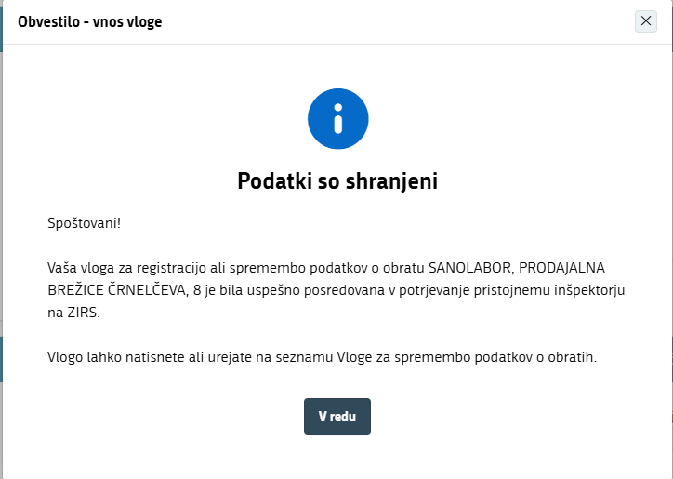

Once the inspector has reviewed and approved the application, its status changes from "Nepotrjena (Unconfirmed)" to ‘’Potrjena (Confirmed)". The user then receives a conformation e-mail at the address entered in the "Podatki o nosilcu (Operator information)" section. The registration process is complete.

