USER GUIDE FOR THE WEB APPLICATION

SUBMISSION OF APPLICATION FOR OFFICIAL CONTROL ON SHIPMENTS FROM
THIRD COUNTRIES

WEB APPLICATION
The application requires a web browser to function. We recommend using Microsoft Edge. The web application can be found at: https://e-storitve-zirs.gov.si/oz/r/zirs_splet/nadzor-uvoza/domov .
Access to the application is available through the SI-PASS system. To set up a SI-PASS account, please visit the portal at SI-PASS.
After entering the address, the introductory page of the web application ‘’ Submission of application for official control on shipments from third countries’’ (‘’Oddaja vlog za uradni nadzor pošiljk iz tretjih držav ‘’) will appear:
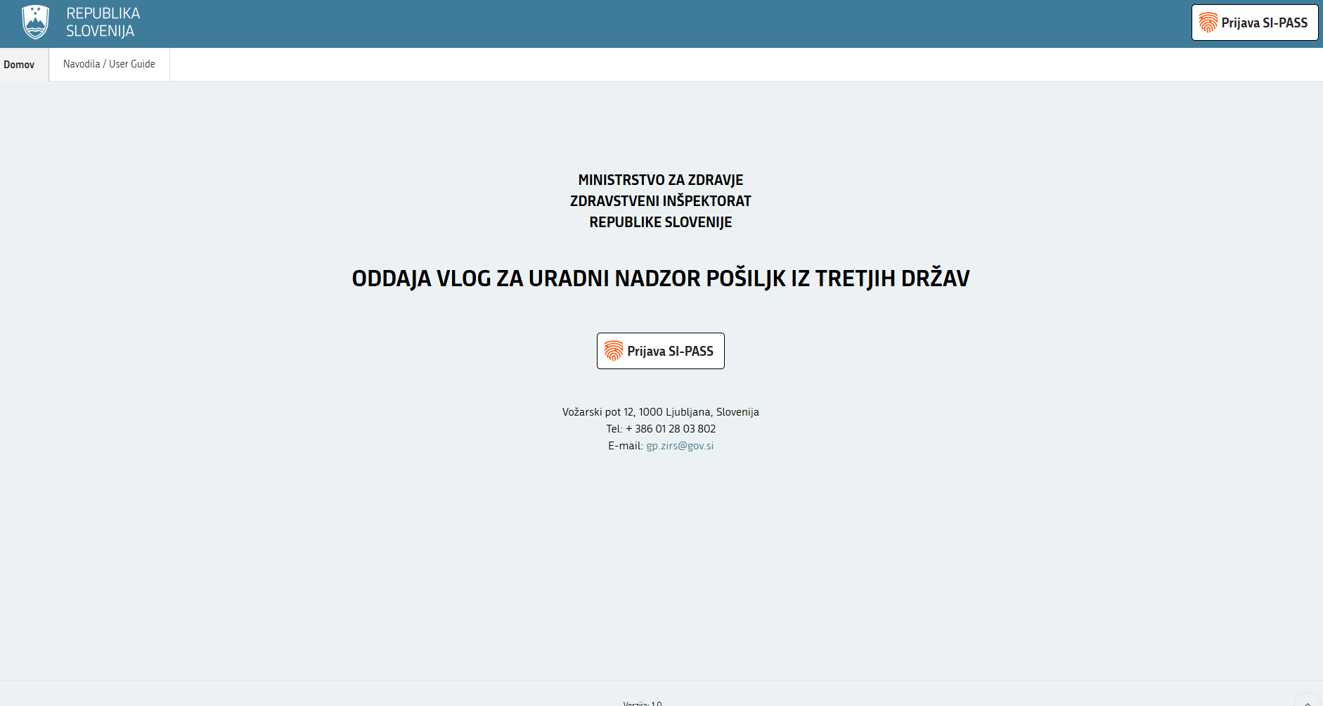

- REGISTRATION

  - Logging in to the web application via the SI-PASS system

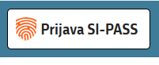

After clicking on the "SI-PASS'' (‘’Prijava SI-PASS’’) login button, the "Login in dialog box will appear. Select your login method.
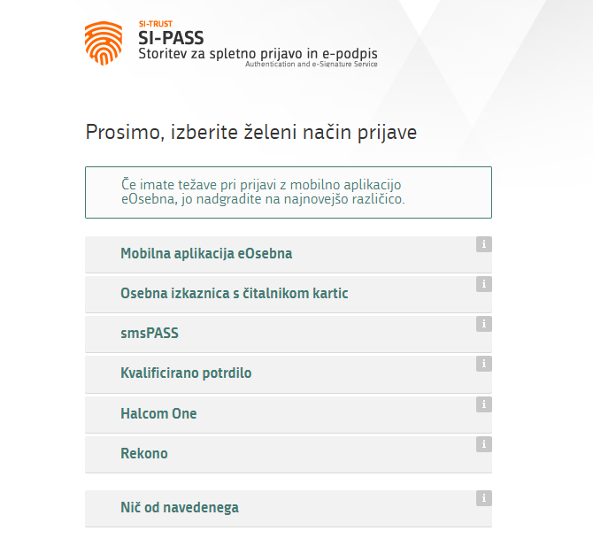

  - Existing user of the old web application

A user who has a username and password for submitting applications in the old web application connects to the old application after logging in to the new web application via the SI-PASS system.
On the page "Connect to old login’’ (‘’Poveži se s staro prijavo’’) enter the username and password from the old web application. The system connects it to the data in the old web application. When you sign in again, you'll see a history of the applications that were recorded in the old web application.

Once connected, logging in to the old web application is no longer possible.

Only one person of the declarant who has used the "old" application in the past can register on this way, all other persons of the declarant must register as a new user.

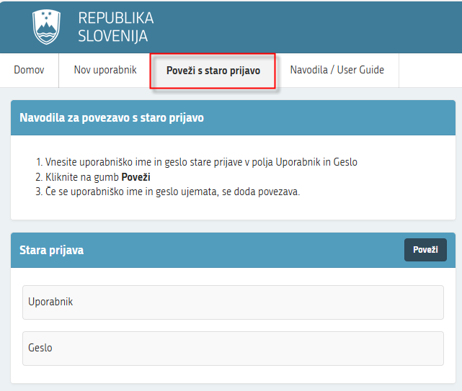

  - New user

If you are a new user, fill in the requested information on the page "New User" (''Nov uporabnik'').

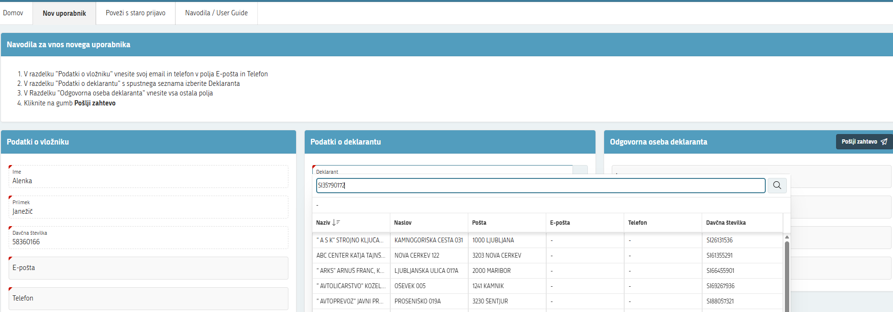

Complete the applicant's details with your e-mail address and a telephone number.
Select the declarant's information from the list where you enter the tax number.
Enter the information about the responsible person of the declarant and click on the button "Send" (‘’Pošlji’’) to complete the request.

A notice will appear on your screen.
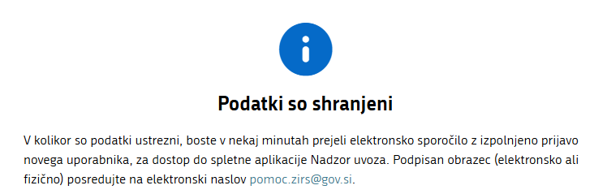

On your e-mail address you will receive a message with the content of the completed form in pdf format. Sign the form electronically or physically and send it to pomoc.zirs@gov.si .

Within a few days, you will receive an email notification confirming your successful registration for the web application.

LOG IN

Successful registration opens the page "List of applications" (‘’Seznam vlog’’). This page has three sections: the "List of your applications"(''Seznam vaših vlog''), the "List of shipments" (''Seznam pošiljk'') and the "List of attachments" (''Seznam prilog''). The lists contain information about applications that have already been in the "old" web application.
If you're applying as a new user, the list will initially be empty.

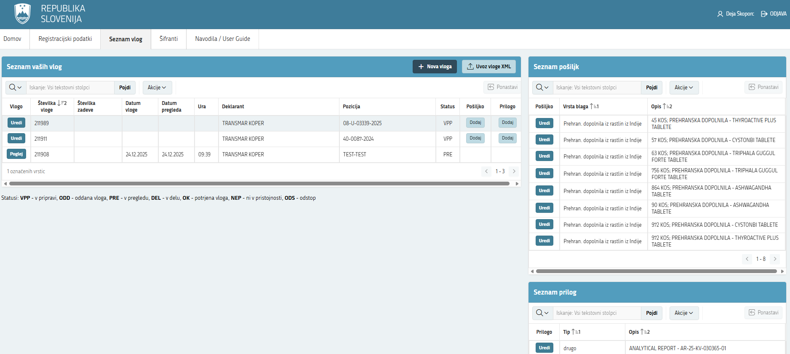
The " List of your applications"(''Seznam vaših vlog''), the "List of shipments" (''Seznam pošiljk'') and the "List of attachments" (''Seznam prilog'')", you can edit or view the application by clicking on the "Edit" (‘’Uredi’’) / "View" (‘’Poglej’’) button.
Applications are arranged by status: VPP - in preparation, ODD - submitted, PRE - under review, DEL - in editing, OK - approved, NEP - not in competence and in DSO – in resignation.

- FILLING IN AN APPLICATION
On the ''List of applications'' page, there are two more buttons in the middle: ''New application'' (‘’Nova vloga’’) and ''Import XML application'' (‘’Uvoz vloge XML’’).
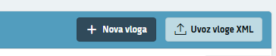

After clicking on the "New application" (‘’Nova vloga’’) button, the "Application" (‘’Vloga’’) window appears. General application data are entered here.
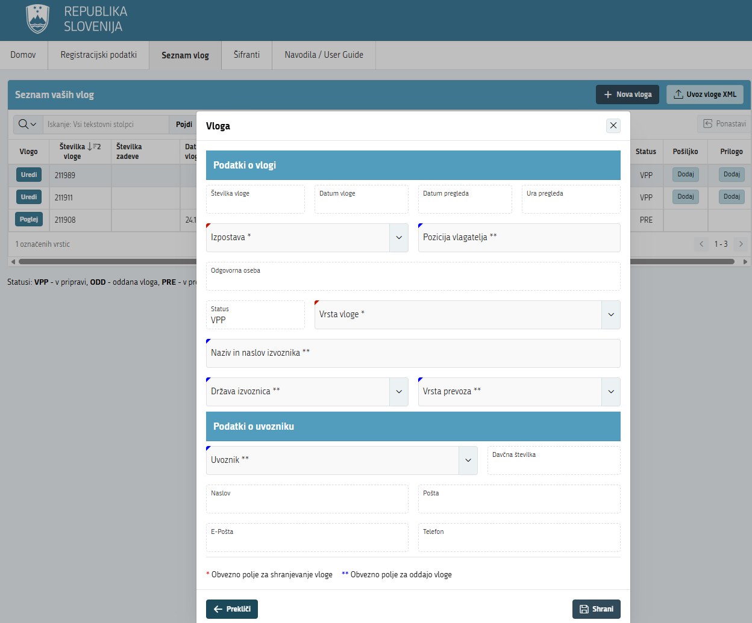

Fields marked with a red-coloured left corner are mandatory for saving an application. Fields marked with a blue-coloured left corner are mandatory for submitting an application.

Application details
Lists can be open by clicking on button 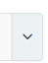 ,select the branch, type of application, exporting country and type of transport.
Manually enter the fields "Position of the applicant" (''Pozicija vlagatelja'') "Title" (''Naziv'') and "Address of the exporter" (''Naslov izvoznika'’).
The responsible person field is automatically filled in with the applicant's data.
Importer data
To select an importer, click on the list. You choose by title or by entering tax number. After selection, the contents of the other fields are automatically filled with data from the list.

Save the application. The application automatically receives a number and VPP status - in preparation.
By clicking on the "Import XML application" (''Uvoz vloge XML'') button, you import the data for the application from the XML file. XML file you can prepare by exporting the previous application or select the file from the disk on your computer.

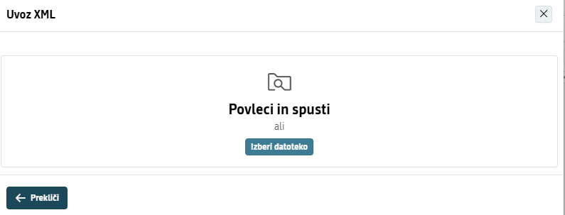

Application data

By clicking on the "Edit" (''Uredi'') button in the first column "Application" (''Vlogo'') of the section "List of your applications" (''Seznam vaših vlog''), you can change the application data.
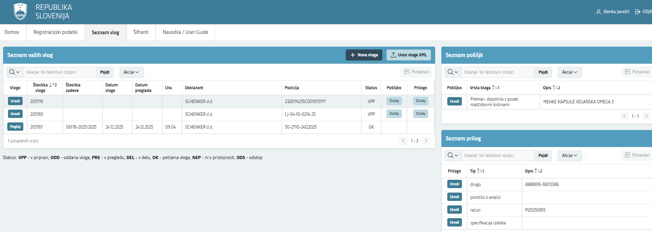

List of shipments

By clicking on the "Add" (''Dodaj'') button in the column "Shipment" (''Pošiljka''), you can enter the data about the new shipment.

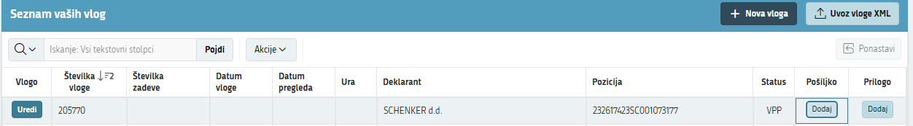

After clicking the "Add" (''Dodaj'') button, a window will appear. Here you can enter your shipment data.

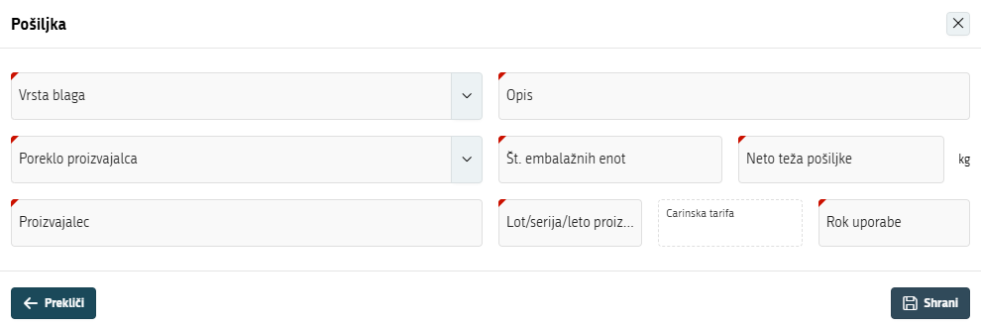

Select "Type of goods" (''Vrsto blaga'') and "Origin of manufacturer" (''Poreklo proizvajalca'') from the list 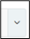. Other data you have to enter in the fields manually. By clicking on the "Save" (‘’Shrani’’) button, the shipment data are saved.
The ''Cancel'' (‘’Prekliči’’) button will return you to the ''List of applications'' (‘’Seznam pošiljk’’) page. The "Shipment List" section is right on the top.

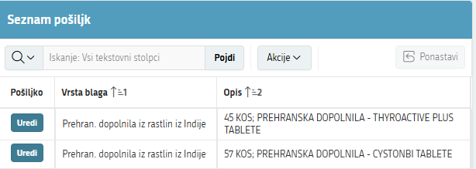
By clicking on the "Edit" (‘’Uredi’’) button, you can change the shipment data, you can also delete the shipment.

List of annexes

In the section "List of your applications" (''Seznam vaših vlog'') click on the "Add" (‘’Dodaj’’) button in the last column "Attachment" to enter a new attachment.

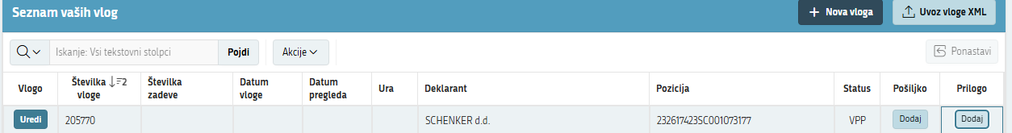

Select ''Attachment Type'' (''Tip priloge'') from the list , and enter the attachment's data manually in the field ''Description'' (''Opis'').

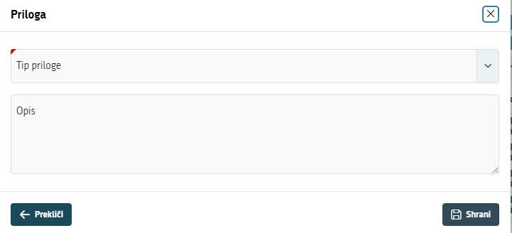

By clicking on the "Save" (‘’Shrani’’) button, the attachment data are saved.
On the page "List of Applications" (''Seznam vlog'') the "List of Attachments" (''Seznam prilog'') section is located right at the bottom.

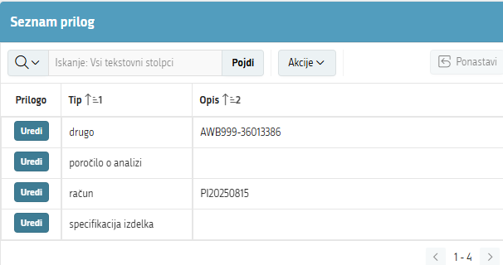

By clicking on the "Edit" (‘’Uredi’’) button, you can change the data about the attachment, you can also delete the attachment.

APPLICATION SUBMISSION

Once the data on the application, shipments and attachments are entered, you can submit the application by clicking the "Submit application" (‘’Oddaj vlogo’’) button. You cannot submit without shipments. Once the application is submitted, it receives the status of ODD - submitted application.
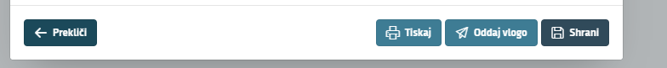

Once the application is submitted, you can no longer change the data. You can view the application; you can print it (the pdf file is saved on your local disk in the downloads folder), or you can make an export in XML format.
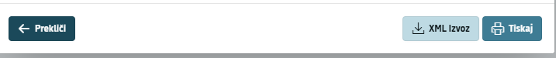

XML Export

‘’XML export’’ (‘’XML izvoz'') button allows you to export data about the application (application in ODD status), shipments and attachments to an XML file format.
By clicking on the ‘’XML export’’ (‘’XML izvoz'') button, the data is exported to a file in XML
format, which is saved to the local disk in the downloads folder.
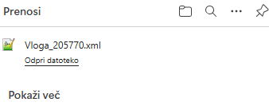

XML import

On the ''List of applications'' (''Seznam vlog'') page you can import the XML file into the list by clicking on the ''Import XML application'' (‘’Uvoz vloge XML’’) button. After import, the application receives a new number and status VPP - in preparation.

By clicking on the ''Import XML application'' (‘’Uvoz vloge XML’’) button, a window for selecting and importing the YML file opens. You can select the XML file from the disk or use the "Drag and Drop" (‘’’Povleci in spusti’’).

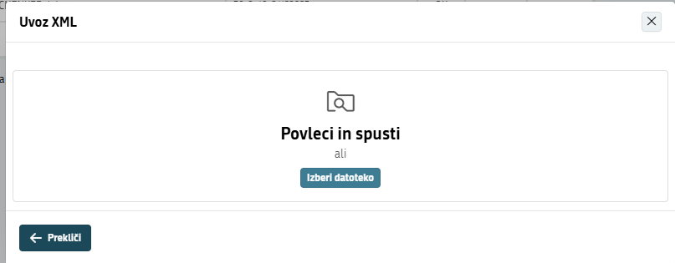

The selected file will be displayed in the window. You proceed by clicking on the ''Import'' (‘’Uvozi’’) button.

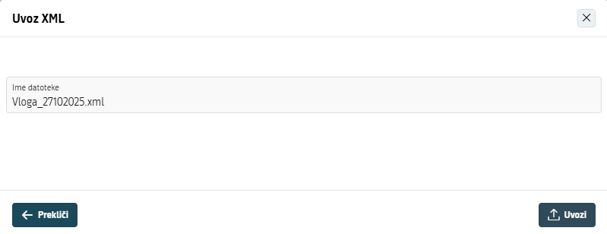

After a successful import, a window appears with information about the imported application, which has received a new number and is in the VPP status - in preparation. You can modify the data as needed and prepare your application for submission in accordance with the chapter 4 of these instructions.

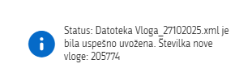

DESCRIPTION OF OTHER PAGES OF THE APPLICATION

On the side there are also pages: "Registration data" (''Registracijski podatki''), "Code lists" (''Šifranti'') in ''Navodila/User Guide''.
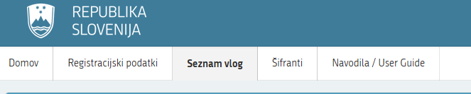

On the ''Registration data'' page there are data about the applicant and the declarant.
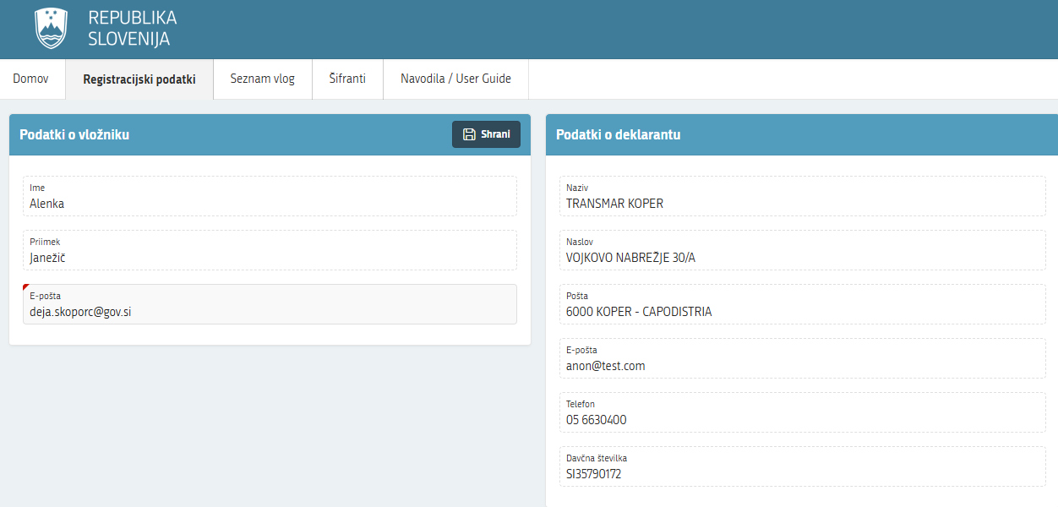

On the ''Code Lists'' page, there are a lists with buttons: ''Countries'' (‘’Države’’), ''Type of Goods'' (‘’Vrste blaga’’), ''Attachment Types'' (‘’Tipi prilog’’), ''Application Type'' (‘’Vrste vlog’’), ''Type of Transport'' (‘’Vrste prevoza’’), ''Post Offices'' (‘’Pošte’’) and ''Branches'' (‘’Izpostave’’). By clicking on one of the buttons, the selected code is exported in xml format.
The file is saved on your local disk in the downloads folder.

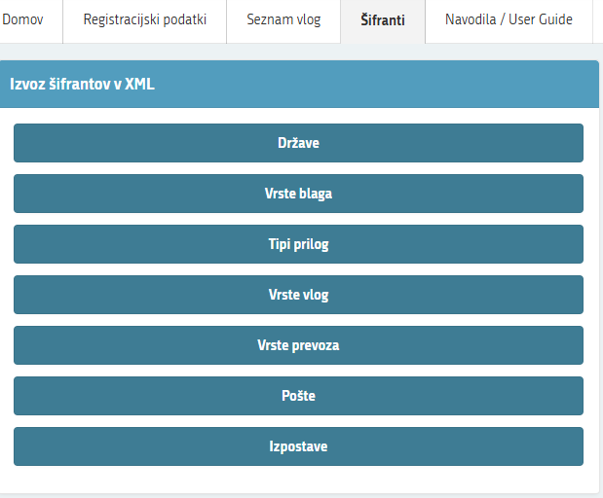

On the page "Navodila / User Guide" there are instructions for using the application in Slovenian and English.

On the top right side there is information about the applicant and a button to unsubscribe (‘’ODJAVA’’).

