Instructions for amending the data of a sole trader via the SPOT portal

Document history

Version | Amendment | Author | Description of amendments
1.0 | 15.4.2023 | AJPES | Document preparation
Contents
1. Introduction 4
2. Legal basis 4
3. Procedure for registering a change in the PRS via the SPOT portal 4
3.1. Updating an application for registering a change of data in the PRS 28
4. Further options of the SPOT portal 29
4.1. Modifying an Application to register changes in the PRS 29
4.2. Withdrawing of a submitted Application to register changes in the PRS 29

List of figures
Figure 1: Portal login 4
Figure 2: Enter your password 5
Figure 3: Selection of relevant application 6
Figure 4: Name and basic information 7
Figure 5: Register address 8
Figure 6: Select address 9
Figure 7: Declaration by the owner of the building 9
Figure 8: Information about the sole trader 10
Figure 9: Registration of a representative 11
Figure 10: Registering the representative’s details 12
Figure 11: Activities 13
Figure 12: Main activity 14
Figure 13: Branch registration 15
Figure 14: Branch 16
Figure 15: Main activity of the branch 17
Figure 16: Information on the method of delivering documents 18
Figure 17: Selection of attachments 19
Figure 18: Preview of information 20
Figure 19: Attachment of documents 21
Figure 20: Central electronic document collection 22
Figure 21: Attaching a document 23
Figure 22: Signing of attached document 24
Figure 23: Review of attached documents 25
Figure 24: Attachments added and stored in the CEH 26
Figure 25: Electronic signing of document 27
Figure 26: Signing the document 27
Figure 27: Status of application 28

Introduction
A sole trader who is already registered in the Slovenian Business Register (PRS) can submit an Application to register changes to the data of their company (s.p.) in the PRS via the SPOT portal. The procedure for registering such changes is free of charge.

Legal basis
Article 75 of the Companies Act (ZGD-1) determines that a sole trader must notify the Agency of the Republic of Slovenia for Public Legal Records and Related Services (AJPES) of any change in information within 15 days of the change occurring.
A sole trader who holds a qualified digital certificate or an SI-PASS user account can submit an Application to register changes in the PRS via the SPOT portal.

Procedure for registering a change in the PRS via the SPOT portal
Please submit your electronic Application to register changes in the PRS via the http://spot.gov.si/ online portal, where you select the ‘Prijava s certifikatom’ [Log in with certificate] option or the ‘SI-PASS prijava’ [SI-PASS login] option.

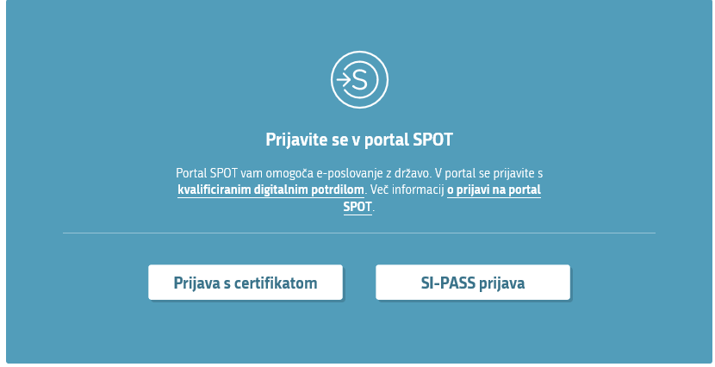
Figure 1: Portal login

Glossary
Prijava s certifikatom | Log in with certificate
SI-PASS prijava | SI-PASS login

After logging in with the password you have set up to use the SPOT portal, select the option ‘Pošlji’ [Submit].

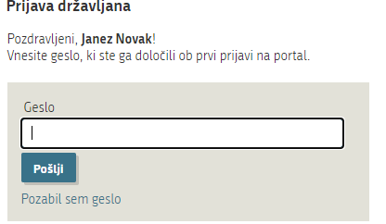
Figure 2: Enter your password

Glossary
Geslo | Password
Pošlji | Submit
Pozabil sem geslo | I have forgotten my password

After entering your tax number, the SPOT information system will check your tax number and offer you the possibility of changing your details and deleting your s.p.

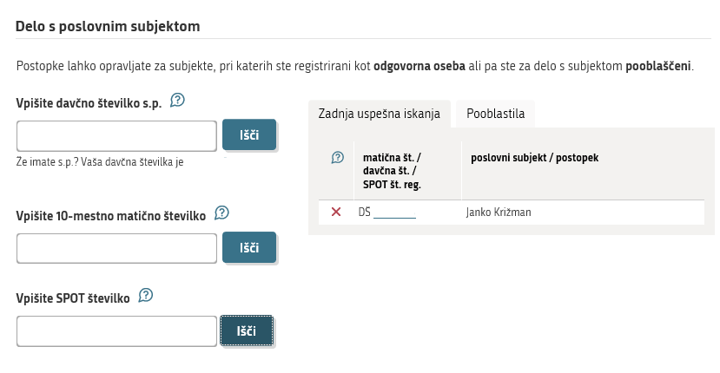

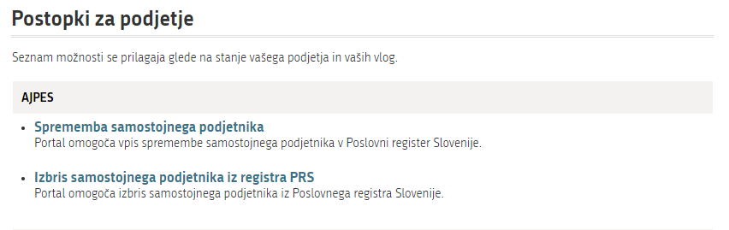
Figure 3: Selection of relevant application

Glossary
Prijava za vpis spremembe samostojnega podjetnika | Application for registration of data change of sole trader
Prijava za izbris samostojnega podjetnika iz registra PRS | Application for termination of a sole trader

After the ‘Prijava sprememb podatkov’ [Application for registration of data changes] option is selected, the SPOT portal opens for entering changes to information.

NB: if you do not complete your application, the SPOT information system deletes it from the system after 30 days.

Step 1: Name and basic information

This step allows you to enter changes to the basic details of the sole trader (s.p.). First, you enter the proposed date of entry of the change, which is mandatory (it can be the current date or up to 1 month in advance).

You can change the company name, abbreviated company name, business address and contact details.

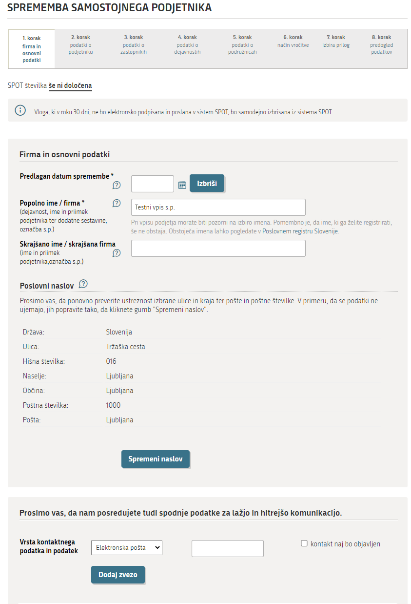
Figure 4: Name and basic information
Glossary
SPOT številka | SPOT number
Predlagan datum vpisa | Proposed date of registration
Izbriši | Delete
Popolno ime / firma | Full name / company
Skrajšano ime / skrajšana firma | Short name / abbreviated company name
Poslovni naslov | Business address
Spremeni naslov | Change address
Vrsta kontaktnega podatka in podatek | Type of contact and information
Telefon | Telephone
Elektronska pošta | Email
Spletni naslov | Website
GSM | Mobile
Kontakt naj bo objavljen | The contact should be published
Dodaj zvezo | Add link
Shrani vlogo | Save application
Naprej | Next

Registering a new address:
Enter the street and number and select ‘Išči naslov’ [Search address].

Figure 5: Register address

Glossary
Država | Country
Ulica (vsaj 2 črki) | Street (at least 2 letters)
Hišna številka (npr. 117b) | House number (e.g. 117b)
Išči naslov | Find address

If the street and house number you have entered exists in several different places, the application will offer you all possible addresses, from which you have to select the right one and confirm your choice by clicking ‘Izberi naslov’ [Select address].

Figure 6: Select address

Glossary
Izberi naslov | Select address

When registering a change of address, indicate whether you are the owner of the building at the business address. If you are the owner of the building, please tick the box. If you are not the owner of the building, you must attach a declaration from the owner of the building that they allow you to operate from the business address. Select the option ‘Prenesi izjavo o lastništvu objekta’ [Download the declaration of ownership of the building] and the app will display the form, which you must print out, then the owner of the building fills in the details, before signing and authenticating the declaration at the administrative unit or a notary’s office. Please attach the completed declaration in the step ‘Pripenjanje prilog’ [Attaching documents].

Figure 7: Declaration by the owner of the building

Glossary
Sem lastnik objekta na poslovnem naslovu | I am the owner of the building at the business address
Prenesi izjavo o lastništvu objekta | Download the declaration of ownership of the building

Step 2: Information about the sole trader

- You cannot correct your data that is automatically downloaded from the Central Population Register (CRP). Any change to this information must be processed by the administrative unit, which will amend the information in the CRP. AJPES updates the data entered in the PRS once a day with the CRP, which means that changes to the sole trader’s name and residential address do not need to be reported.

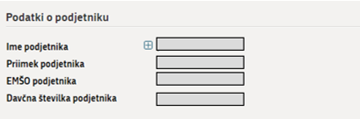
Figure 8: Information about the sole trader

Glossary
Podatki o podjetniku | Information about the sole trader
Ime podjetnika | Forename of the sole trader
Priimek podjetnika | Surname of the sole trader
EMŠO podjetnika | Personal registration number (EMŠO) of the sole trader
Davčna številka podjetnika | Tax number of the sole trader

Step 3: Information on representatives

An sole trader may appoint one or more representatives, and may appoint a proxy or representative to represent them in the event of their death.

A proxy registered in the PRS may, without special authorisation from the sole trader, carry out all legal acts falling within the legal capacity of the s.p., except for the disposal and encumbrance of immovable property, for which the proxy must have special authorisation. The proxy’s powers do not cease upon the death or loss of business capacity of the sole trader.

In the event of the sole trader’s death, the representative registered in the PRS is authorised, from the sole trader’s time of death, to carry out all legal acts falling within the scope of the normal management carried out by the sole trader.

If the representative is not a Slovenian citizen and does not have a registered temporary residence in Slovenia, they must have a Slovenian tax number. Please copy the details of the representative’s place of permanent residence abroad from their personal document.

If you enrol a new representative, you must attach the representative’s consent to the enrolment application. Attach the consent as an Other attachment (‘Druga priloga’) in the step ‘Pripenjanje prilog’ [Attaching documents].

Select the option ‘Dodaj zastopnika’ [Add representative] and enter one or more representatives.

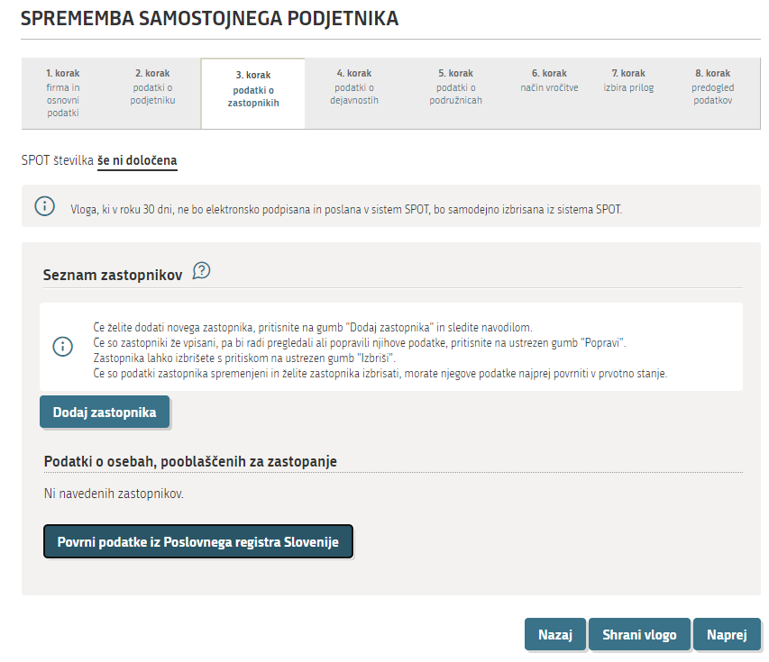
Figure 9: Registration of a representative

Glossary
Seznam zastopnikov | List of representatives
Dodaj zastopnika | Add representative

Please enter the following information:
- the type of representative (proxy, representative in the event of death);
- the representative’s full name;
- the representative’s personal number (EMŠO) or tax number;
- the representative’s permanent or temporary residence.

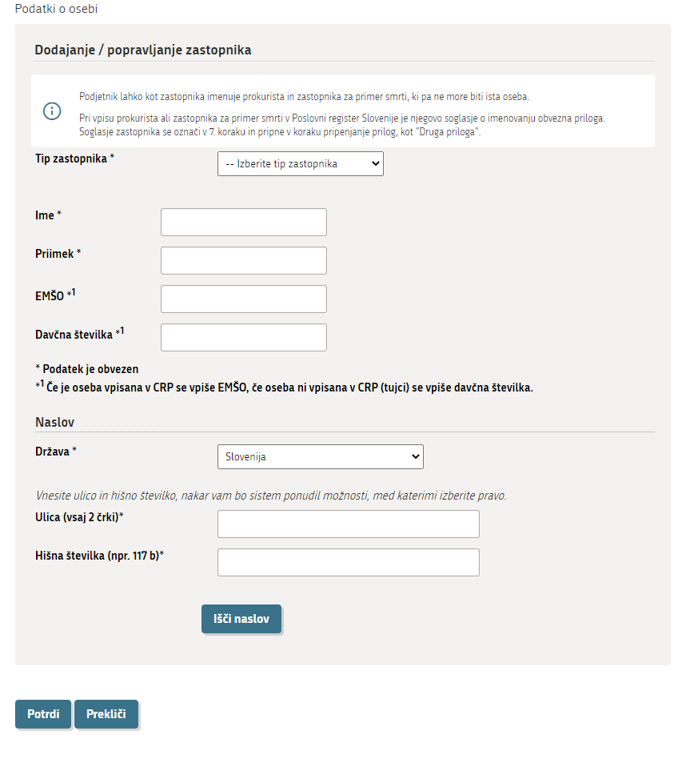
Figure 10: Registering the representative’s details

Glossary
Dodajanje/popravljanje zastopnika | Add/correct a representative
Tip zastopnika | Type of representative
Izberite tip zastopnika | Select representative type
Prokurist | Proxy
Zastopnik za primer smrti | Representative in the event of death
Ime | Forename
Priimek | Surname
EMŠO | EMŠO (personal identification number)
Davčna številka | Tax number
*Podatek je obvezen | *Mandatory information
*¹ Če je oseba vpisana v CRP se vpiše EMŠO, če oseba ni vpisana v CRP (tujci) se vpiše davčna številka | *¹ If the person is registered in the CRP, enter the EMŠO. If the person is not registered in the CRP (foreign nationals), enter the tax number.
Naslov | Address
Država | Country
Ulica (vsaj 2 črki) | Street (at least 2 letters)
Hišna številka (npr. 117b) | House number (e.g. 117b)
Išči naslov | Find address
Potrdi | Confirm
Prekliči | Cancel

Step 4: Activity data

The sole trader’s activities should be registered in the PRS in accordance with the Standard Classification of Activities (SKD). You must enter all the activities you will carry out. Select activities from the SKD code list by selecting ‘Dodaj dejavnost’ [Add activity], then search for the relevant activity and confirm by selecting ‘Potrdi izbiro’ [Confirm selection]. Alternatively, you can enter the corresponding activity code in the ‘Iskanje’ [Search] field and select the option ‘Išči’ [Go].
The selected activities are listed at the bottom of the page, grouped in ascending order according to the activity code. If you wish to remove an activity from the list of selected activities, you can do so by marking the activity and selecting the option ‘Briši izbrane’ [Delete selected].

If the link ‘POGOJI’ [CONDITIONS] appears next to the code and description of the activity, you must comply with these conditions before you can start the activity.

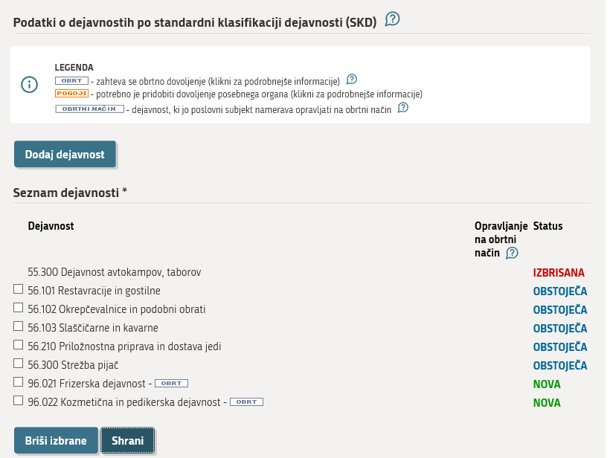
Figure 11: Activities

Glossary
Podatki o dejavnostih po standardni klasifikaciji dejavnosti (SKD) | Activity data by Standard Classification of Activities (SKD)
Dodaj dejavnost | Add activity
Seznam dejavnosti | List of activities
Opravljanje na obrtni način | Provision of craft services
Status | Status
Briši izbrane | Delete selected
Shrani | Save

The Standard Classification of Activities (SKD) in English can be found at www.stat.si/Klasje/Klasje/
Tabela/5531.

Once you have selected all the sole trader’s activities, you need to indicate the main activity. The main activity is one of the activities that will generate the largest amount of added value or that will employ the largest number of persons.

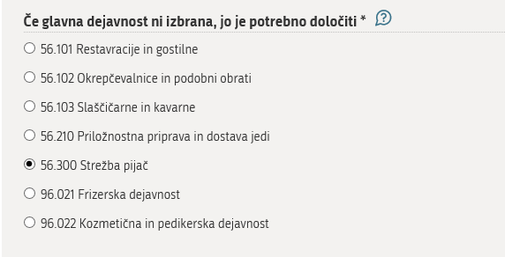
Figure 12: Main activity

Glossary
Če glavna dejavnost ni izbrana, jo je potrebno določiti | If the main activity is not selected, it must be specified

Step 5: Information on branches

The process of registering a branch, registering changes to the details of a branch or terminating a branch is treated as a procedure of change for a sole trader. If you wish to register a new branch, change the details of an already registered branch or terminate an existing branch, you do so in step 5 by selecting the option ‘Dodaj podružnico’ [Add branch], ‘Izbriši podružnico’ [Terminate branch] or ‘Spremeni podatke pri obstoječi podružnici’ [Change details of an existing branch].

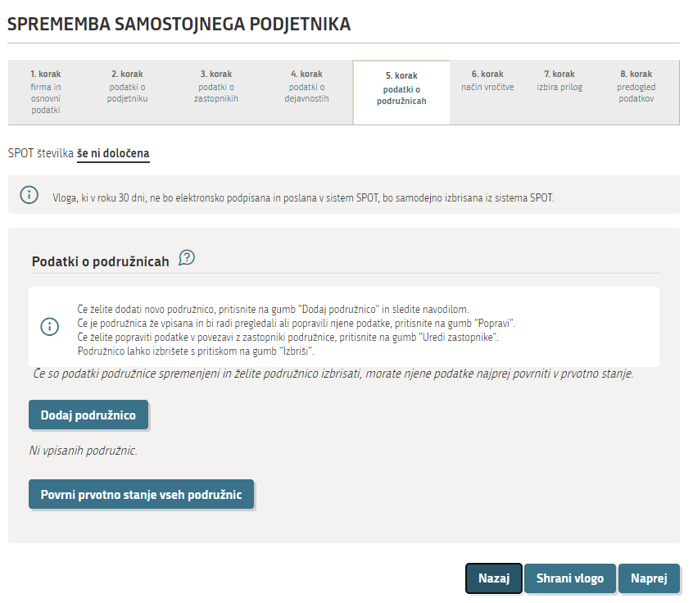
Figure 13: Branch registration

Glossary
Podatki o podružnicah | Information on branches
Dodaj podružnico | Add branch

The following information must be provided:

- full name of the branch (required) – the name of the branch must include at least the forename and surname of the sole trader, a suffix indicating that it is part of a business entity, and the designation ‘s.p.’;
- branch address (required) – please enter the address in the same way as the business address of the sole trader. If you are operating a branch in a movable structure that does not have a house number, you can enter an address without a house number by entering the nearest house number and, in the next step after confirming the address, selecting the option ‘Izbriši hišno številko’ [Delete house number];
- indicate whether you are the owner of the premises at the branch address or attach a declaration from the owner that they permit the business to be carried on at that address, in the same way as for a business address;
- main activity of the branch (required) – the main activity of the branch is one of the activities registered for the sole trader;
- details of the branch representative (optional) – enter the branch representative in the same way as the sole trader’s representative; if you enter a representative, you must determine their consent.

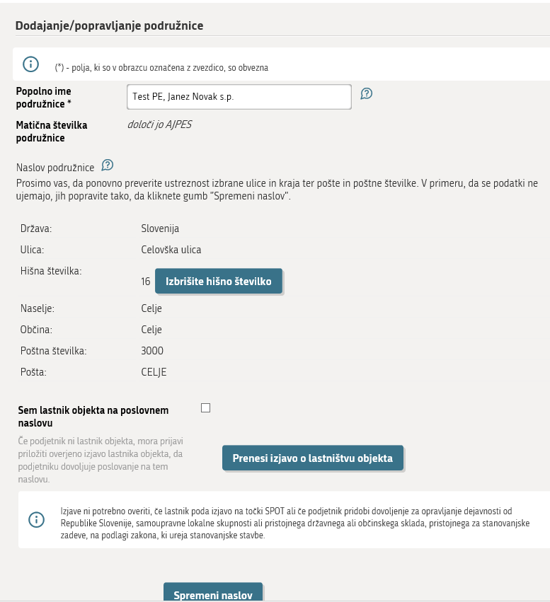
Figure 14: Branch

Glossary
Dodajanje/popravljanje podružnice | Adding/editing a branch
Popolno ime podružnice | Full branch name
Matična številka podružnice | Branch identification number
Določi jo AJPES | Determined by AJPES
Naslov podružnice | Address of the branch
Izbrišite hišno številko | Delete house number
Prenesi izjavo o lastništvu | Download the ownership statement

Select the main activity of the branch, which is one of the activities you have entered for the s.p.

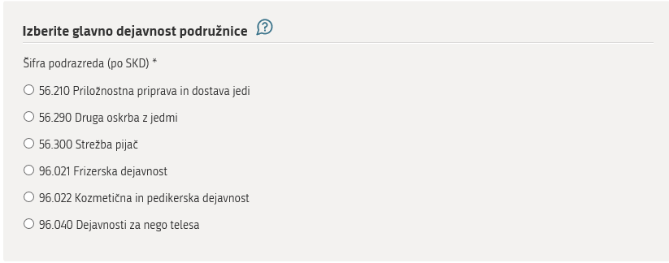
Figure 15: Main activity of the branch

Glossary
Izberite glavno dejavnost podružnice | Select the main activity of the branch

Step 6: Notification method

The decision on the registration of a change of data issued by AJPES is enforced by publication on the AJPES website at Publications of decisions issued in the procedures for registration of data on sole traders (ajpes.si). A paper copy of the decision is sent to the sole trader by AJPES, so you need to choose how you want to receive the decision:
- electronic delivery – the details of the secure electronic mailbox opened with the electronic service provider must be entered;
- delivery by post – select the option ‘Spremeni naslov’ [Change address] if you want AJPES to send the registration decision to an address other than your business address, then enter the desired address;
- personal delivery – select the AJPES branch office where you want to collect the decision.

Decisions in electronic form, issued by AJPES and delivered electronically, are sent to your electronic mailbox using your qualified digital certificate. If you do not collect it within 15 days of receipt of the notification, the decision is deemed to have been delivered.

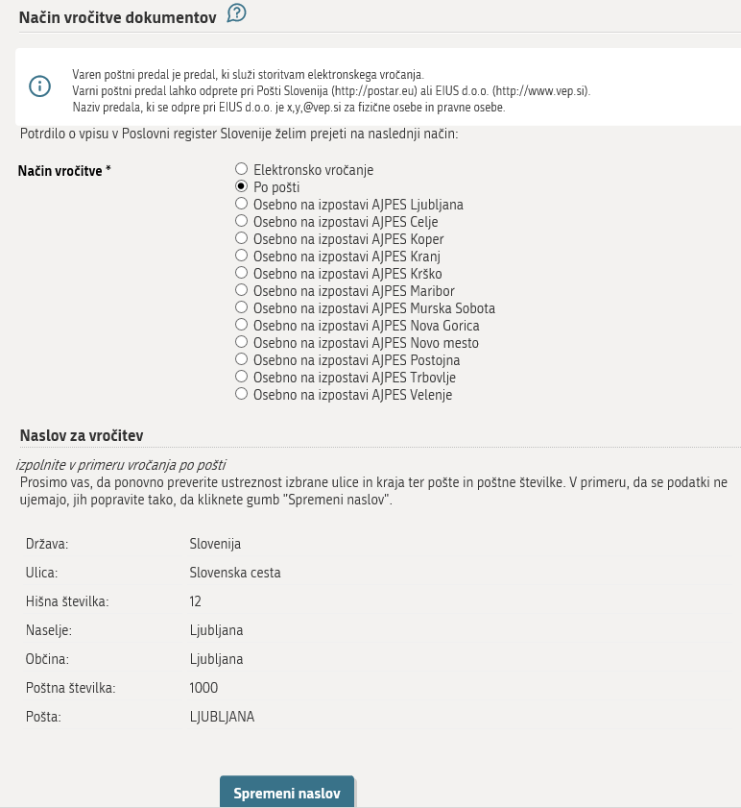
Figure 16: Information on the method of delivering documents

Glossary
Način vročitve dokumentov | Method of delivering documents
Način vročitve | Notification method
Varni poštni predal | Secure mailbox
Po pošti | By post
Naslov za vročitev | Address for delivery
Spremeni naslov | Change address
Osebno na izpostavi AJPES | In person at an AJPES branch office
Nazaj | Back
Shrani vlogo | Save application
Naprej | Next

Step 7: Selection of attachments
In this step, you need to indicate which documents will be attached to the application.

If you are changing the business address of a sole trader or branch and you are not the owner of the building at the business address, you must attach a declaration from the owner of the building that they allow you to do business at the business address or branch address. Mark the option ‘Izjava lastnika objekta’ [Declaration by the building owner] and attach it to the application when completing the application in the step ‘Pripenjanje prilog’ [Attachment of documents].

If you are registering a proxy or a representative in the event of death in the PRS, you must attach to the application to register their consent to this appointment. Mark the option ‘Druga priloga’ [Other attachment].

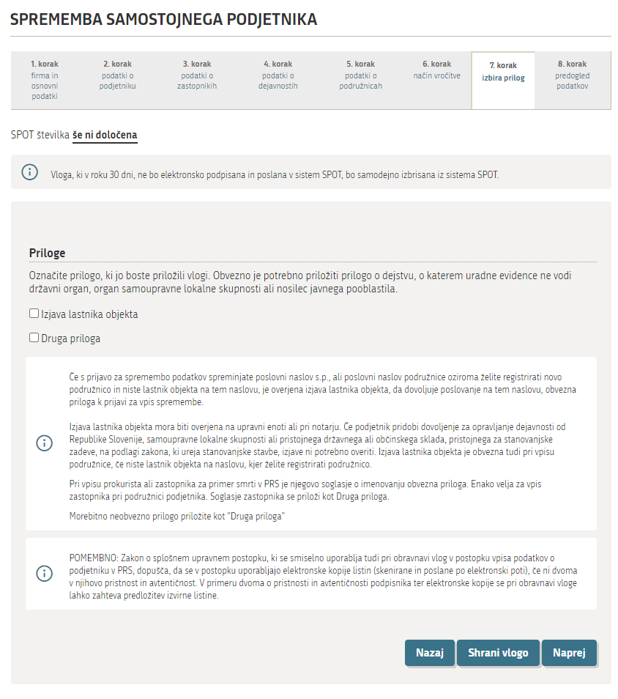
Figure 17: Selection of attachments

Glossary
Priloge | Attachments
Izjava lastnika objekta | Declaration by the owner of the building
Druga priloga | Other attachment

Step 8: Preview of information

Check that you have entered or modified all information correctly and select ‘Naprej’ [Next].

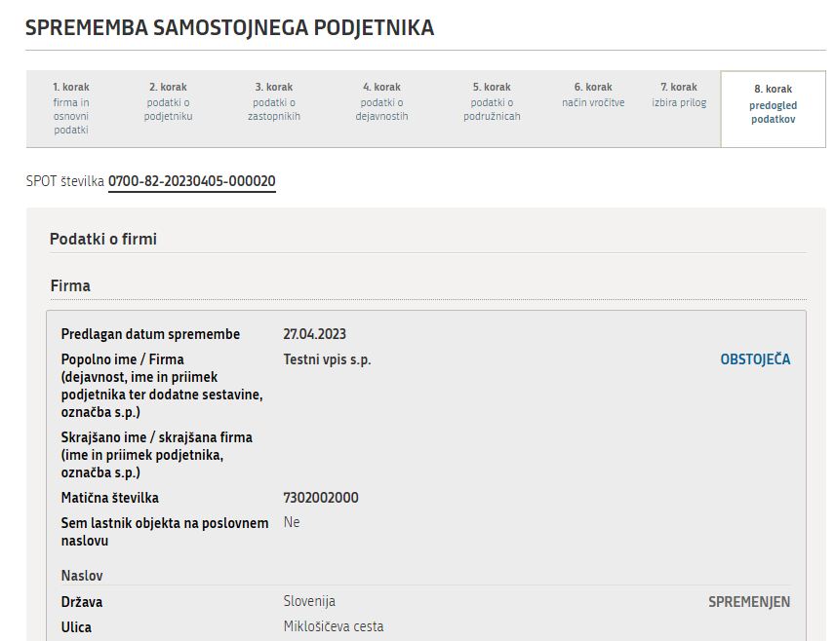
Figure 18: Preview of information

Once the application has been fully and correctly completed, the next step is to sign the application, which is divided into the following steps:

Step 1: on application – you can go back and correct the information on the application;
Step 2: attachment of documents – all the documents that you have previously marked for attachment and that are displayed on the screen must be attached. Attach the documents by selecting the option ‘Prični s pripenjanjem prilog v CEH’ [Start attaching documents to the CEH];

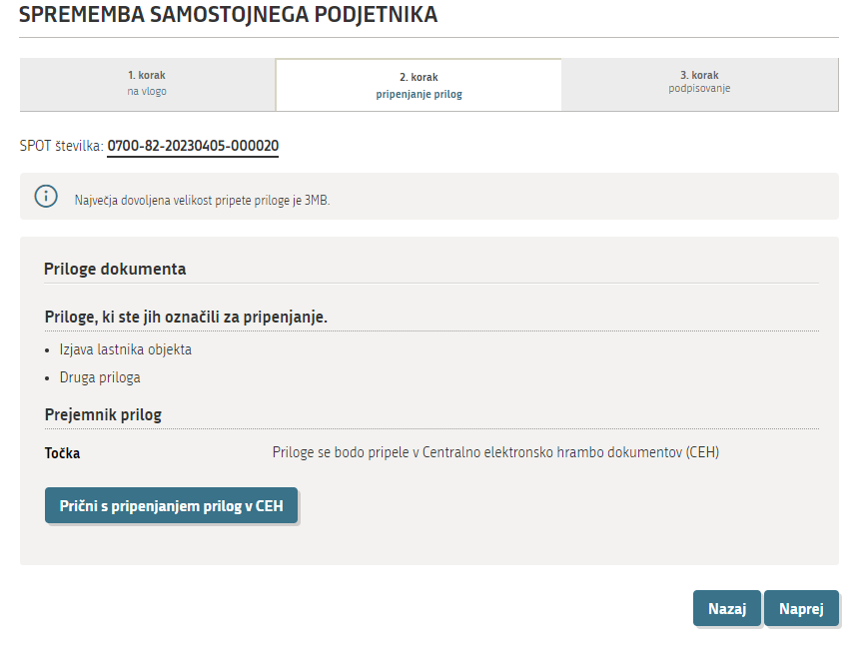
Figure 19: Attachment of documents

Glossary
Priloge dokumenta | Document attachments
Priloge, ki ste jih označili za pripenjanje | Documents you have marked for attachment
Prični s pripenjanjem prilog v CEH | Start attaching the documents to the central electronic document collection (CEH)

A list of the documents to be attached is displayed. Select the option ‘Prični s pripenjanjem prilog v CEH’ [Start attaching documents to the CEH].

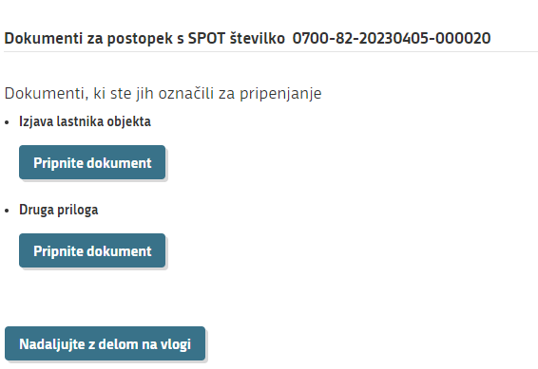
Figure 20: Central electronic document collection

Glossary
Dokumenti, ki ste jih označili za pripenjanje | Documents you have marked for attachment
Izjava lastnika objekta | Declaration by the owner of the building
Druga priloga | Other attachment
Pripnite dokument | Attach document
Nadaljujte z delom na vlogi | Continue with the application

The following fields are opened:
- entering the name of the document;
- language choice – this is always Slovenian;
- entering the date of the document;
- then select ‘Izberite datoteko’ [Select file], search for the document and attach it. Then select the option ‘Pošlji’ [Submit].

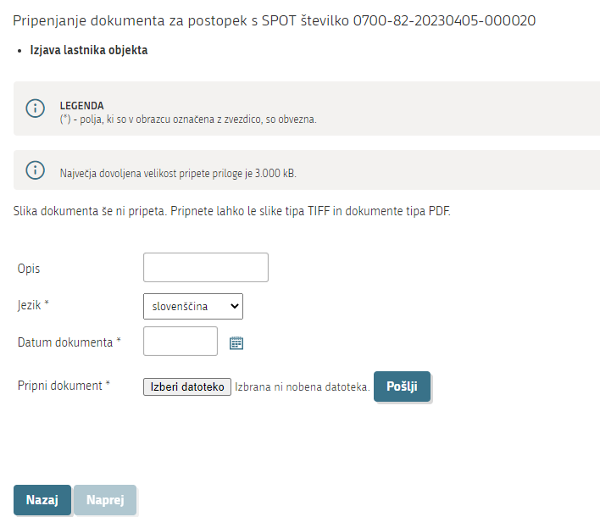
Figure 21: Attaching a document

Glossary
Polja, ki so označena z zvezdico, so obvezna | Fields marked with an asterisk must be completed
Največja dovoljena velikost pripete priloge je 3.000kB | The maximum permitted size of an attachment is 3 000 KB.
Pripnete lahko le dokumente tipa TIFF in PDF | You may only attach documents in TIFF and PDF format.
Opis – ime dokumenta | Description – document name
Jezik | Language
Datum dokumenta | Date of document
Pripni dokument | Attach document
Izberi datoteko | Select file
Pošlji | Submit
Nazaj | Back
Naprej | Next

Once the application has been saved in the CEH, you can check whether you have attached the corresponding document by selecting the option ‘Preverite, ali ste pripeli ustrezen dokument’ [Show image of attached document]. Then, by selecting the option ‘Elektronsko podpiši dokument’ [Sign document electronically], you sign the document, which completes the saving of the document in the CEH.
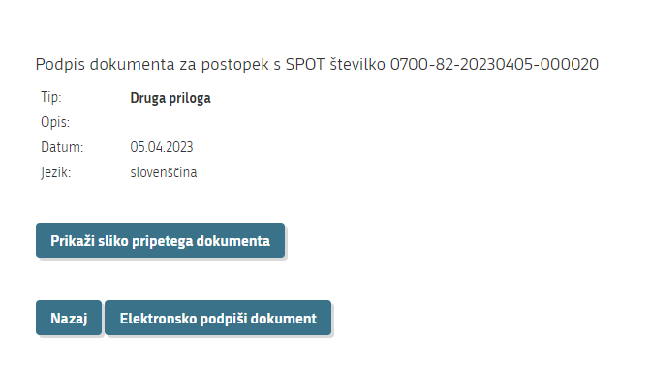
Figure 22: Signing of attached document

Glossary
Prikaži sliko pripetega dokumenta | Show image of attached document
Nazaj | Back
Elektronsko podpiši dokument | Sign the document electronically

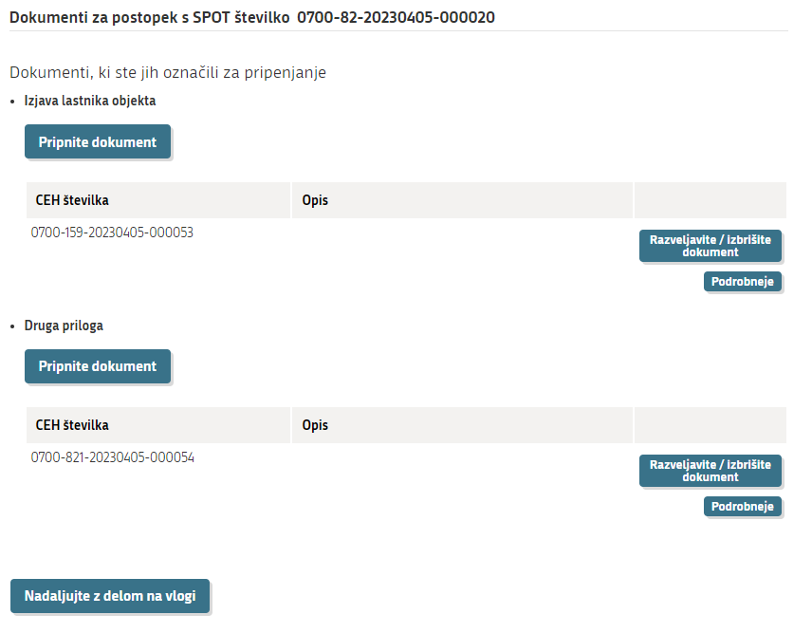
Figure 23: Review of attached documents

Glossary
Pripnite dokument | Attach document
Razveljavite/izbrišite dokument | Cancel/delete document
Podrobneje | More details
Nadaljujte z delom na vlogi | Continue with the application

The information about the attached document will be displayed on the screen. Repeat the attachment process by selecting ‘Prični s pripenjanem prilog v CEH’ [Start attaching attachments to CEH] for as many documents as you want to attach.

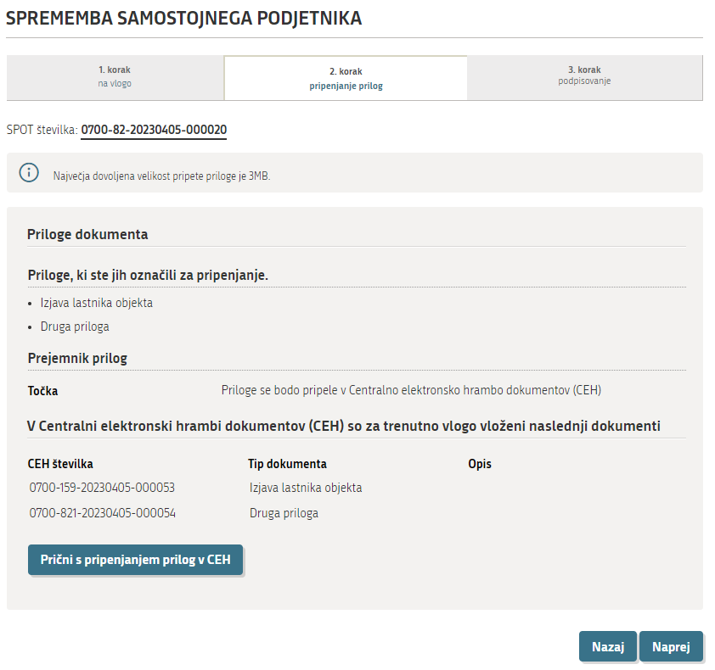
Figure 24: Attachments added and stored in the CEH

Step 3: signing.

Once the documents are attached, you can recheck the information in the application and the attachments. You can make any corrections by selecting the option ‘Nazaj’ [Back]. If no corrections are needed, select ‘Elektronsko podpiši dokument’ [Sign document electronically].

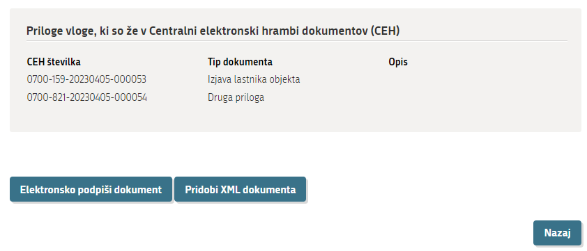
Figure 25: Electronic signing of document

Glossary
Priloge, ki so že v CEH | Attachments already in the CEH
CEH številka | CEH number
Tip dokumenta | Document type
Elektronsko podpiši dokument | Sign the document electronically

The SPOT system displays the notice below, reminding you that by signing, the application will be sent to the registering authority (AJPES). You may select ‘V redu’ [OK] or ‘Prekliči’ [Cancel].

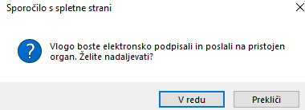
Figure 26: Signing the document

Glossary
Vlogo boste elektronsko podpisali in poslali na pristojen organ. Želite nadaljevati? | Sign the application electronically and send it to the competent authority. Do you want to proceed?
V redu | OK
Prekliči | Cancel

After selecting the option ‘V redu’ [OK], you will see a notification that the application has been successfully submitted, and you will also receive a notification to this effect by email.

You can use the SPOT portal to check the status of an application:

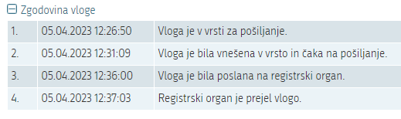
Figure 27: Status of application

Glossary
Zgodovina vloge | Application history
Vloga je v vrsti za pošiljanje | Application is in the queue for sending
Vloga je bila vnešena v vrsto in čaka na pošiljanje | Application has entered the queue and is waiting to be sent
Vloga je bila poslana na registrski organ | The application has been sent to the registration authority
Registrski organ je prejel vlogo | The registration authority has received the application

Once the application has been processed, you will receive the following communication (in Slovenian):
‘Hello,

The changes to the data in the Slovenian Business Register submitted with your request to enter a change of information on DD.MM.YYYY and kept under reference number 0700-82-20120731-000010 have been successfully registered in the Slovenian Business Register (PRS).

The decision regarding entry of the change of data in the PRS will be notified to you in the manner you selected at the time of your application.

This message was automatically sent by the SPOT system. If you have any substantive questions about your application, please contact the competent authority. The contact details of the institutions are published on the Help page of the SPOT portal.

Best regards,
The SPOT team’

Updating an application for registering a change of data in the PRS

If the AJPES officer finds during the procedure that the Application to register changes in the PRS is incomplete, the application must be completed on the SPOT portal. The Application to register changes is given the status of an incomplete application in the SPOT information system. At the same time, AJPES sends you a Request for supplementation by post or email.
Upon receipt of a Request for supplementation, you must complete your Application to register changes in the PRS within 8 days.

Further options of the SPOT portal

Modifying an Application to register changes in the PRS
You may amend your Application to register changes in the PRS at any time until the proposed date of registration of the change.
Select ‘Dopolnite vlogo’ [Supplement the application], modify the information on the Application to register changes in the PRS, re-sign the application and send it to the registering authority (AJPES). AJPES always processes the application most recently received concerning the procedure.

Withdrawing of a submitted Application to register changes in the PRS
You can withdraw your application up to the day before the proposed date you indicated on the PRS Application to register changes.

Select the option ‘Umaknite vlogo’ [Withdraw application]. A request for withdrawal is displayed on the screen and should be confirmed by clicking ‘Potrjujem umik’ [I confirm withdrawal]. After confirming the withdrawal of the Application to register changes in the PRS, please sign the request for withdrawal electronically and send it to the registering authority (AJPES).

