Instructions for completing the application for registration of an economic operator established in the Republic of Slovenia performing an activity in the field of medical devices

Registration of a manufacturer, authorised representative of a manufacturer, custom device manufacturer

Document history

Version | Change | Author | Change Description
1.0 | 14 June 2021 | Vane Savinek | Paper created
1.1 | 12 July 2021 | Denis Fajt | Paper edited
1.2 | 13 June 2022 | Ministry of Public Administration | Image changed
1.3 | 9 June 2023 | Carmen Klun | Updated

The following instructions are intended to assist in the completion of the electronic application on the SPOT portal, which is used to register economic operators dealing with medical devices in the Republic of Slovenia with the Public Agency of the Republic of Slovenia for Medicinal Products and Medical Devices (JAZMP). The document also serves as a clarification of which is which entity under the new Medical Devices Regulation (EU) 2017/745 (MDR), Regulation (EU) 2017/746 on in vitro diagnostic medical devices and the Medical Devices Act, (Official Gazette of the Republic of Slovenia [Uradni list RS], No 98/09), which is still in force regarding the registration procedure.

To facilitate the understanding of the provisions concerning the transition from the regulatory framework of the Directives transposed into Slovenian law by the Medical Devices Act (Official Gazette of the Republic of Slovenia, No 98/09; ZMedPri) to the Medical Devices Regulation (EU) 2017/745 (MDR) and Regulation (EU) 2017/746 on in vitro diagnostic medical devices (IVDR), this document highlights the differences between the basic concepts introduced by the MDR and IVDR and the definitions that applied to the field of medical devices until the application of the MDR and IVDR.

Definitions and terms

MDR - Medical Device Regulation - Regulation (EU) 2017/745 of the European Parliament and of the Council of 5 April 2017 on medical devices, amending Directive 2001/83/EC, Regulation (EC) No 178/2002 and Regulation (EC) No 1223/2009 and repealing Council Directives 90/385/EEC and 93/42/EEC.
The unofficial consolidated version can be found here: Slovene | English

IVDR - In Vitro Medical Device Regulation - Regulation (EU) 2017/746 of the European Parliament and of the Council of 5 April 2017 on in vitro diagnostic medical devices and repealing Directive 98/79/EC and Commission Decision 2010/227/EU (Regulation (EU) 2017/746 (IVDR))
The unofficial consolidated version can be found here: Slovene | English

ZMedPri - Medical Devices Act (Official Gazette of the Republic of Slovenia, No 98/09)

EUDAMED - is the European database established under Regulation (EU) 2017/745 on Medical Devices (MDR) and Regulation (EU) 2017/746 on In Vitro Diagnostic Devices (IVDR), developed by the European Commission. The purpose of the database is to provide transparency on devices on the EU market and strengthen market surveillance, identification of devices and easier traceability. It is an online portal for the exchange of information between economic operators, national competent authorities, notified bodies and the European Commission.

Official launch of EUDAMED - six months after publication in the Official Journal of the European Union that Eudamed is fully functional, it will become mandatory for the use and registration of economic operators.

JAZMP - Public Agency of the Republic of Slovenia for Medicinal Products and Medical Devices. JAZMP is the competent authority for medical devices in Slovenia.

Instructions:

All fields marked with an asterisk * in the application are mandatory. The applicant will not be allowed to proceed without inserting the appropriate data in such field.

Table of contents
- Instructions for completing the form on the SPOT portal 4
- Basic data 5
- Manufacturers 7
- Authorised representatives 9
- Manufacturers of custom-made devices 11
- Declaration 12

Table of figures
Figure 1: Logging in to the system 4
Figure 2: Business Entity Section 4

Instructions for completing the form on the SPOT portal for the registration of a manufacturer, manufacturer's authorised representative and manufacturer of a custom device

Logging in to the SPOT portal

Before filling in the form, please log in to the SPOT portal at https://spot.gov.si/

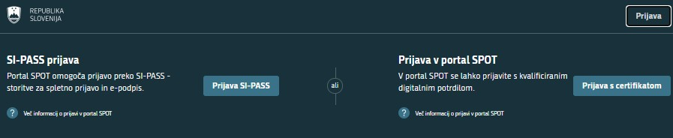
Figure 1: Logging in to the system
Log in to the system via SI-PASS. Registration instructions are available here.

Selection of business entity

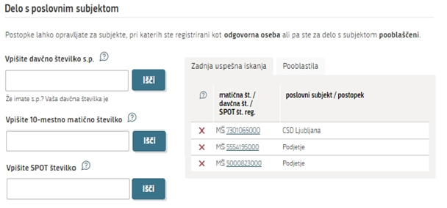
Figure 2: Business Entity Section

Basic data

Basic data:
The basic data about the company is transferred from the Business Register of Slovenia (AJPES). You only need to enter the general contact e-mail address of the company, to which the JAZMP will send you a certificate of registration of the economic operator in the activity registers.

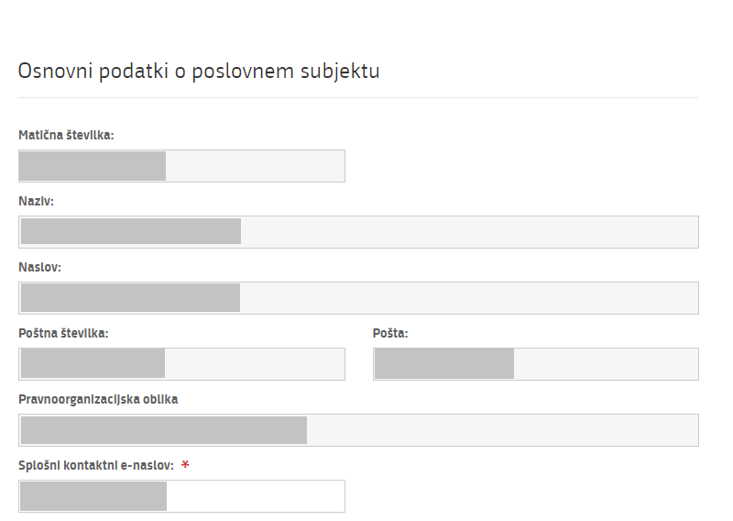

Activity code:
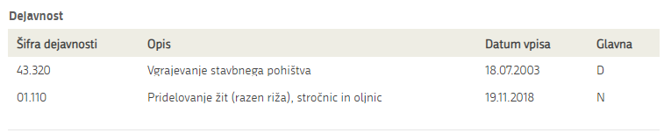
The activity codes of the company are transferred from the Business Register of Slovenia (AJPES). To carry out the activity of manufacturing medical devices, the company must have the registered activity code 32.500 - Manufacture of medical and dental instruments and supplies.

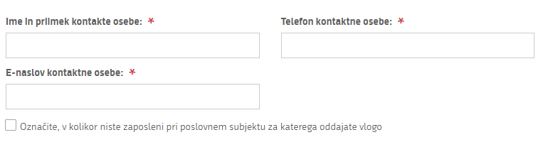
Contact details:
Enter contact details of person responsible for communication with the JAZMP.
Tick if you are not an employee of the economic operator for which you are submitting the application.

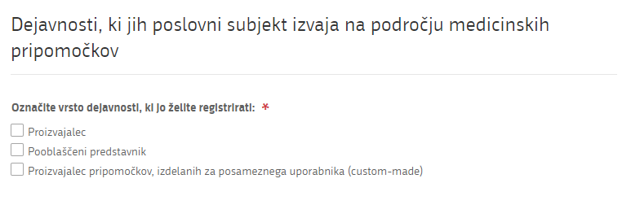
Activity:
Select the activity you wish to register and which the economic operator performs in the field of medical devices. You may select more than one activity.

Manufacturers

According to the definitions of the Regulations, a ‘manufacturer’ means a natural or legal person who manufactures or fully refurbishes a device or has a device designed, manufactured or fully refurbished, and markets that device under its name or trademark. These are the device manufacturers for whom the MDR and IVDR lay down the obligations set out in the requirements of Article 10. Following publication in the Official Journal of the European Union that EUDAMED is fully functional, all Slovenian manufacturers will be required to register (Article 31 of the MDR and Article 28 of the IVDR). Until that publication, registration in EUDAMED is on a voluntary basis, while registration with the JAZMP via the SPOT portal is mandatory in the period until EUDAMED is fully operational.

Device manufacturers and manufacturers of custom-made devices have different obligations under the MDR. Manufacturers will be registered in EUDAMED and SPOT, while manufacturers of custom-made devices will only be registered through the SPOT portal and will be kept in the national register of economic operators. If an economic operator is both a manufacturer and a manufacturer of custom-made devices, it is obliged to comply with the obligations relating to both activities, including the registration of both activities.

Business operators that are manufacturers, i.e. that manufacture and market devices as defined in the two Regulations, must register through the SPOT portal before placing the first device on the market.

The manufacturer must provide the following data:

Data on the person responsible for regulatory compliance, under Article 15 of the MDR, which states that manufacturers must have at least one person responsible for regulatory compliance who possesses the requisite expertise in the field of medical devices.

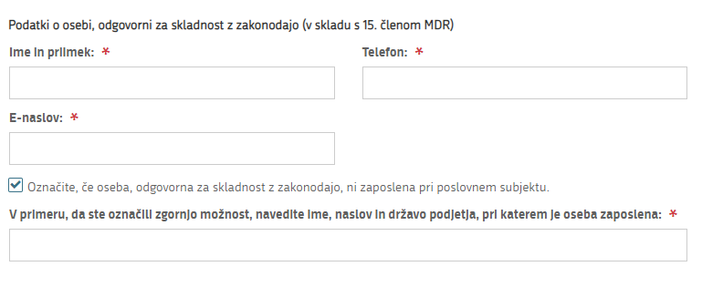

The person responsible for regulatory compliance does not always have to be an employee of the manufacturer.
Tick this box if not.
You will see a field below in which you write the name and address and the country of the company where the person responsible for regulatory compliance is employed, if he/she works for another company.

Please provide the relevant evidence of eligibility for the designation of the person responsible for the manufacturer's regulatory compliance as referred to in Article 15 of the MDR and in the IVDR at the time of submission of the application to the JAZMP.

Upon successful completion of the registration of the economic operator, the manufacturer is legally obliged to notify the device to the Register of Medical Devices at the JAZMP. The forms are available on the JAZMP website under the tab Registration of medical devices or here.

Risk class data:
Select which is the highest risk class of the device you are placing on the market in terms of whether the medical device complies with the Directives or with the MDR or IVDR Regulations.

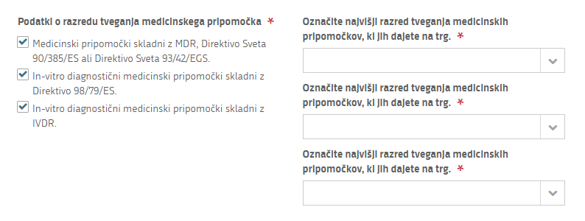

Authorised representatives

According to the definitions of the Regulations, an "authorised representative" means any natural or legal person established within the European Union who has received and accepted a written mandate from a manufacturer located outside the European Union to act on the manufacturer's behalf in relation to specified tasks with regard to the latter's obligations under the MDR and IVDR. It refers to economic operators that enter into a written agreement with third country manufacturers to carry out the tasks set out in the mandate on their behalf. The authorised representative is legally liable for defective devices on the same basis as the manufacturer and jointly and severally with the manufacturer.

Devices of a manufacturer not established in a Member State cannot be placed on the Union market unless the third-country manufacturer has appointed an authorised representative for them. The authorised representative therefore has an important regulatory status which cannot be equated or confused with generic terms such as "official authorised agent", "authorised agent", "official supplier", "exclusive authorised agent", "authorised dealer", "partner", "authorised supplier", "official distribution partner", "exclusive international distributor". Authorised representatives have the obligation to register in EUDAMED once it is fully functional, before the first device for which they are authorised is placed on the EU market. The registration of an authorised representative in EUDAMED is also a condition for the registration of a third country manufacturer in EUDAMED, as the authorised representative registers his/her manufacturer in EUDAMED.

The authorized representative must provide the following data:

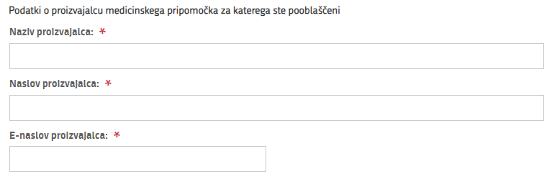
Data on the manufacturer of the medical device for which he/she is authorised:
Please provide the full name of the manufacturer established outside the EU for which you are authorised, its full address, including country, and an e-mail address for communication.

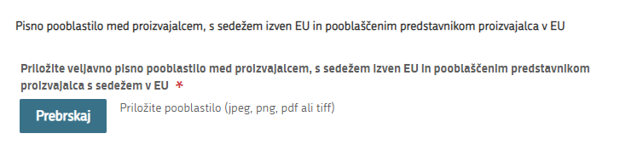
Written authorisation:
Click on this button to upload an image/scan/file of the authorisation or appointment or the contract between the authorised representative and the third country manufacturer.

Data on the person responsible for regulatory compliance under Article 15 of the MDR, which states that authorised representatives must have at least one person responsible for regulatory compliance who possesses the requisite expertise in the field of medical devices.
The person responsible for regulatory compliance does not always have to be an employee of the manufacturer. Tick this box if not.
You will see a field below in which you write the name and address and the country of the company where the person responsible for regulatory compliance is employed, if he/she works for another company.

Please provide the relevant evidence of compliance with the conditions for the designation of the person responsible for regulatory compliance at the manufacturer's authorised representative, as referred to in Article 15 of the MDR and in the IVDR, at the time of submission of the application to the JAZMP.

Upon successful completion of the registration of the economic operator, the legal obligation of the authorised representative of the manufacturer is to notify the device to the Register of Medical Devices at the JAZMP. The forms are available on the JAZMP website under the tab Registration of medical devices or here.

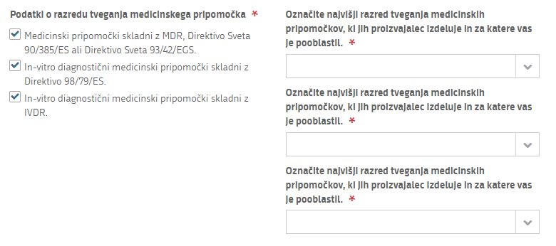
Risk class data:
Select the highest risk class of the devices manufactured by the manufacturer and for which you have been authorised, and select whether the medical device complies with the Directives or the MDR or IVDR Regulations.

Manufacturers of custom-made devices

(custom-made)

For custom-made devices, it is important to note that the MDR narrows the set of devices that meet this regulatory status. These include, for example, custom-made dental appliances and hearing aids, implantable devices to compensate for anatomical defects, custom-made dentures, orthoses, etc. Custom-made devices are defined in point three of Article 2 of the MDR, as follows:

A "custom-made device’" means any device specifically made in accordance with a written prescription of any person authorised by national law by virtue of that person's professional qualifications which gives, under that person's responsibility, specific design characteristics, and is intended for the sole use of a particular patient exclusively to meet their individual conditions and needs.

However, mass-produced devices which need to be adapted to meet the specific requirements of any professional user and devices which are mass-produced by means of industrial manufacturing processes in accordance with the written prescriptions of any authorised person shall not be considered to be custom-made devices.

Only economic operators that manufacture (produce) products that meet the above definition are manufacturers of custom-made devices. Custom-made devices are not the same as devices that are adapted for the final user. A more detailed Question and Answer document summarising the obligations of manufacturers of such devices, with examples of such devices and the demarcation criteria to distinguish them from user-adapted (adaptive) devices has been created by the European Commission and is available here.

We would like to stress in particular that the vast majority of opticians, according to the definition of a custom-made device and in the light of the above European harmonisation rules/guidelines, are not manufacturers, but are distributors or importers of devices by making them available, even if they slightly customise or prepare the devices for the final user.

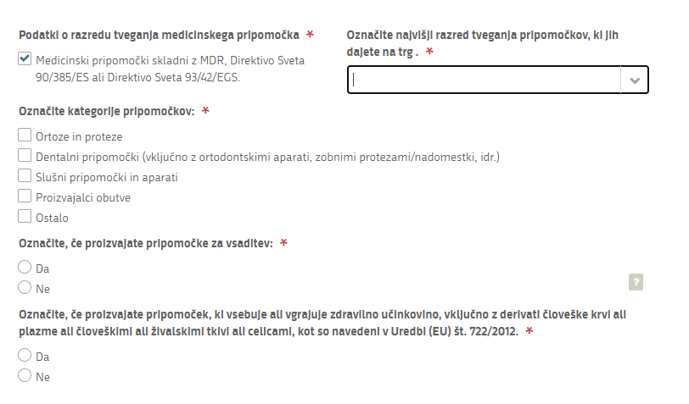
The manufacturer of custom-made devices must provide the following data:
Tick if you manufacture custom-made devices which are implantable.
The MDR defines an "implantable device" as any
device, including those which are partially or fully absorbable, which is intended:
– to be totally introduced into the human body, or
– to replace an epithelial surface or the surface of the eye, by clinical intervention and which is intended to remain in place after the procedure.
Any device intended to be partially introduced into the human body by clinical intervention and
intended to remain in place after the procedure for at least 30 days shall also be deemed to be an
implantable device.
Select the highest risk class of custom-made devices you place on the market.
Select one or more categories that include the devices you manufacture.

Regulation (EU) 722/2012 lays down specific requirements relating to the placing on the market and/or putting into service of medical devices, including active implantable medical devices, manufactured using inactive animal tissues or inactive products derived from animal tissue.

Data on the person responsible for regulatory compliance under Article 15 of the MDR:
Please provide the relevant evidence of eligibility for the designation of the person responsible for the manufacturer's regulatory compliance as referred to in Article 15 of the MDR and IVDR at the time of submission of the application to the JAZMP.

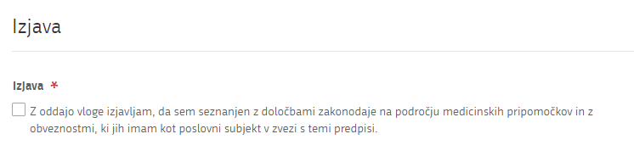
- Declaration
By registering or submitting an application, the economic operator declares that it performs a regulated activity or activities subject to the relevant legislation and that it is aware of its obligations as an economic operator in relation to these regulations.

