Instructions for completing an application for a duplicate licence for the sale of tobacco, tobacco products and related products

Paper history

|  |  |  |  |
| --- | --- | --- | --- |
| Version | Change | Author | Description of changes |
| 1.0 | 20 December 2018 | Ministry of Health (MZ) | Paper created |
| 1.1 | 17 August 2021 | Ministry of Public Administration (MJU) | Paper edited |

TABLE OF CONTENTS

1. INTRODUCTION 4

2. Instructions for completing the application for a duplicate licence to sell tobacco, tobacco products and related products 5

1.1 Logging in to the SPOT portal 5

1.2 Selection of company 5

1.3 Selection of procedure 6

1.4 New application 7

a. Supplementing the application 13

b. Withdrawal of application 15

1.5 Tracking application status 17

TABLE OF FIGURES

Figure 1: Login to the SPOT portal 5

Figure 2: Business entity section 6

Figure 3: Selection of procedure 6

Figure 4: New application or continuation 7

Figure 5: Applicant 8

Figure 6: Duplicate's details 8

Figure 7: Read-out / preview of the application 9

Figure 8: Signing in SiPASS 10

Figure 9: Full application download and submission 11

Figure 10: Conclusion 11

Figure 11: Company desktop – List of pending applications 12

Figure 12: Company desktop – Application details 12

Figure 13: "Supplementing the application" form 13

Figure 14: Company desktop – Application details 14

Figure 15: Withdrawal of application 15

Figure 16: Company desktop – List of pending applications and Partial list of submitted applications 16

1. INTRODUCTION

In September 2018, a new procedure for submitting an electronic application for licences for the sale of tobacco, tobacco products and related products was launched on the SPOT Slovenian Business Point portal. In December 2018, an application for a duplicate of this licence was added.

**Legal framework:**

* [Restriction on the Use of Tobacco Products and Related Products Act (Official Gazette of the Republic of Slovenia [*Uradni list RS*], Nos 9/17 and 29/17), hereinafter: ZOUTPI](http://www.pisrs.si/Pis.web/pregledPredpisa?id=ZAKO6717)  and
* [Rules on licences for the sale of tobacco, tobacco products and related products](http://www.pisrs.si/Pis.web/pregledPredpisa?id=PRAV13444) (Official Gazette of the Republic of Slovenia, [No 53/18](http://www.uradni-list.si/1/objava.jsp?sop=2018-01-2712)).

In the event of destruction, loss or damage of a licence for the sale of tobacco, tobacco products and related products, it will be possible to apply for a duplicate licence electronically. The service is free of charge. The submission of an application for a duplicate will be considered as confirmation that the issue of the duplicate is in progress.

1. Instructions for completing the application for a duplicate licence to sell tobacco, tobacco products and related products

## Logging in to the SPOT portal

Before starting to complete the application, you must first log in to the SPOT portal at the following address – <https://spot.gov.si/>.

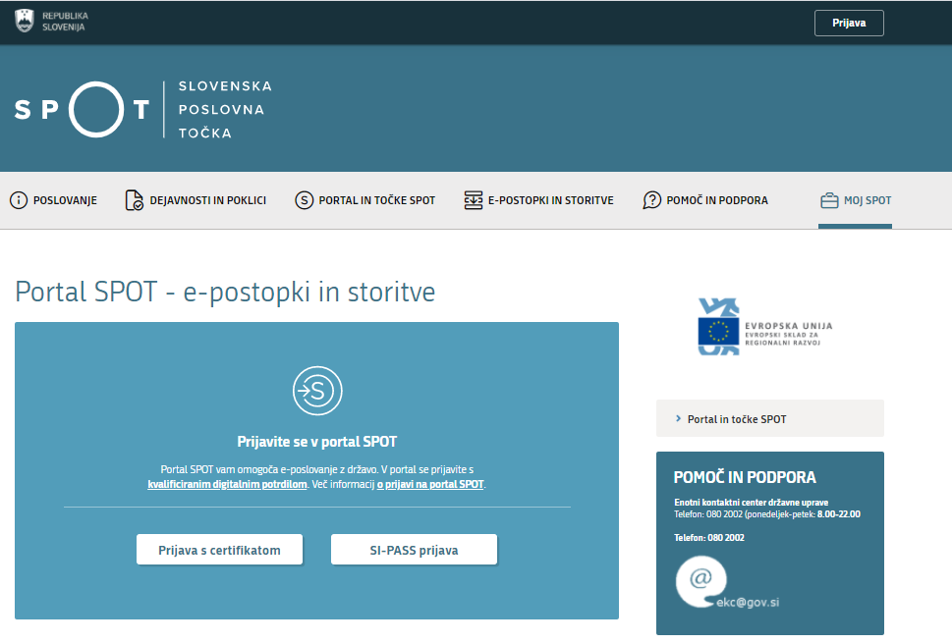

Figure 1: Login to the SPOT portal

You are advised to log in via the SI-PASS login, as this will soon become mandatory. Registration instructions are available [here](https://www.si-trust.gov.si/sl/si-pass/).

## Selection of company

After successfully logging in to the e-VEM information system, you need to select the business entity that is the subject of the application. If the entity is a sole trader, the tax ID number of the entity is entered in the box "Vpišite davčno številko s.p." [Enter the tax ID number of the sole trader]. For other business entities, the registration number of the business entity is entered in the box "Vpišite 10-mestno matično številko" [Enter 10-digit registration number]. The taxable person can also be selected by clicking on the tax ID number in the "Zadnja uspešna iskanja" [Last successful searches] or "Pooblastila" [Powers of attorney] tab. The portal user can only select the business entity for which he/she is registered as a responsible person in the PRS (Slovenian Business Register). If a user who is not the responsible person will be submitting applications, he/she must have power of attorney. Instructions on the procedure for conferring power of attorney are available on this [webpage](https://spot.gov.si/sl/e-postopki-in-storitve/pooblascanje-oseb-za-opravljanje-postopkov-prek-portala-spot/).

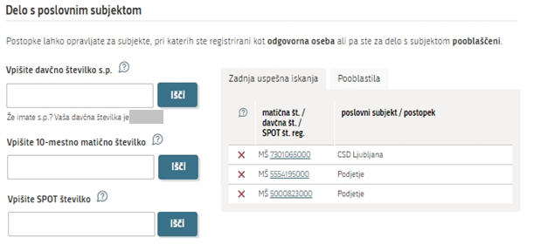

Figure 2: Business entity section

## Selection of procedure

From the procedures for the selected company in the MZ category, you select the procedure "Pridobitev dvojnika dovoljenja za prodajo tobaka, tobačnih in povezanih izdelkov (GD)" [Application for a duplicate licence for the sale of tobacco, tobacco and related products].

Figure containing words text

Description is created automatically

Figure 3: Selection of procedure

## New application

If you have already started the procedure for submitting an application and have not yet submitted it, the portal will offer you the option to continue with your existing application. Click on "Začni novo" [Start New] to start a new application.

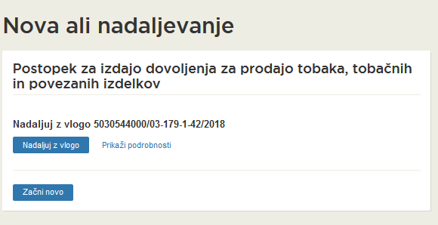

Figure 4: New application or continuation

1. **Step: Completing the application**

The first part of step 1 shows first your personal data extracted from the SiPASS registration system, and your company’s basic details extracted from the Slovenian Business Register.

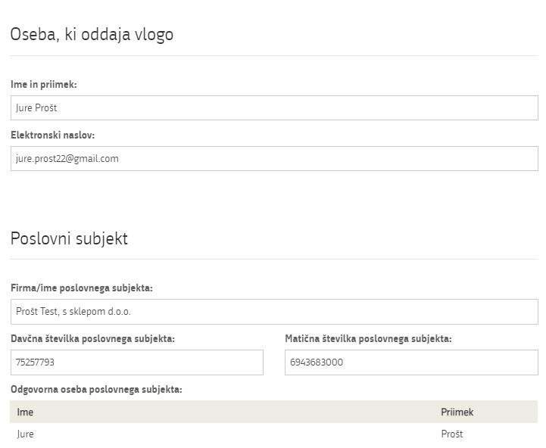

Figure 5: Applicant

Registration of data on the licence.

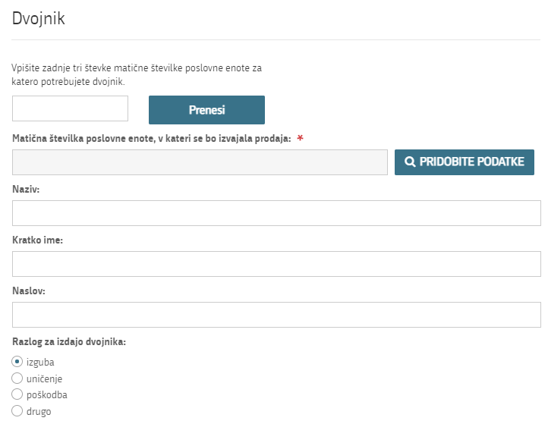

Figure 6: Duplicate's details

You can apply for one duplicate. Enter the last three digits of the registration number and click the "Prenesi" [Transfer] button. The information will be transferred in the mandatory field "Matična številka poslovne enote" [Business entity registration number], then click on the "PRIDOBITE PODATKE" [RETRIEVE DATA] button. The rest of the business unit data is extracted and pre-populated from the Slovenian Business Register.

Select the reason for issuing a duplicate. If you select "drugo" [Other], enter your reason in the entry field.

Proceed to signing.

1. **Step: Signing the application**

In the second step you will see a full read-out of the application.

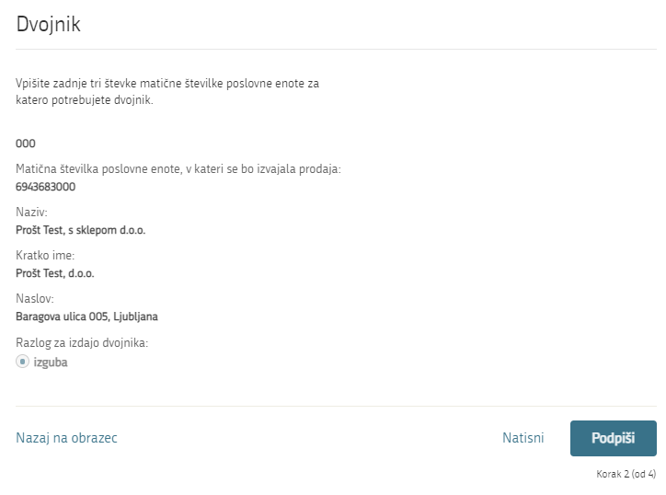

Figure 7: Read-out / preview of the application

By clicking on the "Podpiši" [Sign] button, the portal redirects the user to "SiPASS", which allows cloud-based signing. By entering the SiPASS password, you sign the application.

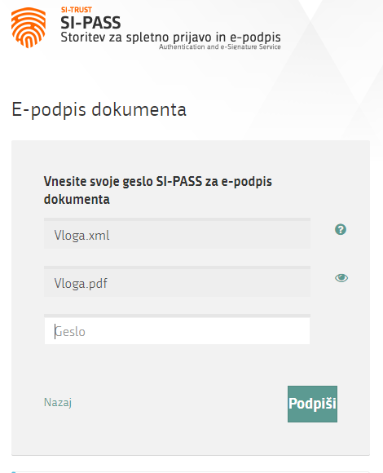

Figure 8: Signing in SiPASS

If you notice that you have made some mistake, by clicking on the "Nazaj na obrazec" [Back to form] button you can return to the form and correct the mistake. You can also print the application before signing it.

The procedure proceeds to submission of the application.

1. **Step: Submission of application**

This is where the system offers you the possibility to save the signed application and its annexes in your own records. Once the application has been submitted, the user no longer has access to it. The "Pošlji" [Submit] button is activated in the event that you download your application or confirm the box "Ne želim prenesti vloge" [I do not want to download my application]. To proceed, click on the "Pošlji" [Submit] button.

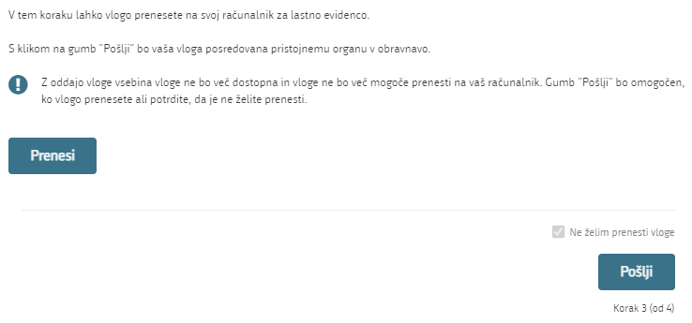

Figure 9: Full application download and submission

1. **Step: Conclusion**

The portal submits the application to the competent authority for processing. The user is presented with the details of the submission and a link to the desktop. The user receives in his/her e-mail a notification that the application has been submitted.

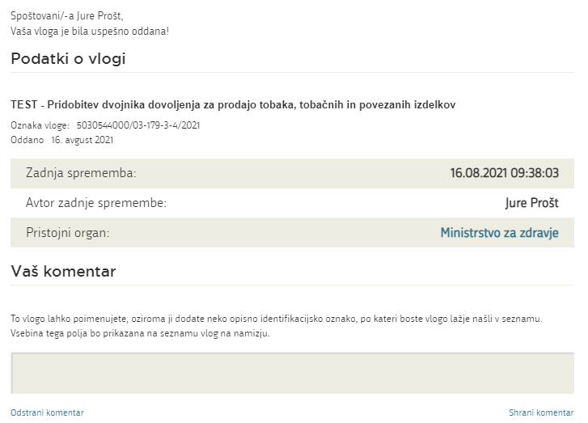

Figure 10: Conclusion

* 1. Supplementing the application

If the application is not complete, the competent authority will ask you to supplement it. You can supplement your application electronically by selecting the application you wish to supplement from the list of pending applications and selecting "Dopolni" [Supplement] in the "Application Section".

Figure containing words text

Description is created automatically

Figure 11: Company desktop – List of pending applications

Figure containing words text

Description is created automatically

Figure 12: Company desktop – Application details

The portal offers a specific form where the applicant has the option of describing missing information or adding missing attachments.

By clicking on the "Naprej" [Next] button, the portal displays a preview of the application and offers signing and submission of the application.

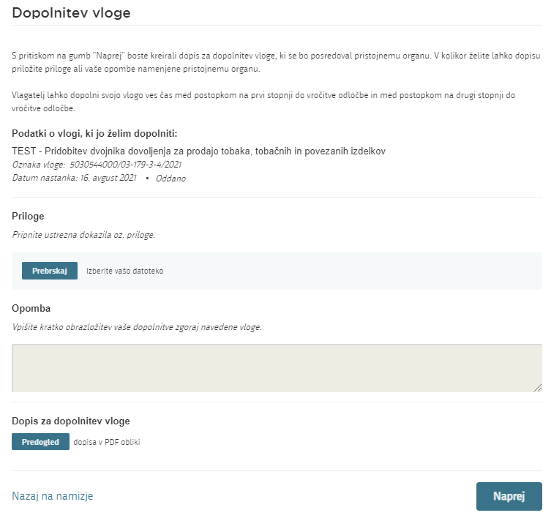

Figure 13: "Supplementing the application" form

* 1. Withdrawal of application

Before the application is decided on, the portal allows the applicant to withdraw the application. On the "Podatki o vlogi" [Application details] page, selecting the "Prekliči" [Cancel] button will start the withdrawal procedure.

Figure containing words text

Description is created automatically

Figure 14: Company desktop – Application details

The portal offers a full read-out of the application for withdrawal of the application, with all the necessary information.

By clicking on the "Naprej" [Next] button, the portal displays a preview of the application and offers signing and submission of the application.

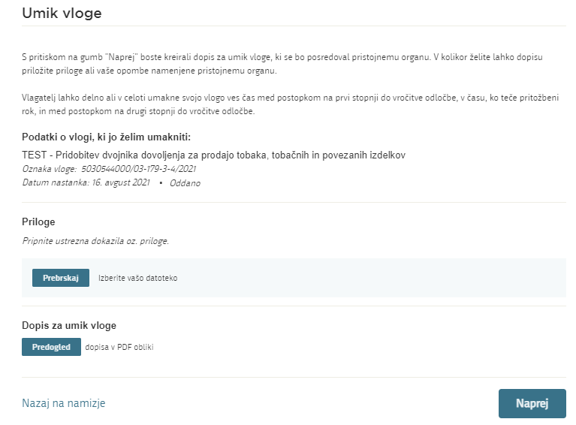

Figure 15: Withdrawal of application

## 

## Tracking application status

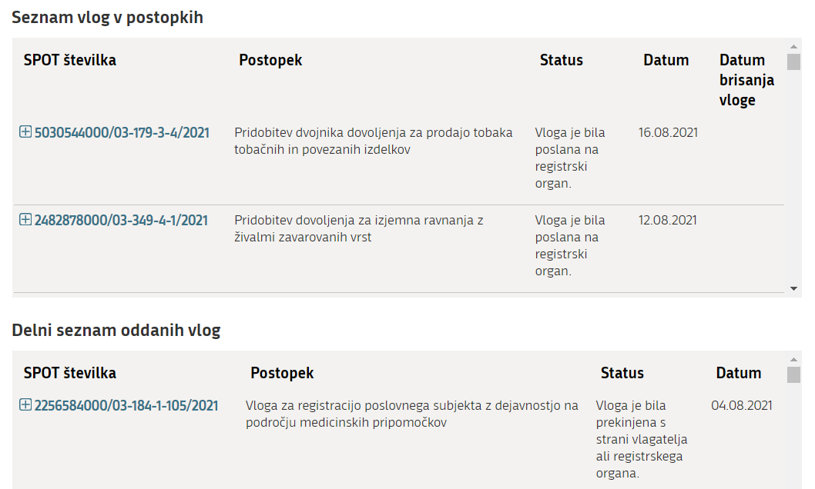

Figure 16: Company desktop – List of pending applications and Partial list of submitted applications

Details of applications not submitted, submitted or under consideration can be found in "Seznam vlog v postopkih" [the list of pending applications]. When an application is decided on, it is moved to in "Delni seznam oddanih vlog" [the partial list of submitted applications].