**Instructions for completing the application for a licence to sell tobacco, tobacco products and related products**

Paper history

|  |  |  |  |
| --- | --- | --- | --- |
| Version | Change | Author | Description of changes |
| 1.0 | 2 September 2018 | Ministry of Health (MZ) | Paper created |
| 1.1 | 17 August 2021 | Ministry of Public Administration (MJU) | Paper edited |

Table of contents

1. Introduction 4

2. Instructions for completing the application for a duplicate licence to sell tobacco, tobacco products and related products 7

2.1 Logging in to the SPOT portal 7

2.2 Selection of company 7

2.3 Selection of procedure 8

a. Selection of procedure 8

b. New application 8

a. Supplementing the application 21

b. Withdrawal of application 23

c. Tracking application status 24

Table of figures

Figure 1: Logging in to the SPOT portal 7

Figure 2: Business entity section 8

Figure 3: Selection of procedure 8

Figure 4: Applicant's details 9

Figure 5: Selecting the type of licence and registering the sales business units 10

Figure 6: Registration of a list of business units 11

Figure 7: List of business units – Help and example 12

Figure 8: Read-out / preview of the application 13

Figure 9: Electronic signature of the application 14

Figure 10: Read-out of payment details (individual unit registration) 15

Figure 11: Read-out of payment details (customising the list) 15

Figure 12: Payment method 16

Figure 13UJP – Amount and selection of payment method 17

Figure 14: Public Payments Administration of the Republic of Slovenia – account 17

Figure 15: Full application download and submission 19

Figure 16: Conclusion 20

Figure 17: Company desktop – List of pending applications 21

Figure 18: Company desktop – Application details 21

Figure 19: "Supplementing the application" form 22

Figure 20: Company desktop – Application details 23

Figure 21: Withdrawal of application 23

Figure 22: Company desktop – List of pending applications and Partial list of submitted applications 24

1. Introduction

In September 2018, a new procedure for submitting an electronic application for licences for the sale of tobacco, tobacco products and related products was launched on the SPOT Slovenian Business Point portal.

**Legal framework:**

* [Restriction on the Use of Tobacco Products and Related Products Act (Official Gazette of the Republic of Slovenia [*Uradni list RS*], Nos 9/17 and 29/17, hereinafter: ZOUTPI)](http://www.pisrs.si/Pis.web/pregledPredpisa?id=ZAKO6717) and
* [Rules on licences for the sale of tobacco, tobacco products and related products](http://www.pisrs.si/Pis.web/pregledPredpisa?id=PRAV13444) (Official Gazette of the Republic of Slovenia, [No 53/18](http://www.uradni-list.si/1/objava.jsp?sop=2018-01-2712)).

In accordance with the ZOUTPI, tobacco, tobacco products and related products may be sold by a person who has a licence to conduct sales in the business premises indicated in the authorisation.

The licence is issued for individual business premises where invoices for the supply of tobacco, tobacco products and related products are issued permanently, occasionally or temporarily, and which are associated with a sole trader or a legal entity engaged in the sale of such products on the premises.

The specific products for the sale of which a licence is required are defined in Article 3 of the ZOUTPI, namely:

* Tobacco shall mean leaves and other natural processed or unprocessed parts of tobacco plants, including expanded and reconstituted tobacco.
  + Pipe tobacco shall mean tobacco that can be consumed via a combustion process and is exclusively intended for use in a pipe.
  + Roll-your-own tobacco shall mean cut rag tobacco, which is further defined in paragraph three of Article 84 of the Excise Duty Act.
* Tobacco products shall mean products that can be consumed and that consist, even partly, of tobacco, whether genetically modified or not.
  + Nasal tobacco shall mean a smokeless tobacco product that can be inhaled through the nose.
  + Waterpipe tobacco shall mean a tobacco product that can be consumed via a waterpipe. For the purpose of the ZOUTPI, waterpipe tobacco shall be deemed to be a tobacco product for smoking. If a product can be used both via waterpipes and as roll-your-own tobacco, it shall be deemed to be roll-your-own tobacco.
  + Chewing tobacco shall mean a smokeless tobacco product intended exclusively for the purpose of chewing. Smokeless tobacco product shall mean a tobacco product that does not involve a combustion process, including chewing tobacco, nasal tobacco and tobacco for oral use.
* Related products shall mean electronic cigarettes and nicotine-free electronic cigarettes, herbal products for smoking and novel tobacco products.
  + Electronic cigarette shall mean a product that can be used for the consumption of nicotine-containing vapour via a mouth piece, or any component of this product, including a cartridge, a tank and the device without cartridge or tank Electronic cigarettes can be disposable or refillable with a refill container and a tank, or rechargeable with single use cartridges. Refill container shall mean a receptacle that contains a nicotine-containing liquid, which can be used to refill an electronic cigarette.
  + Herbal product for smoking shall mean a product based on plants, herbs or fruits which contains no tobacco and that can be consumed via a combustion process.
  + Novel tobacco product shall mean a tobacco product which:
    - does not fall into any of the following categories: cigarettes, roll-your-own tobacco, pipe tobacco, waterpipe tobacco, cigars, cigarillos, chewing tobacco, nasal tobacco or tobacco for oral use; and
    - has been placed on the market after 19 May 2014.

The applicant may file the application for several business units at the same time, indicating the registration number and address of each business unit. When submitting an application, the applicant selects the type of products for the sale of which he/she wishes to obtain a licence (tobacco, tobacco products, related products or various combinations of those products).

The licence is valid for five years from the date of issue, with a possibility of extension, for five years each time.

The competent authority for issuing the licence is the Ministry of Health.

The licence is not transferable and shall be prominently displayed in the business premises.

The licence is subject to an administrative fee, which, in accordance with the Administrative Fees Act (Official Gazette of the Republic of Slovenia, Nos 106/10 – official consolidated text, 14/15 – ZUUJFO, 84/15 – ZZelP-J, 32/16 and 30/18 – ZKZaš), amounts to EUR 18.10 per business unit.

Steps of the procedure and timeframe for completion: - The applicant submits the application and pays the administrative fee, both electronically.- The competent authority reviews the application and invites the applicant to complete it (5 days). - The applicant completes the application (8 days). - The competent authority issues the licence.

Legal protection: Administrative dispute against a decision rejecting the application for a permit.

**Useful information:**

The condition for the extension of the licence is that at the moment of submission of the application no ban on sale of tobacco, tobacco and related products has been imposed on the holder of the licence for the business unit for which the application for extension has been submitted.

The condition for reissuing the licence is that at the moment of submission of the application the business unit for which the application for reissuing the licence has been submitted is not subject to a prohibition on the reissuance of the licence.

In the event of infringement, established by a final decision, of the provisions of Article 29 or 30 of the ZOUTPI (Advertising and Ban on sale), the offender's sales licence will be withdrawn for a limited period and, in the event of repeated infringements, permanently.

1. Instructions for completing the application for a duplicate licence to sell tobacco, tobacco products and related products
   1. Logging in to the SPOT portal

Before starting to complete the application, you must first log in to the SPOT portal at the following address – <https://spot.gov.si/>.

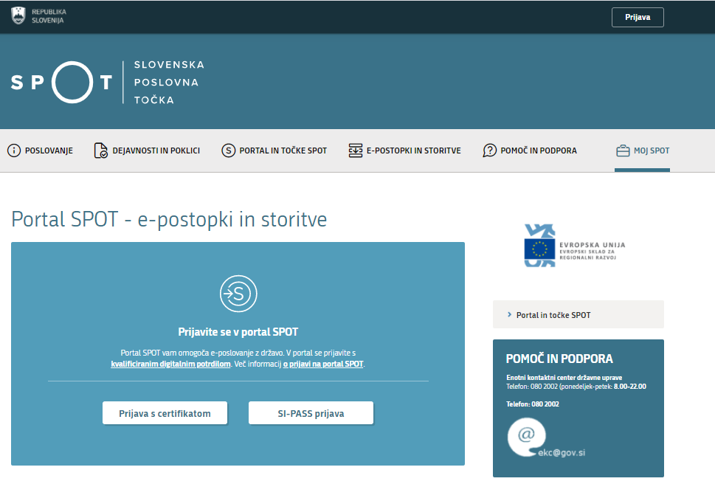

Figure 1: Logging in to the SPOT portal

You are advised to log in via the SI-PASS login, as this will soon become mandatory. Registration instructions are available [here](https://www.si-trust.gov.si/sl/si-pass/).

* 1. Selection of company

After successful login to the SPOT portal, the applicant must select the business entity that is the subject of the application. If the entity is a sole trader, the tax ID number of the entity is entered in the box "Vpišite davčno številko s.p." [Enter the tax ID number of the sole trader]. For other business entities, the registration number of the business entity is entered in the box "Vpišite 10-mestno matično številko" [Enter 10-digit registration number]. The taxable person can also be selected by clicking on the tax ID number in the "Zadnja uspešna iskanja" [Last successful searches] or "Pooblastila" [Powers of attorney] tab. The portal user can only select the business entity for which he/she is registered as a responsible person in the PRS (Slovenian Business Register). If a user who is not the responsible person will be submitting applications, he/she must have power of attorney. Instructions on the procedure of conferring power of attorney are available on this [webpage](https://spot.gov.si/sl/e-postopki-in-storitve/pooblascanje-oseb-za-opravljanje-postopkov-prek-portala-spot/).

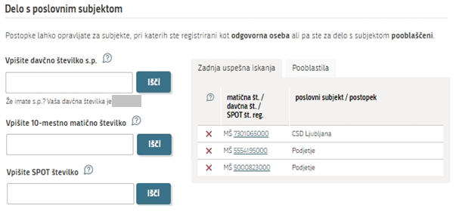

Figure 2: Business entity section

* 1. Selection of procedure

From the procedures for the selected company in the MZ category, you select the procedure "Pridobitev dovoljenja za prodajo tobaka, tobačnih in povezanih izdelkov" [Application for a duplicate licence for the sale of tobacco, tobacco and related products].

Figure containing words text

Description is created automatically

Figure 3: Selection of procedure

* 1. Selection of procedure

From the procedures for the selected company in the MZ category, you select the procedure " Vloga za izdajo dovoljenja za prodajo tobaka, tobačnih in povezanih izdelkov " [Application for a licence for the sale of tobacco, tobacco and related products].

* 1. New application

If you have already started the procedure for submitting an application and have not yet submitted it, the portal will offer you the option to continue with your existing application. Click on "Začni novo" [Start New] to start a new application.

1. **Step: Completing the application**

The first part of step 1 shows first your personal data extracted from the SiPASS registration system, and your company’s basic details extracted from the Slovenian Business Register.

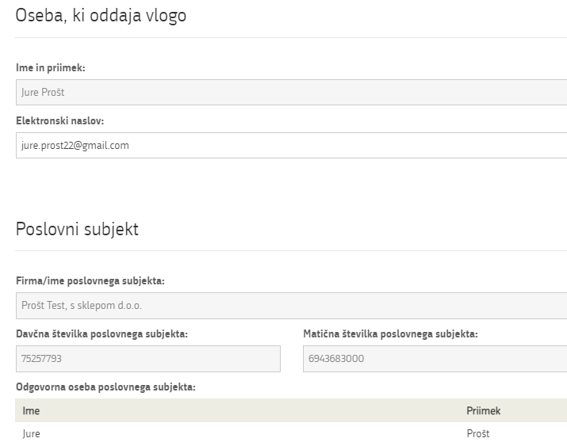

Figure 4: Applicant's details

Registration of business units

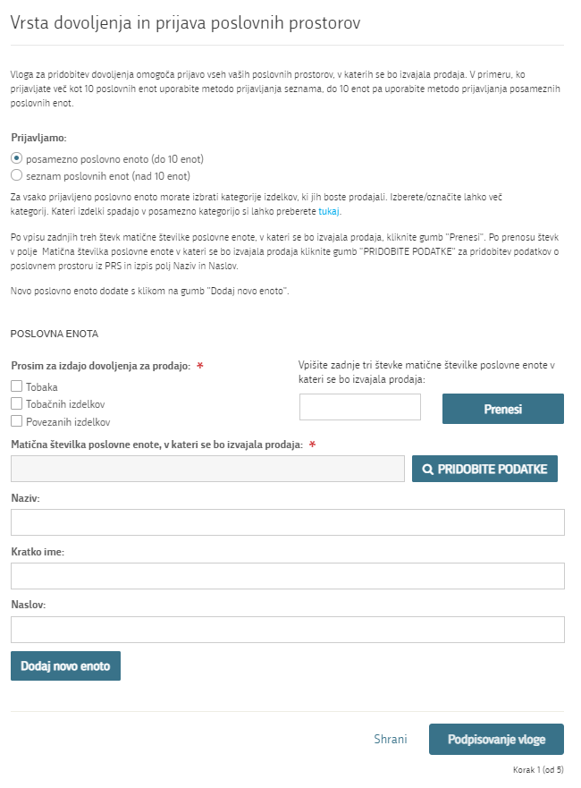

Figure 5: Selecting the type of licence and registering the sales business units

If you are declaring a single location which is also the registered office of the business, please copy the registration number from the Business Entity section.

If you want to register several business units, click on the "Dodaj novo enoto" [Add new unit] button. The portal will offer you an additional section to register an additional unit.

If you wish to register more than 10 business units, we recommend registering a list of business units.

Once all the business units have been entered, please sign the application electronically.

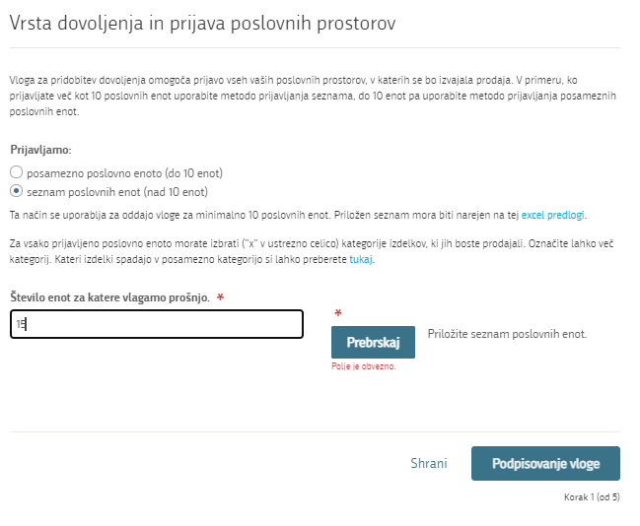

Figure 6: Registration of a list of business units

After entering the number of units for which you are applying for the licence, attach the list in the pre-prepared template. The document template is available [here](http://evem.gov.si/info/data/user_upload/Obrazec_priloga/MZ/Seznam_poslovnih_enot_01.xlsx).

The template contains some conditions and controls to facilitate compliance. Further help can be found on the "Pomoč in primer vnosa" [Help and example] tab.

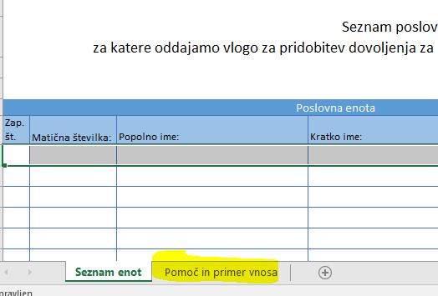

Figure 7: List of business units – Help and example

Once you have submitted the list, you sign the application electronically.

1. **Step: Signing the application**

In the second step you will see a full read-out of the application.

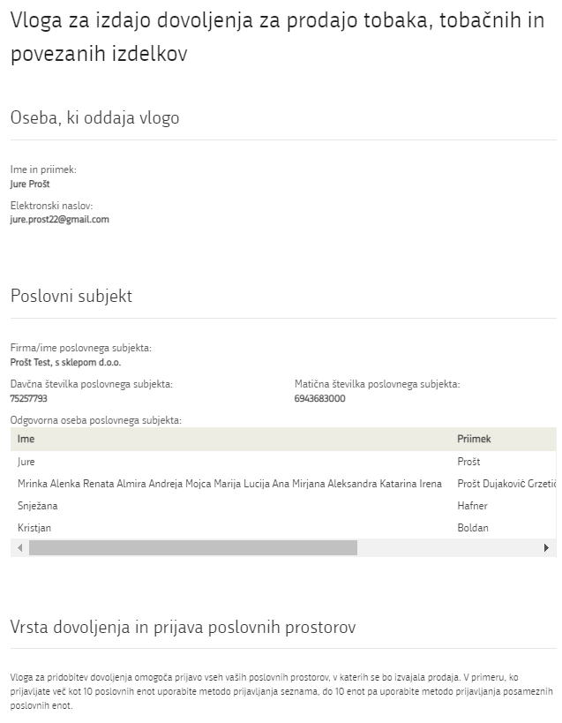

Figure 8: Read-out / preview of the application

By clicking on the "Podpiši" [Sign] button, the portal redirects the user to "SiPASS", which allows cloud-based signing. By entering your SiPASS password, you sign the application.

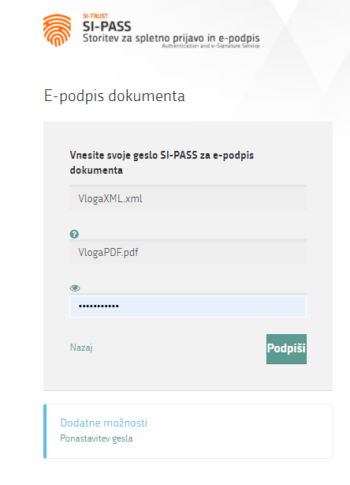

Figure 9: Electronic signature of the application

If you notice that you have made some mistake, by clicking on the "Nazaj na obrazec" [Back to form] button you can return to the form and correct the mistake. You can also print the application before signing it.

The procedure proceeds to the payment of the fee.

1. **Step: Electronic payment**

The Payment of Costs of Procedure step displays the amount of the charge and payment details.

Before you pay, check the amount calculated by the portal. The amount is linked to the number of units you are applying for. If you are registering a list, the amount is linked to the list total, which is the product of the registered business units and the fee (tariff number 3 – EUR 18.10).

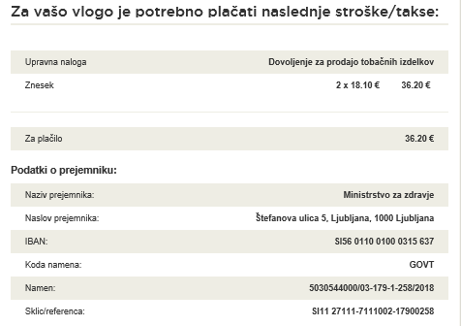

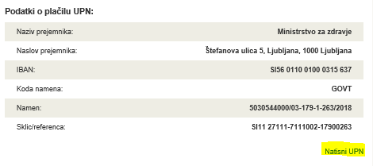

Figure 10: Read-out of payment details (individual unit registration)

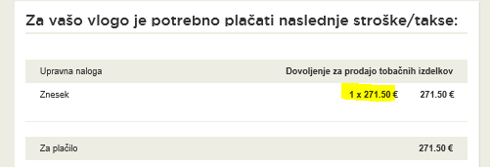

Figure 11: Read-out of payment details (customising the list)

Selection of payment method:

1. This payment method allows you to print out the universal payment order and pay the charges at your bank, enclosing a receipt. If the payment cannot be made in a short time, by clicking on the
2. "Shrani in zapri" [Save and close] link you interrupt the procedure and resume it after the payment has been made. To proceed, you need proof of payment, which you can attach in image (JPEG, PNG, TIFF) or PDF format.

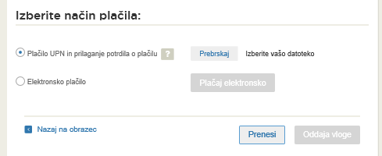

Figure 12: Payment method

1. The second payment method, the "Elektronsko plačilo" [Electronic payment] allows the user to pay charges electronically via the eUJP system. The eUJP system supports card payments, mobile payments and online banking.

To proceed with the payment, click on "Plačaj elektronsko" [Pay electronically].

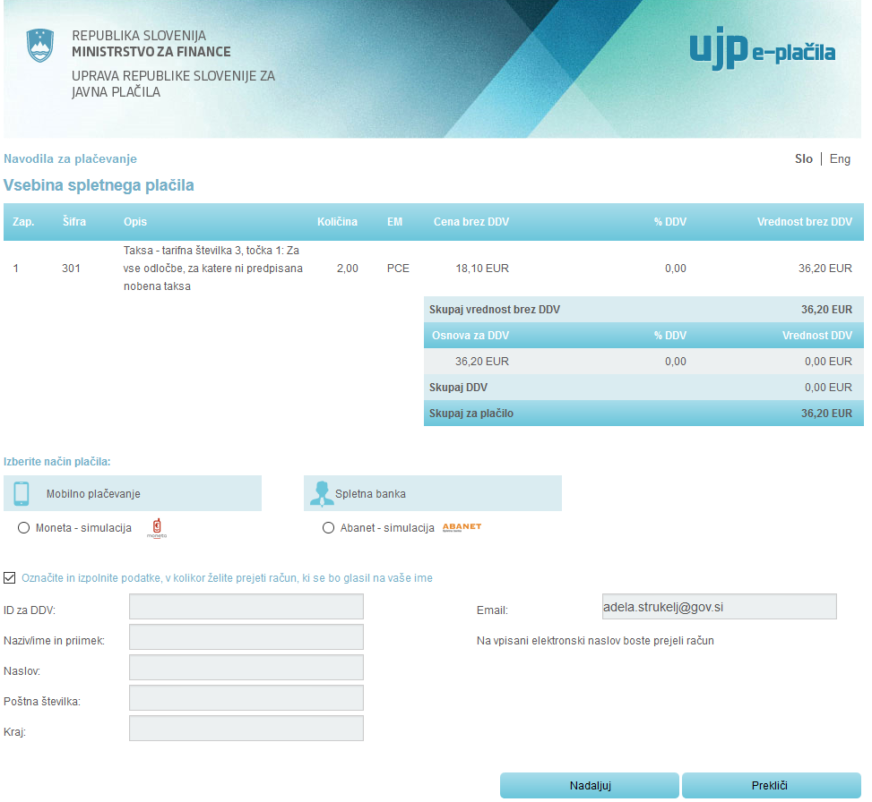

Figure 13UJP – Amount and selection of payment method

The portal directs you to the UJP e-payment service page, which offers various forms of payment. *Select the most suitable one and fill in the details.* If you want to receive an anonymous invoice, tick the checkbox "Označite in izpolnite podatke, v kolikor želite prejeti račun, ki se bo glasil na vaše ime" [Tick and fill in the details if you want to receive an invoice issued to your name]. Then click on the "Nadaljuj" [Continue] button.

Once the payment has been made, the UJP system will display the invoice for you. Click "Zapri" [Close] to continue the process.

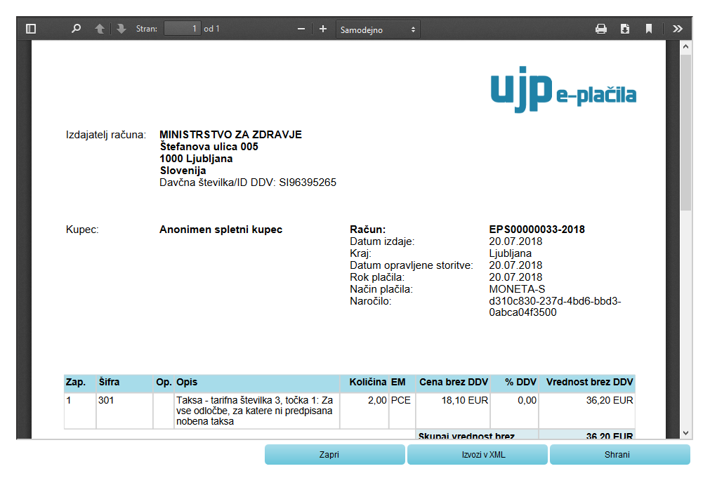

Figure 14: Public Payments Administration of the Republic of Slovenia – account

1. **Step: Submission of application**

This is where the system offers you the possibility to save the signed application and its annexes in your own records. Once the application has been submitted, the user no longer has access to it. The "Pošlji" [Submit] button is activated in the event that you download your application or confirm the box "Ne želim prenesti vloge" [I do not want to download my application]. To continue, click on the "Pošlji" [Submit] button.

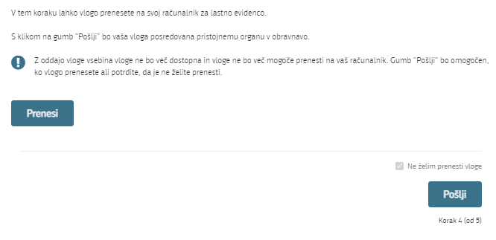

Figure 15: Full application download and submission

1. **Step: Conclusion**

The portal submits the application to the competent authority for processing. The user is presented with the details of the submission and a link to the desktop. The user receives an email notification that the application has been submitted.

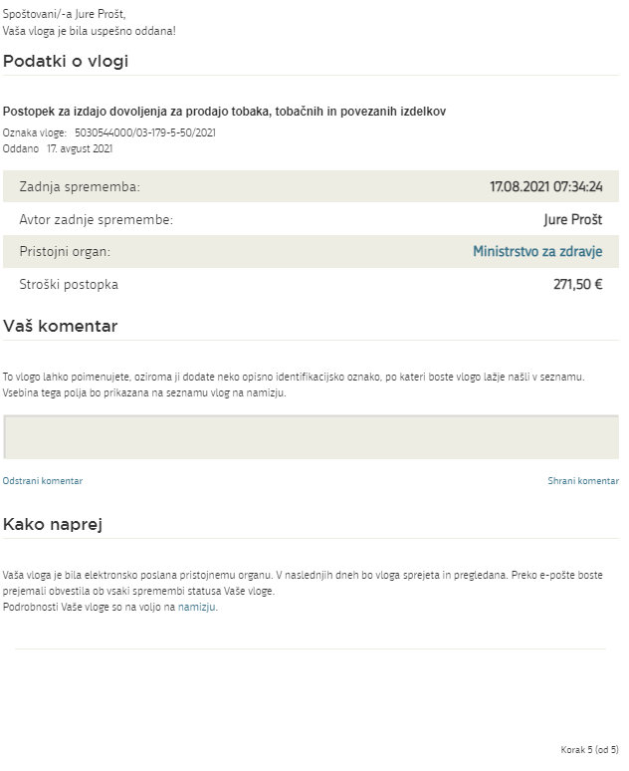

Figure 16: Conclusion

* 1. Supplementing the application

If the application is not complete, the competent authority will ask you to supplement it. You can supplement your application electronically by selecting the application you wish to supplement from the list of pending applications and selecting "Dopolni" [Supplement] in the "Delo z vlogo" [Application Section].

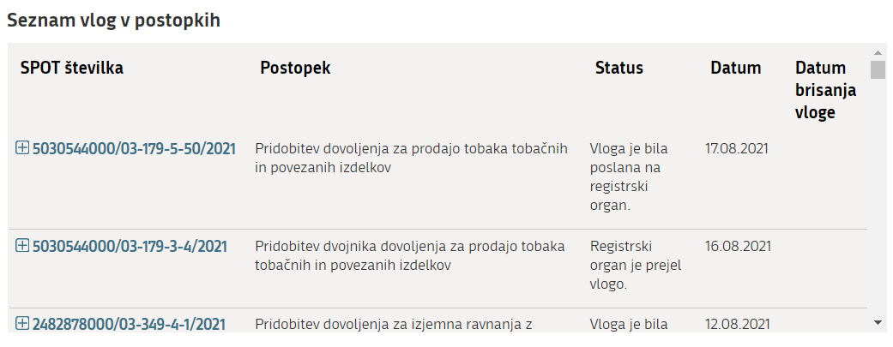

Figure 17: Company desktop – List of pending applications

Figure containing words text

Description is created automatically

Figure 18: Company desktop – Application details

The portal offers a specific form where the applicant has the option of describing missing information or adding missing attachments.

By clicking on the "Naprej" [Next] button, the portal displays a preview of the application and offers signing and submission of the application.

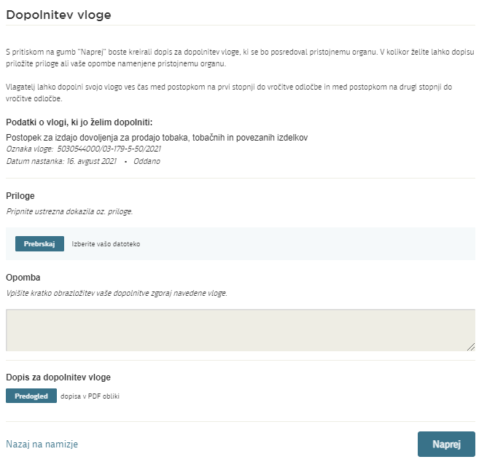

Figure 19: "Supplementing the application" form

* 1. Withdrawal of application

Before the application is decided on, the portal allows the applicant to withdraw the application. On the "Podatki o vlogi" [Application details] page, selecting the "Prekliči" [Cancel] button will start the withdrawal procedure.

Figure containing words text

Description is created automatically

Figure 20: Company desktop – Application details

The portal offers a full read-out of the application for withdrawal of the application, with all the necessary information.

By clicking on the "Naprej" [Next] button, the portal displays a preview of the application and offers signing and submission of the application.

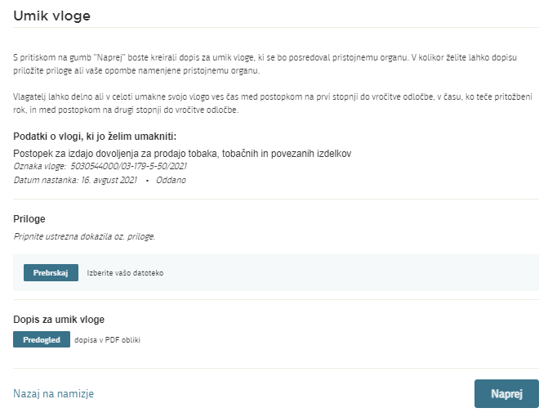

Figure 21: Withdrawal of application

* 1. Tracking application status

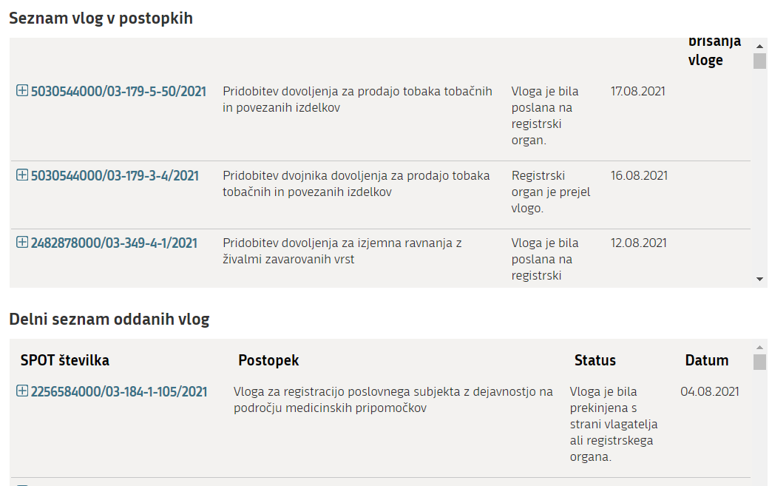

Figure 22: Company desktop – List of pending applications and Partial list of submitted applications

Details of applications not submitted, submitted or under consideration can be found in "Seznam vlog v postopkih" [the list of pending applications]. When an application is decided on, it is moved to "Delni seznam oddanih vlog" [the partial list of submitted applications].